CERTIFIED RECORD

OF

PROCEEDINGS

OF

THE CITY COUNCIL

OF

THE CITY OF GRAND JUNCTION, COLORADO

RELATING TO

AN ORDINANCE

AUTHORIZING THE ISSUANCE OF

ADJUSTABLE RATE REVENUE BONDS FOR

PYRAMID PRINTING, INC. PROJECT

SERIES 2002 AND SERIES 2003

STATE OF COLORADO )
)
COUNTY OF MESA ) ss.
)
CITY OF GRAND JUNCTION )

The City Council of the City of Grand Junction, Colorado, held a regular meeting open to the public in the Auditorium located at 250 N. 5th Street, Grand Junction, Colorado, on Wednesday, the 18th day of September 2002, at the hour of 7:30 p.m.
The following members of City Council, constituting a quorum thereof, were present:
Name Title
Cindy Enos-Martinez Mayor
Dennis Kirtland Mayor Pro Tem
Harry Butler Councilmember
William McCurry Councilmember
James Spehar Councilmember
Janet Terry Councilmember

Councilmember Reford Theobold was absent

The following persons were also present:

Name Title

Stephanie Tuin City Clerk
Ron Lappi Administrative Services Director
Dan Wilson City Attorney

Thereupon, the following proceedings, among others, were had and taken:
Councilmember Spehar then introduced and moved the adoption on first reading of the following Ordinance, which was read by title, copies thereof having been made available to the Council and to the public:
CITY OF GRAND JUNCTION
ORDINANCE NO. 3454
AN ORDINANCE AUTHORIZING THE ISSUANCE AND SALE OF CITY OF GRAND JUNCTION, COLORADO, ADJUSTABLE RATE REVENUE BONDS (PYRAMID PRINTING, INC. PROJECT), SERIES 2002, IN THE AGGREGATE PRINCIPAL AMOUNT NOT TO EXCEED $1,600,000 AND SERIES 2003, IN THE AGGREGATE PRINCIPAL AMOUNT NOT TO EXCEED $1,600,000; MAKING DETERMINATIONS AS TO SUFFICIENCY OF REVENUES AND AS TO OTHER MATTERS RELATED TO THE PROJECT AND APPROVING THE FORM AND AUTHORIZING THE EXECUTION OF CERTAIN DOCUMENTS RELATING THERETO.

WHEREAS, the City of Grand Junction, Colorado (the "Issuer") is authorized by its Home Rule Charter (the "Charter"), and the provisions of the County and Municipality Development Revenue Bond Act, article 3 of title 29, Colorado Revised Statutes, as amended (the "Act") and existing under the Constitution and laws of the State of Colorado (the "State"), to issue revenue bonds for the purpose of financing or refinancing projects to the end of promoting industry and developing trade or other economic activity by inducing nonprofit corporations to locate, expand or remain in the State and to secure and maintain a balanced economy in the State, to enter into financing agreements with others for the purpose of providing revenues to pay such bonds, and further to secure the payment of such bonds;
WHEREAS, the following documents have been submitted to City Council (the "Council") and filed in the office of the City Clerk (the "Clerk") and are there available for public inspection:
(a) a proposed form of a Loan Agreement, dated as of December 1, 2002 (the "Loan Agreement"), by and between the Issuer and TOT, L.L.C. (the "Company");
(b) a proposed form of a Trust Indenture, dated as of December 1, 2002 (the "Indenture"), by and between the Issuer and Wells Fargo Bank West, National Association (the "Trustee");
(c) the Official Statement dated December ___, 2002 (the "OS");
(d) proposed forms of a Series 2002 Bond Purchase Agreement and Series 2003 Bond Purchase Agreement (collectively, the "Purchase Agreement") by and among the Issuer, the Company and Wells Fargo Brokerage Services, LLC (the "Underwriter"); and
(e) a proposed form of a Remarketing Agreement (the "Remarketing Agreement") by and among the Issuer, the Company and Wells Fargo Brokerage Services, LLC, as the remarketing agent (the "Remarketing Agent").
WHEREAS, if Council proceeds with the Project, as defined below, then Council is willing to (i) enter into the Loan Agreement, the Trust Indenture, the Purchase Agreement, and the Remarketing Agreement; (ii) acknowledge the use and distribution of the Official Statement and consent to the use of the information therein under the caption "THE ISSUER" and "ABSENCE OF LITIGATION AFFECTING THE BONDS — THE ISSUER"; and (iii) issue, execute and deliver the Bonds;
WHEREAS, if Council proceeds with the Project, as defined below, then the issuance of the Bonds shall be approved by the "applicable elected representative" of the Issuer following proceedings under, and in accordance with, Section 147(f) of the Internal Revenue Code of 1986, as amended (the "Code"), and the regulations promulgated thereunder (the "Regulations");
WHEREAS, Council desires to issue the City of Grand Junction, Colorado, Adjustable Rate Revenue Bonds (Pyramid Printing, Inc. Project), Series 2002, in the aggregate principal amount not to exceed $1,600,000 (the "Series 2002 Bonds") and Series 2003, in the aggregate principal amount not to exceed $1,600,000 (the "Series 2003 Bonds" and together with the Series 2002 Bonds, the "Bonds"), for the presently anticipated purposes of financing (i) the acquisition, construction, equipping and improving of real and personal property in the form of an approximately 25,000 square-foot printing production and office facility located within the boundaries of the City of Grand Junction, Colorado, and (ii) paying for a portion of the costs of issuance incurred with respect to the Bonds (collectively, the "Project"); and
WHEREAS, it is necessary or desirable to authorize the issuance of the Bonds by Ordinance and to approve the form and authorize the execution of the aforementioned documents thereby.
NOW, THEREFORE, BE IT ORDAINED BY THE CITY COUNCIL OF THE CITY OF GRAND JUNCTION, COLORADO:
Section 1. Approvals and Authorizations. The forms of the Loan Agreement, Remarketing Agreement, Indenture (including the form of the Bonds) and Purchase Agreement are hereby approved with only such changes therein, if any, as are not inconsistent herewith. In accordance with the terms of the Indenture, Wells Fargo Bank West, National Association, is hereby appointed as a trustee with respect to the Bonds. The Underwriter is hereby appointed as an underwriter in connection with the purchase of the Bonds. The Remarketing Agent is hereby appointed as a remarketing agent with respect to the remarketing of the Bonds. The Mayor or the Mayor Pro Tem and the Clerk or a deputy, and such other duly authorized officers of the Issuer, are hereby authorized and directed to execute the Loan Agreement, the Indenture, the Purchase Agreement, the Remarketing Agreement, the Bonds, the Official Statement, and to affix the seal of the Issuer thereto, and further to execute and authenticate such other documents, instruments or certificates as are deemed necessary or desirable by bond counsel in order to issue and secure the Bonds. Such documents are to be executed in substantially the form hereinabove approved, provided that such documents may be completed, corrected, prepared or revised as deemed necessary by the parties thereto in order to carry out the purposes of this Bond Ordinance. Copies of all of the documents shall be delivered, filed and recorded as provided therein. The rights, title and interest of the Issuer in the Loan Agreement when executed, shall, by the terms thereof, have been assigned to the Trustee, except as therein provided.
The proper officers of the Issuer are hereby authorized and directed to prepare and furnish to bond counsel certified copies of all proceedings and records of the Issuer relating to the Bonds and such other affidavits and certificates as may be required to show the facts relating to the authorization and issuance thereof, as such facts appear from the books and records in such officers' custody and control.
The approval hereby given to the various documents referred to above includes the approval of such additional details therein as may be necessary and appropriate for their completion and such modifications thereof, deletions therefrom, and additions thereto as may be approved by bond counsel and Issuer's attorney prior to the execution of the documents. The execution of any instrument by the appropriate officers of the Issuer herein authorized shall be conclusive evidence of the approval by the Issuer of such instrument in accordance with the terms hereof.
Section 2. Issuance and Sale of Bonds. Subject to receipt by the Issuer at the time of delivery of the Bonds of the approving legal opinion or opinions of Brownstein Hyatt & Farber, P.C., as bond counsel, and the opinion of counsel to the Company, which opinions shall be in forms and substance acceptable to the Issuer, the Issuer shall issue the Bonds, for the purposes, in the form and upon the terms set forth in this Bond Ordinance, the Indenture, the Loan Agreement and the Remarketing Agreement, including the form of the Bonds as set forth in the Indenture.
The Bonds shall be payable in the manner and to the persons set forth in the Indenture and the form of the Bonds set forth therein.
The maximum net effective interest rate authorized for the Bonds is 10% per annum. The interest rates on the Bonds are as set forth in the Indenture.
Section 3. Determinations. It is hereby found, determined and declared, in accordance with Sections 29-3-113, 29-3-114 and 29-3-120 of the Act, that:
(a) The financing of the Project will promote the public health, welfare, safety, convenience and prosperity and promote and develop trade or other economic activity by inducing commercial and business enterprises and nonprofit corporations to locate, expand, or remain in the Issuer and the State, in order to mitigate the serious threat of extensive unemployment and to secure and maintain a balanced and stable economy for the Issuer and the State.
(b) The maximum amounts necessary in each year to pay the principal of and interest on the Bonds and the interest rates to be borne by the Bonds are as provided in the Indenture.
(c) The payments required in the Loan Agreement to be made are sufficient to pay the principal of and interest on the Bonds when due, and to pay all other costs required in the Loan Agreement to be paid, including all sums referred to in paragraphs (e) and (f) of this section.
(d) The Loan Agreement provides that the Company shall maintain the Project in good repair and carry all proper insurance with respect thereto.
(e) The Loan Agreement requires that the Company pay all required taxes and other governmental charges including, without limitation, those specified in Section 29-3-120 of the Act with respect to the Project, and sufficient revenues for such purpose are thereby provided.
(f) The Loan Agreement provides that all fees and expenses of the Issuer shall be paid by the Company.
Section 4. Nature of Obligation. Under the provisions of the Act, and as provided in the Loan Agreement, the Bonds shall be special, limited obligations of the Issuer payable solely from, and secured by a pledge of the revenues derived from the Loan Agreement. The Issuer will not pledge any of its property or secure the payment of the Bonds with its property. The Bonds and the interest thereon shall never constitute the debt or indebtedness or the financial obligation of the Issuer within the meaning of any provision or limitation of the Colorado Constitution or statutes of the State and shall not constitute or give rise to a pecuniary liability of the Issuer, its agents, employees or officers, or a charge against its general credit or taxing powers. In entering into the Purchase Agreement, the Remarketing Agreement, the Loan Agreement, the Indenture and the other documents relating to the issuance of the Bonds to which the Issuer is a party, the Issuer will not obligate itself, except with respect to the application of the revenues derived from the Loan Agreement and the Bond proceeds. The Issuer will not pay out of its general fund or otherwise contribute any part of the Cost of the Project (as said term is defined in the Indenture). No costs are to be borne by the Issuer in connection with the issuance of the Bonds.
Section 5. Bonds and Official Statement Printing. The officers of the Issuer are hereby authorized and directed to assist in, to the extent necessary, the printing of the Bonds and the Official Statement with respect to the Bonds, all in connection with the offer and purchase of the Bonds, provided that no costs are to be borne by the Issuer in connection therewith.
Section 6. Issuance of Series 2002 Bonds Contingent on Receipt of 2003 Private Activity Bond Allocation. The Series 2003 Bonds shall not be issued until the City is awarded its 2003 private activity bond allocation. The Administrative Service's Director for the City is hereby authorized and directed to execute any necessary documents to effectuate the award of $1,600,000 of the City's 2003 private activity bond allocation to the Project.
Section 7. Bond Ordinance Irrepealable. After the Bonds are issued, this Bond Ordinance shall constitute an irrevocable contract between the Issuer and the holders of the Bonds and shall be and remain irrepealable until the Bonds, both principal and interest, shall be fully paid, canceled and discharged.
Section 8. Ratification. All actions heretofore taken by the Issuer and by the officers thereof or on their behalf not inconsistent herewith directed toward the financing of the Project and the issuance and sale of the Bonds are ratified, approved and confirmed.
Section 9. Repealer. All acts, orders, resolutions, ordinances or parts thereof, taken by the Issuer and in conflict with this Bond Ordinance, are hereby repealed, to the extent of such inconsistency except that this repealer shall not be construed so as to revive any act, order, resolution, ordinance or part thereof, heretofore repealed.
Section 10. Other Matters. By the passage of this Bond Ordinance, the Council does not intend to approve, nor is it approving hereby, any matters relating to licensing, subdivision, zoning, planning or landscaping of the Project. Approval of such matters must be obtained under normal procedures of the Issuer. Nothing herein or in any other document authorized herein shall be interpreted as limiting the Issuer's powers with respect to the Project.
Section 11. Severability. If any paragraph, clause, section or provision of this Bond Ordinance, except Section 4 hereof, is judicially adjudged invalid or unenforceable, such judgment shall not effect, impair or invalidate the remaining paragraphs, clauses, sections or provisions hereof.
Section 12. Effective Date. This Ordinance shall be effective upon thirty days after publication of the ordinance in full following the public hearing.

INTRODUCED AND ADOPTED ON FIRST READING, this 18th day of September, 2002.

CITY OF GRAND JUNCTION, COLORADO

By: /s/ Cindy Enos-Martinez
Mayor

(SEAL)

ATTEST:

/s/ Stephanie Tuin
City Clerk

ADOPTED AND FINALLY APPROVED, this 2nd day of October, 2002.

CITY OF GRAND JUNCTION, COLORADO

By: /s/ Cindy Enos-Martinez
Mayor
(SEAL)

ATTEST:

/s/ Stephanie Tuin
City Clerk

Councilmember Kirtland seconded the motion to adopt on first reading, and the question being upon the passage of said proposed Ordinance on first reading, the roll was called with the following results:
Those voting "AYE":

Cindy Enos-Martinez Mayor
Dennis Kirtland Mayor Pro Tem
Harry Butler Councilmember
William McCurry Councilmember
James Spehar Councilmember
Janet Terry Councilmember

Those voting "NO":

None

Those absent:

Reford Theobold Councilmember

A majority of the members of Council present having voted in favor of the passage on first reading of said proposed Ordinance, the presiding officer thereupon declared the motion duly passed and instructed the City Clerk or her deputy to publish in full the Ordinance once in a newspaper legally qualified for City publications at least ten (10) days before consideration of the Ordinance for final passage and adoption or second reading.

Thereupon, after consideration of other business to come before Council, the meeting was adjourned.

/s/ Cindy Enos-Martinez
Mayor
City of Grand Junction, Colorado
(SEAL)

ATTEST:

/s/ Stephanie Tuin
City Clerk
City of Grand Junction, Colorado

STATE OF COLORADO )
)
COUNTY OF MESA ) ss.
)
CITY OF GRAND JUNCTION )

The City Council of the City of Grand Junction, Colorado, held a regular meeting open to the public in the Auditorium located at 250 N. 5th Street, Grand Junction, Colorado, on Wednesday, the 2nd day of October 2002, at the hour of 7:30 p.m.
The following members of the Council, constituting a quorum thereof, were present:

Cindy Enos-Martinez Mayor
Dennis Kirtland Mayor Pro Tem
Harry Butler Councilmember
William McCurry Councilmember
James Spehar Councilmember
Janet Terry Councilmember
Reford Theobold Councilmember

The following members of the Council were absent: None

The following persons were also present:

Stephanie Tuin City Clerk
Ron Lappi Administration Services Director
Dan Wilson City Attorney

Thereupon, the following proceedings, among others, were had and taken:
The City Clerk informed Council that the proposed Ordinance, which was ordered published in full at the meeting of September 18, 2002, was duly published in a newspaper legally qualified for City publication, in its issue of September 20, 2002.
The Mayor declared that this was the time and place scheduled for a hearing on the proposed bonds, on the nature and location of project and on the ordinance, and declared the public hearing open, whereupon the following persons appeared:
None
The Mayor thereupon declared the public hearing closed.
Councilmember Theobold then moved that the proposed Ordinance, as amended, which was read by title, copies thereof having previously been made available to Council and to the public, be passed and adopted on second reading, and that the proposed Ordinance be approved. Councilmember McCurry seconded the motion, and the question being upon passage and adoption of said Ordinance or second reading, the roll was called, with the following result:
Those voting "AYE":

Cindy Enos-Martinez Mayor
Dennis Kirtland Mayor Pro Tem
Harry Butler Councilmember
William McCurry Councilmember
James Spehar Councilmember
Janet Terry Councilmember
Reford Theobold Councilmember

Those voting "NO":
None

Those absent:
None

At least five (5) members of the entire City Council having voted in favor of the final passage and adoption of said Ordinance, the presiding officer thereupon declared the same finally passed and adopted and instructed the City Clerk to record such Ordinance in an Ordinance Book kept for such purposes, and to publish the title of the proposed Ordinance and a summary of the provisions thereof including a notice that copies of the Ordinance are available at the office of the City Clerk or to publish the Ordinance in full in a newspaper legally qualified for City publication.
Thereupon, after consideration of other business to come before Council, the meeting was adjourned.

/s/ Cindy Enos-Martinez
Mayor
City of Grand Junction, Colorado
(SEAL)

ATTEST:

/s/ Stephanie Tuine
City Clerk
City of Grand Junction, Colorado

STATE OF COLORADO )
)
COUNTY OF MESA ) ss.
)
CITY OF GRAND JUNCTION )

The undersigned, City Clerk of the City of Grand Junction, Colorado, does hereby certify that the attached copy of Ordinance No. 3454, authorizing the issuance of City of Grand Junction, Colorado, Adjustable Rate Revenue Bonds (Pyramid Printing, Inc. Project) Series 2002, in the total principal amount not to exceed $1,600,000, and Series 2003, in the total aggregate principal amount not to exceed $1,600,000 (collectively, the "Bonds") is a true and correct copy thereof as finally enacted, passed and adopted by Council at regular meetings thereof held in the Auditorium, City of Grand Junction, Colorado, the regular meeting place thereof, on Wednesday the 18th day of September, 2002, and Wednesday, the 2nd day of October, 2002; that the original of said Ordinance has been duly executed and authenticated by the signatures of the Mayor or Mayor Pro Tem of the City and myself, sealed with the seal of the City, and recorded in the Ordinance Book of the City; that a public hearing on the nature and location of the project to be financed with proceeds of the Bonds and on the Bonds was held at a regular meeting of Council on Wednesday, the 2nd day of October, 2002, following publication of a notice of hearing in a newspaper of general circulation in the City of Grand Junction, Colorado, as evidenced by the affidavit of publication attached hereto as Exhibit A; that the attached constitutes a full, true and correct copy of the record of the proceedings of Council at said regular meetings insofar as said proceedings relate to said Ordinance and hearing; that said proceedings were duly had and taken; that said meetings were duly held; that the persons were present at said meetings as therein shown; and that said Ordinance was published after first reading, such publication being in a newspaper legally qualified for City publication, as evidenced by the Affidavit of Publication attached hereto as Exhibit B, and after final adoption, as evidenced by the Affidavit of Publication attached hereto as Exhibit C.
IN WITNESS WHEREOF, I have hereunto set my hand and the seal of the City of Grand Junction, Colorado, this 21st day of October, 2002.

/s/ Stephanie Tuin
City Clerk
City of Grand Junction, Colorado
(SEAL)

STATE OF COLORADO )
)
COUNTY OF MESA ) ss.
)
CITY OF GRAND JUNCTION )

Attached is Proof of Publication Exhibit A

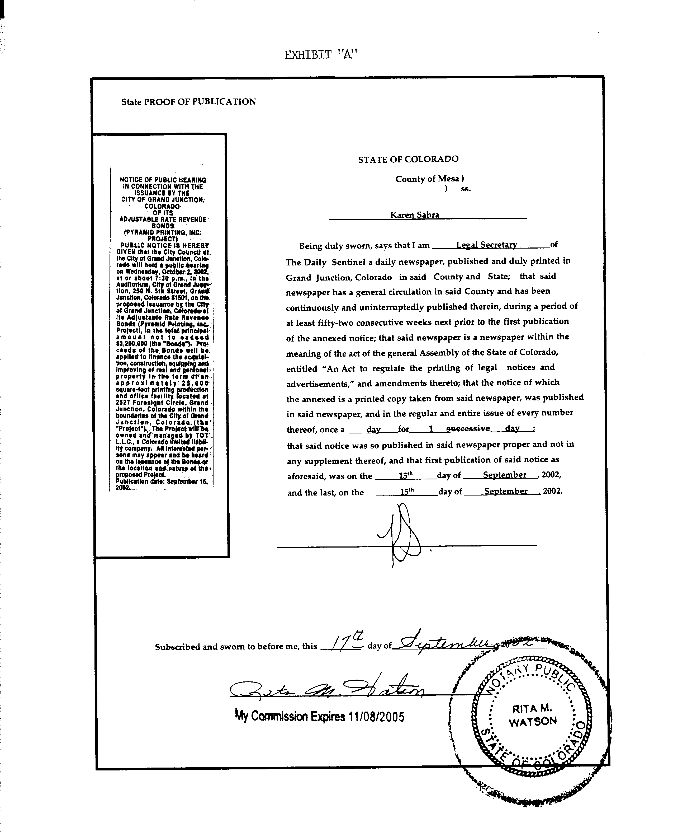
STATE OF COLORADO )
)

COUNTY OF MESA )ss

CITY OF GRAND JUNCTION )
)

Attached is Proof of Publication of Ordinance following first reading - Exhibit B
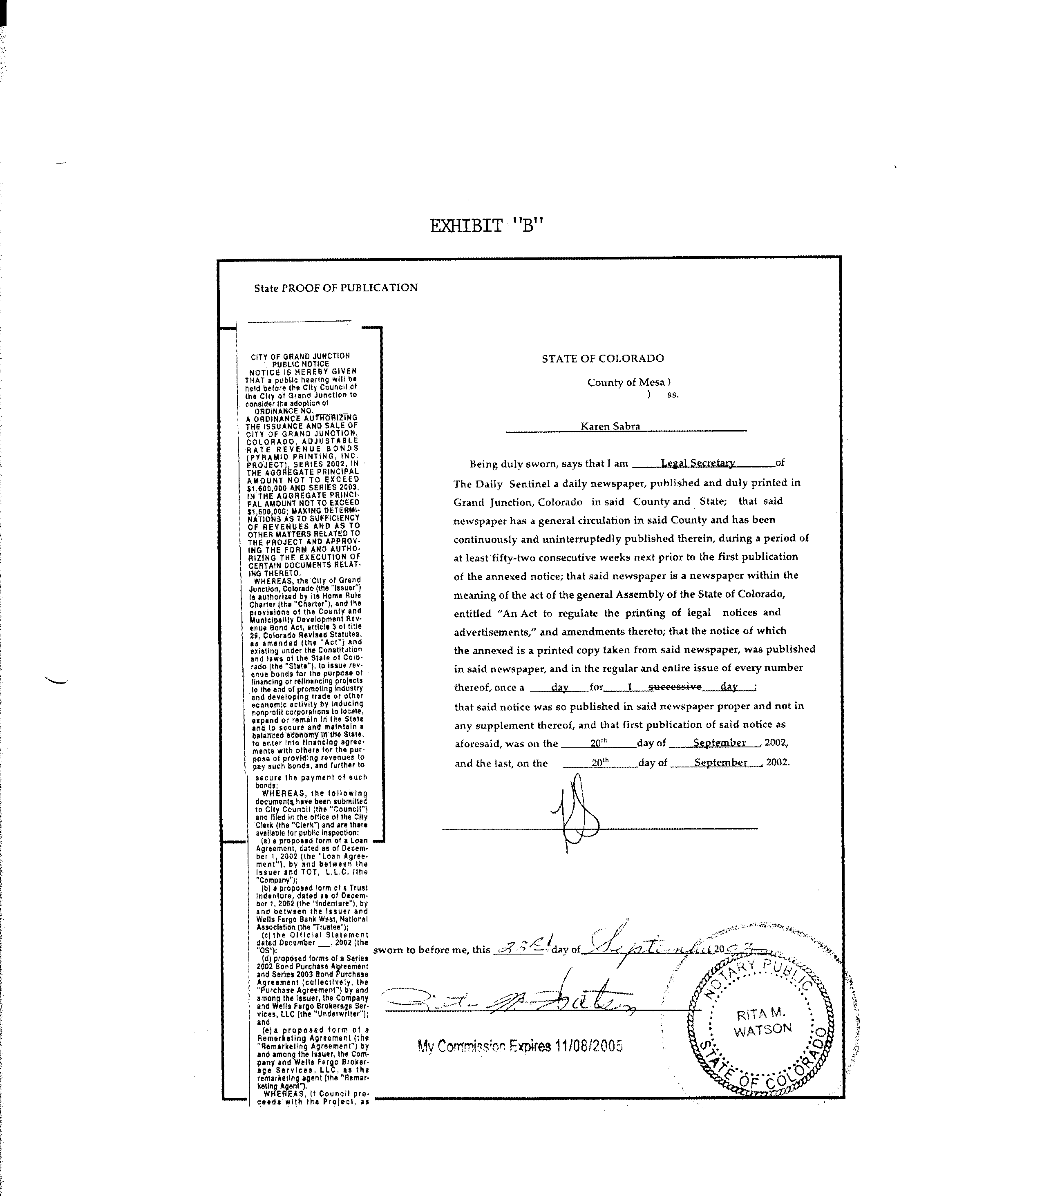

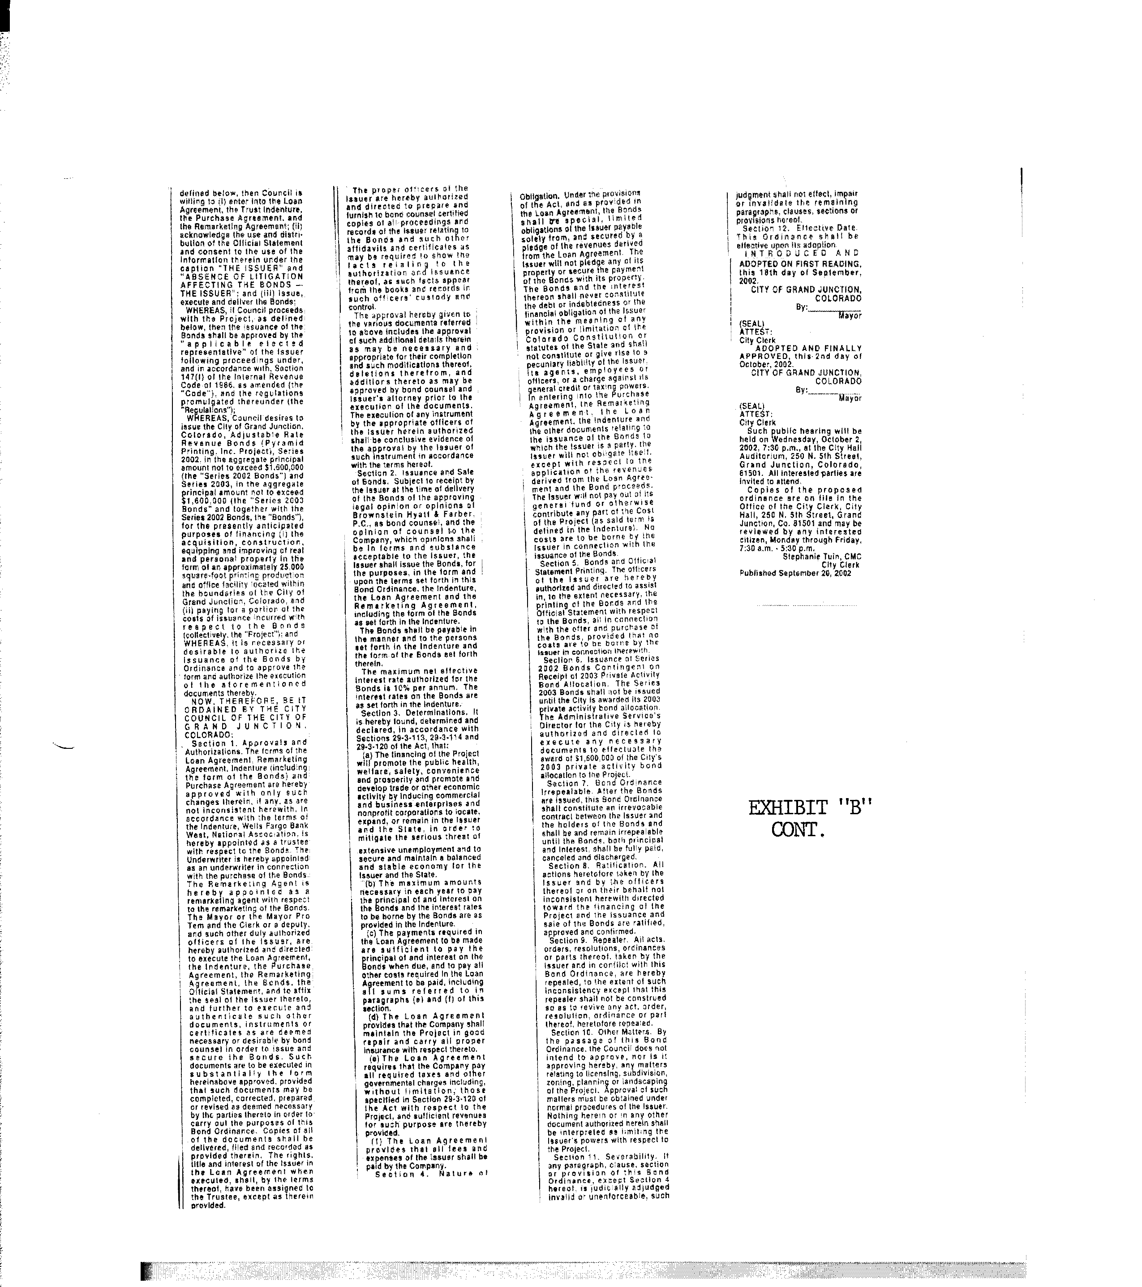
STATE OF COLORADO )
)

COUNTY OF MESA )ss

CITY OF GRAND JUNCTION )
)

Attached is proof of publication of Ordinance following adoption – Exhibit C

