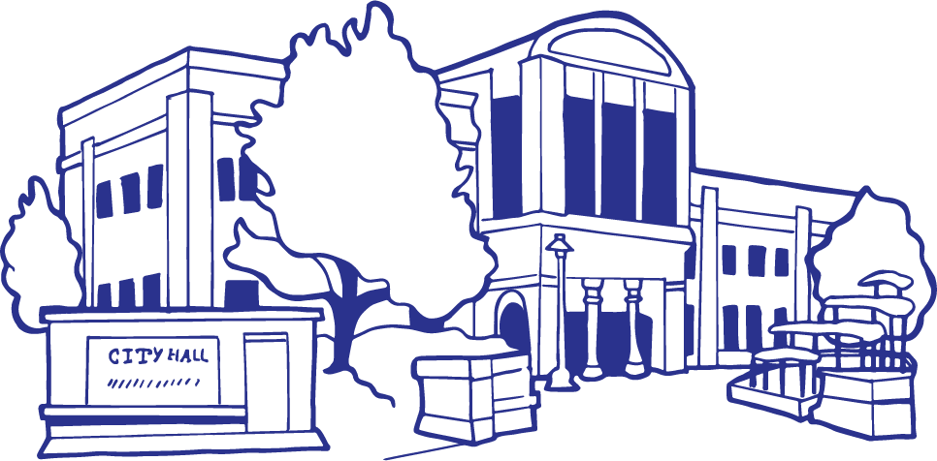
City of Grand Junction, State of Colorado
Proclamation
Whereas, | many people in our community are struggling to make ends meet as fuel and food costs continue to increase; and
Whereas, | in Colorado in 2018, nearly 1 in 10 people (and 1 in 7 children) struggle with hunger; and
Whereas, | food banks are being depleted at the end of each month; and
Whereas, | the Canyon West Worship Center and Western Slope Food Bank of the Rockies distribute thousands of meals monthly on the second Saturday of each month and are sponsoring a virtual food drive with a 100% matching donation from corporate sponsors including Timberline Bank for the first $5,500 of individual donations received to help the hungry in Mesa County; and
Whereas, | community action in the form of individuals volunteering time and contributing financially is a critical resource in our battle against hunger and can be as easy as visiting www.GJfooddrive.com to make a meaningful contribution that when matched dollar for dollar can provide eight meals for every dollar contributed; and
Whereas, | every resident in Mesa County should have enough to eat and sufficient nutrition to carry out the daily tasks of life.
NOW, THEREFORE, I, Rick Taggart, by the power vested in me as Mayor of the City of Grand Junction, do hereby proclaim the month of September 2019 as
“National Hunger Action Month”
in the City of Grand Junction and call upon all citizens, community agencies, religious organizations, medical facilities, and businesses to increase their participation in support of our efforts to prevent food insecurity among individuals and families thereby strengthening the community in which we live.
 |  | IN WITNESS WHEREOF, I have hereunto set my hand and caused to be affixed the official Seal of the City of Grand Junction this 4th day of September, 2019.
 |  | Mayor

