CERTIFIED RECORD
OF
PROCEEDINGS
OF
THE CITY COUNCIL
OF
THE CITY OF GRAND JUNCTION, COLORADO
RELATING TO
AN ORDINANCE
AUTHORIZING THE ISSUANCE
OF
A DEVELOPMENT REVENUE BOND

(COMMUNITY HOSPITAL Project)
SERIES 2003
IN A TOTAL PRINCIPAL AMOUNT NOT TO EXCEED
$3,025,000

STATE OF COLORADO )
)
COUNTY OF MESA ) ss.
)
CITY OF GRAND JUNCTION )

The City Council of the City of Grand Junction, Colorado, held a regular meeting open to the public in the Auditorium located at 250 N. 5th Street, Grand Junction, Colorado, on Wednesday, the 2nd day of April 2003, at the hour of 7:30 p.m.
The following members of City Council, constituting a quorum thereof, were present:
Name Title
Cindy Enos-Martinez Mayor
Dennis Kirtland Mayor Pro Tem
Harry Butler Councilmember
Janet Terry Councilmember
William McCurry Councilmember
James Spehar Councilmember
Reford Theobold Councilmember

The following persons were also present:

Name Title

Stephanie Tuin City Clerk
Ron Lappi Administrative Services Director
Dan Wilson City Attorney

Thereupon, the following proceedings, among others, were had and taken:
Councilmember Kirtland then introduced and moved the adoption on first reading of the following Ordinance, which was read by title, copies thereof having been made available to the Council and to the public:
ORDINANCE NO. 3528

AN ORDINANCE AUTHORIZING THE ISSUANCE AND SALE OF CITY OF GRAND JUNCTION, COLORADO, DEVELOPMENT REVENUE BOND (COMMUNITY HOSPITAL PROJECT), SERIES 2003, IN THE AGGREGATE PRINCIPAL AMOUNT NOT TO EXCEED $3,025,000; MAKING DETERMINATIONS AS TO SUFFICIENCY OF REVENUES AND AS TO OTHER MATTERS RELATED TO THE PROJECT AND APPROVING THE FORM AND AUTHORIZING THE EXECUTION OF CERTAIN DOCUMENTS RELATING THERETO.

WHEREAS, the City of Grand Junction, Colorado (the "Issuer" or the "City"), is authorized by its Home Rule Charter (the "Charter"), the provisions of the County and Municipality Development Revenue Bond Act, article 3 of title 29, Colorado Revised Statutes, as amended (the "Act"), and the provisions of the Supplemental Public Securities Act, part 2, article 57 of title 11, Colorado Revised Statutes, as amended (the "Supplemental Act") to issue revenue bonds for the purpose of financing projects to be located within the Issuer for the purposes enumerated in the Act, to enter into financing agreements with others for the purpose of providing revenues to pay such bonds, and further to secure the payment of such bonds; and
WHEREAS, the Act provides that title to any project may at all times remain in the name of the user of the project; and
WHEREAS, Colorado West HealthCare System, d.b.a. Community Hospital, a Colorado nonprofit corporation and an organization described in Section 501(c)(3) of the Internal Revenue Code of 1986, as amended (the "Borrower"), has requested that the Issuer issue its revenue bond in accordance with the Charter and the Act, such bond to be designated the City of Grand Junction, Colorado, Development Revenue Bond (Community Hospital Project) Series 2003 (the "Bond"), the proceeds of which shall be loaned to the Borrower for the purposes of (i) providing funds which will be sufficient to finance the purchase of a new phone system and medical equipment, including MRI, CT Scanner, Ultra-sound machines and diagnostic software and other medical equipment to be used at the Borrower's healthcare facilities located at 2021 North 12th Street, Grand Junction, Colorado 81501 (the "Project"), and (ii) paying certain costs relating to the issuance of the Bond; and
WHEREAS, a Financing and Security Agreement, to be dated as of May 1, 2003 (the "Agreement"), among the Issuer, the Borrower and Wells Fargo Bank West, N.A., a national banking association (the "Bank") has been submitted to the City Council (the "Council") and filed in the office of the City Clerk (the "Clerk"), and is there available for public inspection; and
WHEREAS, the Council desires at this time to authorize the issuance of the Bond, for the purpose of the Project; and
WHEREAS, a public hearing before the Council concerning the proposed Bonds and the nature and location of the Project is scheduled to be held on April 16, 2003, and such public hearing in accordance with Section 147(f) of the Internal Revenue Code of 1986 will be required as condition to the issuance and sale of the Bonds; and
WHEREAS, it is necessary or desirable to authorize the issuance of the Bond by Ordinance and to approve the form and authorize the execution of the Agreement.
NOW, THEREFORE, BE IT ORDAINED BY THE CITY COUNCIL OF THE CITY OF GRAND JUNCTION, COLORADO:

Section 1. Approvals and Authorizations. The form of the Agreement, including the form of the Bond (collectively, the “Issuer Documents”) is hereby approved. The Mayor or the Mayor-Pro-Tem and the Clerk or a deputy are hereby authorized and directed to execute the Issuer Documents and to affix the seal of the Issuer thereto, and further to execute and authenticate such other documents, instruments or certificates as are deemed necessary or desirable by bond counsel in order to issue and secure the Bond. Such documents are to be executed in substantially the form hereinabove approved, provided that such documents may be completed, corrected, or revised as deemed necessary by the parties thereto in order to carry out the purposes of this Ordinance. Copies of all of the documents shall be delivered, filed and recorded as provided therein. The rights, title and interest of the Issuer in the Agreement when executed, shall, by the terms thereof, have been assigned to the Trustee except as therein provided.
Section 11-57-204 of the Supplemental Act provides that a public entity, including the City, may elect in an act of issuance to apply all or any of the provisions of the Supplemental Act. The Board hereby elects to apply all of the Supplemental Act to the Bonds.
The proper officers of the Issuer are hereby authorized and directed to prepare and furnish to bond counsel certified copies of all proceedings and records of the Issuer relating to the Bond and such other affidavits and certificates as may be required to show the facts relating to the authorization and issuance thereof, as such facts appear from the books and records in such officers' custody and control.
The approval hereby given to the various documents referred to above includes the approval of such additional details therein as may be necessary and appropriate for their completion and such modifications thereof, deletions therefrom, and additions thereto as may be approved by bond counsel prior to the execution of the documents. The execution of any instrument by the appropriate officers of the Issuer herein authorized shall be conclusive evidence of the approval by the Issuer of such instrument in accordance with the terms hereof.
Section 2. Issuance and Sale of Bond. The Issuer shall issue its Development Revenue Bond (Community Hospital Project) Series 2003, to be in registered form and to be dated as provided in the Agreement, in a total principal amount not to exceed $3,025,000, for the purposes, in the forms and upon the terms set forth in this Ordinance and the Agreement, including the form of the Bond as set forth in the Agreement.
The Bond shall be payable in the manner and to the persons set forth in the Agreement and the form of the Bond set forth therein.
The maximum net effective interest rate authorized for the Bond shall not exceed 10% per annum.
Section 3. Determinations. It is hereby found, determined and declared, that:
(a) The financing of the Project will promote the public health, welfare, safety, convenience and prosperity and promote and develop trade or other economic activity by including commercial and business enterprises to locate, expand or remain in the Issuer and the State of Colorado, in order to mitigate the serious threat of extensive unemployment and to secure and maintain a balanced and stable economy for the Issuer and the State of Colorado.
(b) The maximum amounts necessary in each year to pay the principal of and interest on the Bond and the interest rate or rates to be borne by the Bond are as provided in the Agreement.
(c) The payments required in the Agreement to be made are sufficient to pay the principal of and interest on the Bond when due, and to pay all other costs required in the Agreement to be paid, including all sums referred to in paragraphs (b), (d) and (e) of this section.
(d) The Agreement provides that the Borrower shall maintain the Project in good repair and carry all proper insurance with respect thereto.
(e) The Agreement requires that the Borrower pay the taxes and other governmental charges with respect to the Project, including taxes and charges which the taxing entities specified in C.R.S. Section 29-3-120 are entitled to receive, and sufficient revenues for such purpose are thereby provided.
(f) The City hereby certifies that the reasonably anticipated aggregate amount of tax-exempt obligations which will be issued by the City and all subordinate entities of the City during the calendar year 2003 (excluding the portion of obligations issued to currently refund any obligation to the extent the amount of the refunding obligation does not exceed the outstanding amount of the refunded obligation) will not exceed $10,000,000. Accordingly, the City hereby designates the Bond for purposes of Section 265(b)(3) of the Code as a "qualified tax-exempt obligation."
Section 4. Nature of Obligation. Under the provisions of the Charter, the Act and the Supplemental Act, and as provided in the Agreement and the Bond, the Bond shall be a special, limited obligation of the Issuer payable solely from, and secured by a pledge of, the revenues derived from the Agreement, and any collateral provided by the Borrower. The Issuer does not pledge any of its property or secure the payment of the Bond with its property. The Bond and the interest thereon shall never constitute the debt or indebtedness or a multi-year fiscal obligation or the financial obligation of the State of Colorado or any political subdivision thereof, including the Issuer, within the meaning of any provision or limitation of the Colorado Constitution or statutes of the State of Colorado or the Charter, and shall not constitute or give rise to a pecuniary liability of the Issuer, its agents, employees or officers, or a charge against its general credit or taxing powers. In entering into the Issuer Documents, the Issuer will not obligate itself, except with respect to the application of the revenues derived from the Agreement and the Bond proceeds. The Issuer will not pay out of its general fund or otherwise contribute any part of the cost of financing the Project. No costs are to be borne by the Issuer in connection with the issuance of the Bond. The Agreement provides that all fees and expenses of the Issuer shall be paid by the Borrower.
Section 5. Bond Printing and Related Matters. The officers of the Issuer are hereby authorized and directed to arrange for the printing of the Bond, provided that, subject to Section 3(c) above, the Borrower shall pay for all costs in connection with the preparation and printing of the Bond and no such costs are to be borne by the Issuer. The Bond will be purchased by the Bank in accordance with the Agreement.
Section 6. Bond Ordinance Irrepealable. After the Bond is issued, this Ordinance shall constitute an irrevocable contract between the Issuer and the holder(s) of the Bond and shall be and remain irrepealable until the Bond, both principal and interest, shall be fully paid, cancelled and discharged.
Section 7. Ratification. All actions heretofore taken by the Issuer and by the officers thereof or on their behalf not inconsistent herewith directed toward the financing of the Project and the issuance and sale of the Bond, or the conduct of a public hearing relating to the issuance of the Bond or the location and nature of the Project, are hereby ratified, approved and confirmed.
Section 8. Repealer. All acts, orders, ordinances, resolutions or parts thereof, taken by the Issuer and in conflict with this Ordinance, are hereby repealed except that this repealer shall not be construed so as to revive any act, order, ordinance, resolution or part thereof heretofore repealed.
Section 9. Other Matters. By the passage of this Ordinance, the Council does not intend to approve, nor is it approving hereby, any matters relating to licensing, subdivision zoning, planning or landscaping of the Project. Approval of such matters must be obtained under normal procedures of the Issuer.
Section 10. Severability. If any paragraph, clause, section or provision of this Ordinance, except Section 4 hereof, is judicially adjudged invalid or unenforceable, such judgment shall not affect, impair or invalidate the remaining paragraphs, clauses, sections or provisions hereof.
Section 11. Effective Date. This Ordinance shall be effective thirty days after proper publication.
INTRODUCED AND ADOPTED ON FIRST READING, this 2nd day of April, 2003.

CITY OF GRAND JUNCTION, COLORADO

By: /s/: Cindy Enos-Martinez
Cindy Enos-Martinez, Mayor

(SEAL)

ATTEST:

/s/: Stephanie Tuin
Stephanie Tuin, City Clerk

ADOPTED AND FINALLY APPROVED, this 16th day of April, 2003.

CITY OF GRAND JUNCTION, COLORADO

By: /s/: Cindy Enos-Martinez
Cindy Enos-Martinez, Mayor
(SEAL)

ATTEST:

/s/: Stephanie Tuin
Stephanie Tuin, City Clerk

Councilmember Terry seconded the motion to adopt on first reading, and the question being upon the passage of said proposed Ordinance on first reading, the roll was called with the following results:
Those voting "AYE":

Harry Butler
Dennis Kirtland
Bill McCurry
Jim Spehar
Reford Theobold
Cindy Enos-Martinez

Those voting "NO":
None.

Those abstaining

Janet Terry

Those absent:

None.

A majority of the members of the Council present having voted in favor of the passage on first reading of said proposed Ordinance, the presiding officer thereupon declared the motion duly passed and instructed the City Clerk or her deputy to publish in pamphlet form the Ordinance once in a newspaper legally qualified for City publications at least ten (10) days before consideration of the Ordinance for final passage and adoption or second reading.

Thereupon, after consideration of other business to come before the Council, the meeting was adjourned.

/s/: Cindy Enos-Martinez
Cindy Enos-Martinez, Mayor
City of Grand Junction, Colorado
(SEAL)

ATTEST:

/s/: Stephanie Tuin
Stephanie Tuin, City Clerk
City of Grand Junction, Colorado

STATE OF COLORADO )
)
COUNTY OF MESA ) ss.
)
CITY OF GRAND JUNCTION )

The City Council of the City of Grand Junction, Colorado, held a regular meeting open to the public in the Auditorium located at 250 N. 5th Street, Grand Junction, Colorado, on Wednesday, the 16th day of April 2002, at the hour of 7:30 p.m.
The following members of City Council, constituting a quorum thereof, were present:
Name Title
Cindy Enos-Martinez Mayor
Dennis Kirtland Mayor Pro Tem
Harry Butler Councilmember
Janet Terry Councilmember
William McCurry Councilmember
James Spehar Councilmember
Reford Theobold Councilmember

The following persons were also present:

Name Title

Stephanie Tuin City Clerk
Ron Lappi Administrative Services Director
Dan Wilson City Attorney

Thereupon, the following proceedings, among others, were had and taken:
The City Clerk informed the City Council that the proposed Ordinance, which was ordered published in pamphlet at the meeting of April 2, 2003, was duly published in a newspaper legally qualified for City publication, in its issue of April 4th, 2003.
The Mayor declared that this was the time and place scheduled for a hearing on the proposed bonds, on the nature and location of project and on the ordinance, and declared the public hearing open, whereupon the following persons appeared:
[None]
The Mayor thereupon declared the public hearing closed.
Councilmember Spehar then moved that the proposed Ordinance, as amended, which was read by title, copies thereof having previously been made available to the council and to the public, be passed and adopted on second reading, and that the proposed Ordinance be approved. Councilmember Kirtland seconded the motion, and the question being upon passage and adoption of said Ordinance or second reading, the roll was called, with the following result:
Those voting "AYE":
Harry Butler
Dennis Kirtland
Bill McCurry
Jim Spehar
Reford Theobold
Cindy Enos-Martinez

Those voting "NO":
None

Those abstaining
Janet Terry

Those absent:
None.

At least four (4) members of the entire City Council having voted in favor of the final passage and adoption of said Ordinance, the presiding officer thereupon declared the same finally passed and adopted and instructed the City Clerk to record such Ordinance in an Ordinance Book kept for such purposes, and to publish the title of the proposed Ordinance and a summary of the provisions thereof including a notice that

{remainder of page intentionally blank}
copies of the Ordinance are available at the office of the City Clerk or to publish the Ordinance in full in a newspaper legally qualified for City publication.
Thereupon, after consideration of other business to come before the Council, the meeting was adjourned.

/s/: Cindy Enos-Martinez
Cindy Enos-Martinez, Mayor
City of Grand Junction, Colorado
(SEAL)

ATTEST:

/s/: Stephanie Tuin
Stephanie Tuin, City Clerk
City of Grand Junction, Colorado

STATE OF COLORADO )
)
COUNTY OF MESA ) ss.
)
CITY OF GRAND JUNCTION )

The undersigned, City Clerk of the City of Grand Junction, Colorado, does hereby certify that the attached copy of Ordinance No. 3528, authorizing the issuance of City of Grand Junction, Colorado, Development Revenue Bond (Community Hospital Project) Series 2003, in the total principal amount not to exceed $3,025,000 (the "Bond") is a true and correct copy thereof as finally enacted, passed and adopted by the Council at regular meetings thereof held at the Auditorium located at 250 N. 5th Street, Grand Junction, Colorado, the regular meeting place thereof, on Wednesday the 2nd day of April, 2003 and Wednesday the 16th day of April, 2003, that the original of said Ordinance has been duly executed and authenticated by the signatures of the Mayor or Mayor Pro Tem of the City and myself, sealed with the seal of the City, and recorded in the Ordinance Book of the City; that a public hearing on the nature and location of the project to be financed with proceeds of the Bond and on the Bond was held at a regular meeting of the Council on Wednesday, the 16th day of April, 2003, following publication of a notice of hearing in a newspaper of general circulation in the City of Grand Junction, Colorado, as evidenced by the affidavit of publication attached hereto at page A; that the attached constitutes a full, true and correct copy of the record of the proceedings of the Council at said regular meetings insofar as said proceedings relate to said Ordinance and hearing; that said proceedings were duly had and taken; that said meetings were duly held; that the persons were present at said meetings as therein shown; and that said Ordinance was published after first reading, such publication being in a newspaper legally qualified for City publication, as evidenced by the Affidavit of Publication attached hereto at page B, and after final adoption, as evidenced by the Affidavit of Publication attached hereto at page C.

IN WITNESS WHEREOF, I have hereunto set my hand and the seal of the City of Grand Junction, Colorado, this 16th day of April, 2003.

/s/: Stephanie Tuin
Stephanie Tuin, City Clerk
City of Grand Junction, Colorado
(SEAL)

STATE OF COLORADO )
)
COUNTY OF MESA ) ss.
)
CITY OF GRAND JUNCTION )

Proof of publication of
Notice of Public Hearing

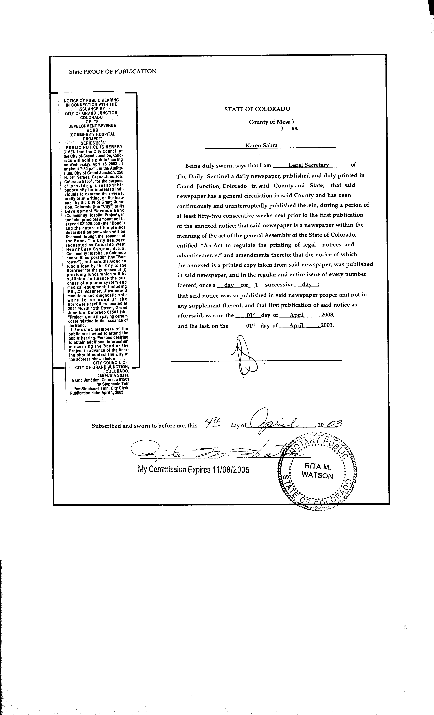
STATE OF COLORADO )
)
COUNTY OF MESA ) ss.
)
CITY OF GRAND JUNCTION )

Proof of publication of Ordinance following first reading

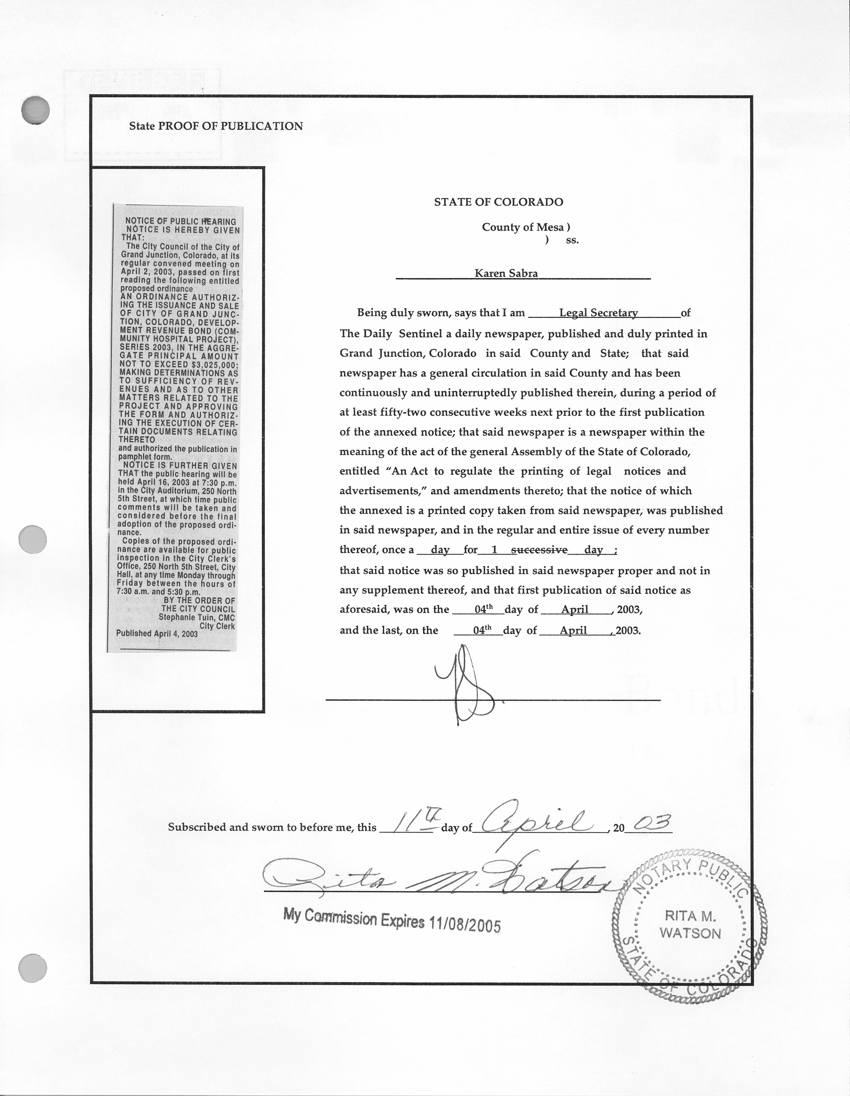
STATE OF COLORADO )
)
COUNTY OF MESA ) ss.
)
CITY OF GRAND JUNCTION )

Proof of publication of Ordinance following adoption

