**CITY OF GRAND JUNCTION**

**RESOLUTION NO. 33-13**

**A RESOLUTION VACATING A PORTION OF AN EXISTING PUBLIC UTILITY EASEMENT LOCATED AT 615 28 1/4 ROAD (VILLAGE PARK)**

RECITALS:

The applicant proposes to vacate a portion of a public utility easement dedicated with the Village Park subdivision plat identified at Plat Book 19 Page 125 of the Mesa County public records and located at 615 28 1/4 Road.

The City Council finds that the request is consistent with the Comprehensive Plan, the Grand Valley Circulation Plan and Section 21.02.100 of the Zoning and Development Code.

The Planning Commission, having heard and considered the request, found the criteria of the Code to have been met, and recommends that the vacation be approved.

NOW, THEREFORE BE IT ORDAINED BY THE CITY COUNCIL OF THE CITY OF GRAND JUNCTION THAT:

The following described utility easement is hereby vacated:

A tract of land situated in the Southwest Quarter of the Southwest Quarter of Section 6, Township 1 South, Range 1 East, of the Ute Meridian, Mesa County, Colorado and being more particularly described as follows:

Commencing at the Southwest corner of said Section 6 from whence the Southeast corner of the Southwest Quarter of the Southwest Quarter of said Section 6 bears N89°57’18”E a distance of 1272.82 feet for a basis of bearings with all bearings hereon related thereto, thence along the South line of the Southwest Quarter of the Southwest Quarter of said Section 6 N89°57’18”E a distance of 949.25 feet; thence N0°02’42”W a distance of 55.00 to the Southeast corner of Block 2 Village Park as recorded in Plat Book 19 at Page 125 of the Mesa County Clerk and Recorder’s Office; thence N0°02’42”W along the East line of said Block 2 a distance of 290.37 feet to the North line of an existing 30 foot Utility, Irrigation and Drainage Easement as recorded in Plat Book 19 at Page 125 of the Mesa County Clerk and Recorder’s; thence along said North line N47°33’43”W a distance of 188.68 feet to the Point of Beginning; thence N47°33’15”W a distance of 55.17 feet; thence N89°56’08”E a distance of 40.69 feet; thence S0°01’58”E a distance of 37.28 feet to the Point of Beginning.

Said tract of land contains 758 square feet as described and is depicted on Exhibit A attached.

ADOPTED this 22nd day of May, 2013.

ATTEST:

/s/ Sam Susuras

President of City Council

/s/ Stephanie Tuin

City Clerk

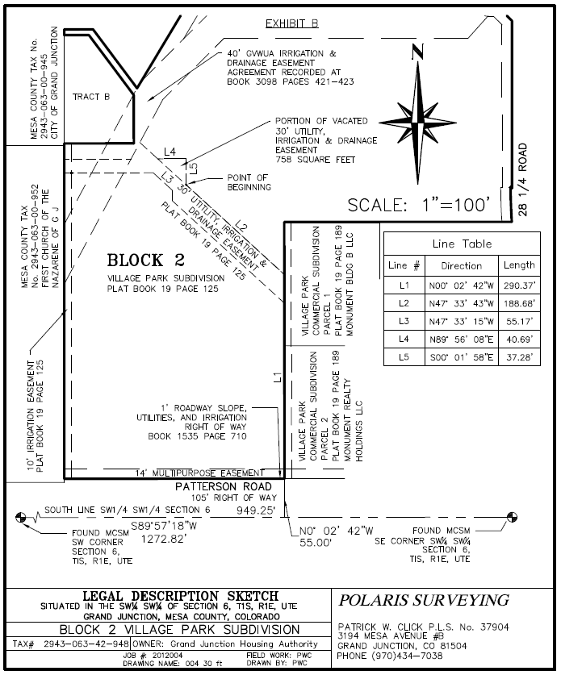

**Exhibit A**