CITY OF GRAND JUNCTION, COLORADO

ORDINANCE NO. 3568

AN ORDINANCE VACATING A PORTION OF RIGHT-OF-WAY
ALONG A PORTION OF UNAWEEP AVENUE, KNOWN AS ROCKY PITCH ROAD

Recitals.

A vacation of a portion of the undeveloped right-of-way for Rocky Pitch Road, adjacent to Unaweep Avenue, has been requested by the adjoining property owners. The vacation request is a result of the re-alignment and new construction of Unaweep Avenue, along the northern portion of the road. This ordinance retains the 14 foot multi-purpose easement in this area.

The City Council finds that the request is consistent with the Growth Plan, the Grand Valley Circulation Plan and Section 2.11 of the Zoning and Development Code.

The Planning Commission, having heard and considered the request, found the criteria of the Code to have been met, and recommends that the vacation be approved.

BE IT ORDAINED BY THE CITY COUNCIL OF THE CITY OF GRAND JUNCTION THAT:

The following described dedicated right-of-way for Unaweep Avenue is hereby vacated subject to the listed conditions:

1. Applicants shall pay all recording/documentary fees for the Vacation
Ordinance.
2. The Vacation Ordinance will be recorded and shall be effective concurrent with the recordation of the Final Plat for the Unaweep Heights Subdivision.

The following right-of-way as shown on “Exhibit A” as part of this vacation of description.

Dedicated right-of-way to be vacated:
A PARCEL OF LAND SITUATED IN THE NORTH HALF OF THE NORTHEAST QUARTER OF SECTION 30, TOWNSHIP 1 SOUTH, RANGE 1 EAST, UTE P.M. ALSO BEING PART OF THE RIGHT-OF-WAY DESCRIBED IN BOOK 3134, PAGE 463 THRU 465 IN THE OFFICE OF THE COUNTY CLERK AND RECORDER OF MESA COUNTY, COLORADO AND MORE PARTICULARLY DESCRIBED AS FOLLOWS:

COMMENCING AT THE SOUTHEAST CORNER OF THE NORTHEAST QUARTER OF THE NORTHEAST QUARTER OF SAID SECTION 30; THENCE S 89°58’29” W ALONG THE SOUTHERLY LINE OF SAID NORTHEAST QUARTER OF THE NORTHEAST QUARTER A DISTANCE OF 842.45 FEET; THENCE N 00°01’31” W A DISTANCE OF 20.00 FEET TO A POINT ON THE NORTHERLY RIGHT-OF-WAY LINE OF B3/4 ROAD ALSO BEING A POINT ON A NON-TANGENT CURVE IN WHICH THE RADIUS POINT BEARS N 35°53’16” E A DISTANCE OF 820.00 FEET; THENCE ALONG THE ARC OF SAID NON-TANGENT CURVE TO THE RIGHT HAVING A RADIUS OF 820.00 FEET, A LONG CHORD WHICH BEARS N 40°21’23” W A DISTANCE OF 389.96 FEET, AN ARC DISTANCE OF 393.73 FEET; THENCE N 26°36’03” W A DISTANCE OF 170.28 FEET TO A POINT ON THE NORTHEASTERLY RIGHT-OF-WAY LINE OF SAID RIGHT-OF-WAY DESCRIBED IN BOOK 3134, PAGE 463 THRU 465 IN THE OFFICE OF THE COUNTY CLERK AND RECORDER OF MESA COUNTY, COLORADO; THENCE N 26°36’03” W ALONG SAID NORTHEASTERLY RIGHT-OF-WAY LINE A DISTANCE OF 244.76 FEET TO A POINT OF CURVATURE; THENCE CONTINUING ALONG SAID NORTHEASTERLY RIGHT-OF-WAY LINE ALONG THE ARC OF A CURVE TO THE LEFT HAVING A RADIUS OF 855.00 FEET, A LONG CHORD WHICH BEARS N 44°16’29” W A DISTANCE OF 519.15 FEET, AN ARC DISTANCE OF 527.48 FEET; THENCE N 61°56’55” W CONTINUING ALONG SAID NORTHEASTERLY RIGHT-OF-WAY LINE A DISTANCE OF 38.48 FEET TO THE TRUE POINT OF BEGINNING; THENCE N 61°56’55” W A DISTANCE OF 100.01 FEET TO A POINT ON SAID NORTHEASTERLY RIGHT-OF-WAY LINE OF THE RIGHT-OF-WAY DESCRIBED IN BOOK 3134, PAGE 463 THRU 465 IN THE OFFICE OF THE COUNTY CLERK AND RECORDER OF MESA COUNTY, COLORADO; THENCE ALONG SAID NORTHEASTERLY RIGHT-OF-WAY LINE THE FOLLOWING ELEVEN (11) COURSES: N 73°03’05” E A DISTANCE OF 35.36 FEET; THENCE N 28°03’05” E A DISTANCE OF 25.00 FEET TO A POINT OF CURVATURE; THENCE ALONG THE ARC OF A CURVE TO THE LEFT HAVING A RADIUS OF 150.00 FEET, A LONG CHORD WHICH BEARS N 14°02’50” E A DISTANCE OF 72.60 FEET, AN ARC DISTANCE OF 73.33 FEET; THENCE N 00°02’35” E A DISTANCE OF 41.67 FEET; THENCE N 44°57’16” W A DISTANCE OF 28.29 FEET; THENCE S 89°57’08” E A DISTANCE OF 90.00 FEET; THENCE S 45°02’44” W A DISTANCE OF 28.28 FEET; THENCE S 00°02’35” W A DISTANCE OF 41.67 FEET TO A POINT OF CURVATURE; THENCE ALONG THE ARC OF A CURVE TO THE RIGHT HAVING A RADIUS OF 200.00 FEET, A LONG CHORD WHICH BEARS S 14°02’50” W A DISTANCE OF 96.80 FEET, AN ARC DISTANCE OF 97.77 FEET; THENCE S 28°03’05” W A DISTANCE OF 25.00 FEET; THENCE S 16°56’55” E A DISTANCE OF 35.36 FEET TO THE POINT OF BEGINNING.
SAID PARCEL OF LAND CONTAINS 10,886 SQ. FT. OR 0.25 ACRES MORE OR LESS.

UNAWEEP AVENUE – NORTH RESERVED MULTI-PURPOSE EASEMENT
A PARCEL OF LAND FOR A 14 FOOT WIDE MULTI-PURPOSE EASEMENT SITUATED IN THE NORTH HALF OF THE NORTHEAST QUARTER OF SECTION 30, TOWNSHIP 1 SOUTH, RANGE 1 EAST, UTE P.M. AND MORE PARTICULARLY DESCRIBED AS FOLLOWS: COMMENCING AT THE SOUTHEAST CORNER OF THE NORTHEAST QUARTER OF THE NORTHEAST QUARTER OF SAID SECTION 30; THENCE S 89°58’29” W ALONG THE SOUTHERLY LINE OF SAID NORTHEAST QUARTER OF THE NORTHEAST QUARTER A DISTANCE OF 842.45 FEET; THENCE N 00°01’31” W A DISTANCE OF 20.00 FEET TO A POINT ON THE NORTHERLY RIGHT-OF-WAY LINE OF B3/4 ROAD ALSO BEING A POINT ON A NON-TANGENT CURVE IN WHICH THE RADIUS POINT BEARS N 35°53’16” E A DISTANCE OF 820.00 FEET; THENCE ALONG THE ARC OF SAID NON-TANGENT CURVE TO THE RIGHT HAVING A RADIUS OF 820.00 FEET, A LONG CHORD WHICH BEARS N 40°21’23” W A DISTANCE OF 389.96 FEET, AN ARC DISTANCE OF 393.73 FEET; THENCE N 26°36’03” W A DISTANCE OF 170.28 FEET TO A POINT ON THE NORTHEASTERLY RIGHT-OF-WAY LINE OF A RIGHT-OF-WAY DESCRIBED IN BOOK 3134, PAGE 463 THRU 465 IN THE OFFICE OF THE COUNTY CLERK AND RECORDER OF MESA COUNTY, COLORADO; THENCE N 26°36’03” W ALONG SAID NORTHEASTERLY RIGHT-OF-WAY LINE A DISTANCE OF 244.76 FEET TO A POINT OF CURVATURE; THENCE CONTINUING ALONG SAID NORTHEASTERLY RIGHT-OF-WAY LINE ALONG THE ARC OF A CURVE TO THE LEFT HAVING A RADIUS OF 855.00 FEET, A LONG CHORD WHICH BEARS N 44°16’29” W A DISTANCE OF 519.15 FEET, AN ARC DISTANCE OF 527.48 FEET; THENCE N 61°56’55” W CONTINUING ALONG SAID NORTHEASTERLY RIGHT-OF-WAY LINE A DISTANCE OF 38.48 FEET TO THE TRUE POINT OF BEGINNING; THENCE N 61°56’55” W A DISTANCE OF 100.01 FEET TO A POINT ON SAID NORTHEASTERLY RIGHT-OF-WAY LINE OF THE RIGHT-OF-WAY DESCRIBED IN BOOK 3134, PAGE 463 THRU 465 IN THE OFFICE OF THE COUNTY CLERK AND RECORDER OF MESA COUNTY, COLORADO; THENCE N 73°03’05” E ALONG SAID NORTHEASTERLY RIGHT-OF-WAY LINE A DISTANCE OF 19.80 FEET; THENCE S 61°56’55” E A DISTANCE OF 72.01 FEET TO A POINT ON SAID NORTHEASTERLY RIGHT-OF-WAY LINE; THENCE S 16°56’55” E A DISTANCE OF 19.80 FEET TO THE POINT OF BEGINNING.
SAID 14 FOOT WIDE MULTI-PURPOSE EASEMENT CONTAINS 1,204 SQ. FT. OR 0.03 ACRES MORE OR LESS.

UNAWEEP AVENUE – NORTH MULTI-PURPOSE EASEMENT VACATION

A PORTION OF A 14 FOOT MULTI-PURPOSE EASEMENT SITUATED IN THE NORTH HALF OF THE NORTHEAST QUARTER OF SECTION 30, TOWNSHIP 1 SOUTH, RANGE 1 EAST, UTE P.M. ALSO BEING PART OF THE MULTI-PURPOSE EASEMENT DESCRIBED IN BOOK 3134, PAGE 466 THRU 469 IN THE OFFICE OF THE COUNTY CLERK AND RECORDER OF MESA COUNTY, COLORADO AND IS PARALLEL AND ADJACENT TO THE PROPOSED UNAWEEP AVENUE – NORTH RIGHT-OF-WAY VACATION DESCRIBED BELOW: A PARCEL OF LAND SITUATED IN THE NORTH HALF OF THE NORTHEAST QUARTER OF SECTION 30, TOWNSHIP 1 SOUTH, RANGE 1 EAST, UTE P.M. ALSO BEING PART OF THE RIGHT-OF-WAY DESCRIBED IN BOOK 3134, PAGE 463 THRU 465 IN THE OFFICE OF THE COUNTY CLERK AND RECORDER OF MESA COUNTY, COLORADO AND MORE PARTICULARLY DESCRIBED AS FOLLOWS: COMMENCING AT THE SOUTHEAST CORNER OF THE NORTHEAST QUARTER OF THE NORTHEAST QUARTER OF SAID SECTION 30; THENCE S 89°58’29” W ALONG THE SOUTHERLY LINE OF SAID NORTHEAST QUARTER OF THE NORTHEAST QUARTER A DISTANCE OF 842.45 FEET; THENCE N 00°01’31” W A DISTANCE OF 20.00 FEET TO A POINT ON THE NORTHERLY RIGHT-OF-WAY LINE OF B3/4 ROAD ALSO BEING A POINT ON A NON-TANGENT CURVE IN WHICH THE RADIUS POINT BEARS N 35°53’16” E A DISTANCE OF 820.00 FEET; THENCE ALONG THE ARC OF SAID NON-TANGENT CURVE TO THE RIGHT HAVING A RADIUS OF 820.00 FEET, A LONG CHORD WHICH BEARS N 40°21’23” W A DISTANCE OF 389.96 FEET, AN ARC DISTANCE OF 393.73 FEET; THENCE N 26°36’03” W A DISTANCE OF 170.28 FEET TO A POINT ON THE NORTHEASTERLY RIGHT-OF-WAY LINE OF SAID RIGHT-OF-WAY DESCRIBED IN BOOK 3134, PAGE 463 THRU 465 IN THE OFFICE OF THE COUNTY CLERK AND RECORDER OF MESA COUNTY, COLORADO; THENCE N 26°36’03” W ALONG SAID NORTHEASTERLY RIGHT-OF-WAY LINE A DISTANCE OF 244.76 FEET TO A POINT OF CURVATURE; THENCE CONTINUING ALONG SAID NORTHEASTERLY RIGHT-OF-WAY LINE ALONG THE ARC OF A CURVE TO THE LEFT HAVING A RADIUS OF 855.00 FEET, A LONG CHORD WHICH BEARS N 44°16’29” W A DISTANCE OF 519.15 FEET, AN ARC DISTANCE OF 527.48 FEET; THENCE N 61°56’55” W CONTINUING ALONG SAID NORTHEASTERLY RIGHT-OF-WAY LINE A DISTANCE OF 38.48 FEET TO THE TRUE POINT OF BEGINNING; THENCE N 61°56’55” W A DISTANCE OF 100.01 FEET TO A POINT ON SAID NORTHEASTERLY RIGHT-OF-WAY LINE OF THE RIGHT-OF-WAY DESCRIBED IN BOOK 3134, PAGE 463 THRU 465 IN THE OFFICE OF THE COUNTY CLERK AND RECORDER OF MESA COUNTY, COLORADO; THENCE ALONG SAID NORTHEASTERLY RIGHT-OF-WAY LINE THE FOLLOWING ELEVEN (11) COURSES: N 73°03’05” E A DISTANCE OF 35.36 FEET; THENCE N 28°03’05” E A DISTANCE OF 25.00 FEET TO A POINT OF CURVATURE; THENCE ALONG THE ARC OF A CURVE TO THE LEFT HAVING A RADIUS OF 150.00 FEET, A LONG CHORD WHICH BEARS N 14°02’50” E A DISTANCE OF 72.60 FEET, AN ARC DISTANCE OF 73.33 FEET; THENCE N 00°02’35” E A DISTANCE OF 41.67 FEET; THENCE N 44°57’16” W A DISTANCE OF 28.29 FEET; THENCE S 89°57’08” E A DISTANCE OF 90.00 FEET; THENCE S 45°02’44” W A DISTANCE OF 28.28 FEET; THENCE S 00°02’35” W A DISTANCE OF 41.67 FEET TO A POINT OF CURVATURE; THENCE ALONG THE ARC OF A CURVE TO THE RIGHT HAVING A RADIUS OF 200.00 FEET, A LONG CHORD WHICH BEARS S 14°02’50” W A DISTANCE OF 96.80 FEET, AN ARC DISTANCE OF 97.77 FEET; THENCE S 28°03’05” W A DISTANCE OF 25.00 FEET; THENCE S 16°56’55” E A DISTANCE OF 35.36 FEET TO THE POINT OF BEGINNING.

Introduced on first reading this 6th day of August, 2003 and ordered published.

PASSED and ADOPTED on second reading this 20th day of August, 2003.

Attest:

/s/ Stephanie Tuin /s/ Harry Butler
City Clerk President of the Council Pro Tem
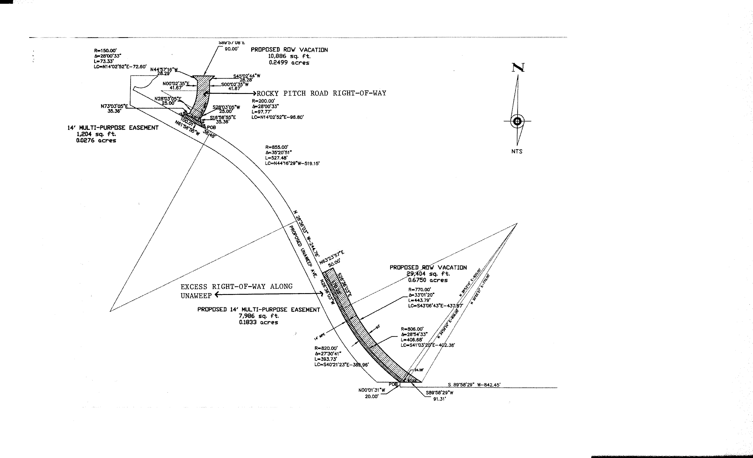
EXHIBIT “A”

