CITY OF GRAND JUNCTION, COLORADO

ORDINANCE No. 3579

AN ORDINANCE VACATING A PORTION OF GARY DRIVE
LOCATED NORTH OF B ¾ ROAD AND EAST OF LINDEN AVENUE

RECITALS:

A request to vacate a portion of the dedicated right-of-way for Gary Drive has been submitted by the Grand Junction Housing Authority.

The portion of Gary Drive right-of-way to be vacated will be vacated in favor of a public access easement which will connect the remaining Gary Drive right-of-way over to David Street right-of-way.

The City Council finds that the request to vacate a portion of the dedicated right-of-way for Gary Drive is consistent with the Growth Plan, the Grand Valley Circulation Plan and Section 2.11 of the Zoning and Development Code.

The Planning Commission, having heard and considered the request, found the criteria of the Zoning Code to have been met, and recommends that the vacation for a portion of the Gary Drive right-of-way be approved as requested.

NOW, THEREFORE BE IT ORDAINED BY THE CITY COUNCIL OF THE CITY OF GRAND JUNCTION THAT:

The following described dedicated right-of-way for Gary Drive Road is hereby vacated subject to the listed conditions:

1. Applicants shall pay all recording/documentation fees for the Vacation
Ordinance, any easement documents and dedication documents.
2. The vacation ordinance will be recorded and shall be effective concurrent with the recordation of the final plat that dedicates the public access easement from Gary Drive over to David Street.

The following right-of-way is shown on “Street Vacation Exhibit A” as part of this vacation of description.

Dedicated right-of-way for Gary Drive to be vacated:

All that part of the right-of-way of Gary Drive as shown and dedicated on Linden Acres Subdivision Replat lying north of a line between the Northwest corner of Lot 3 and the Northeast corner of Lot 10 of said Linden Acres Subdivision Replat.

Introduced for first reading on this 15th day of October, 2003

PASSED and ADOPTED this 5th day of November, 2003.

ATTEST:
_/s/: Jim Spehar
President of City Council

/s/: Stephanie Tuin
City Clerk
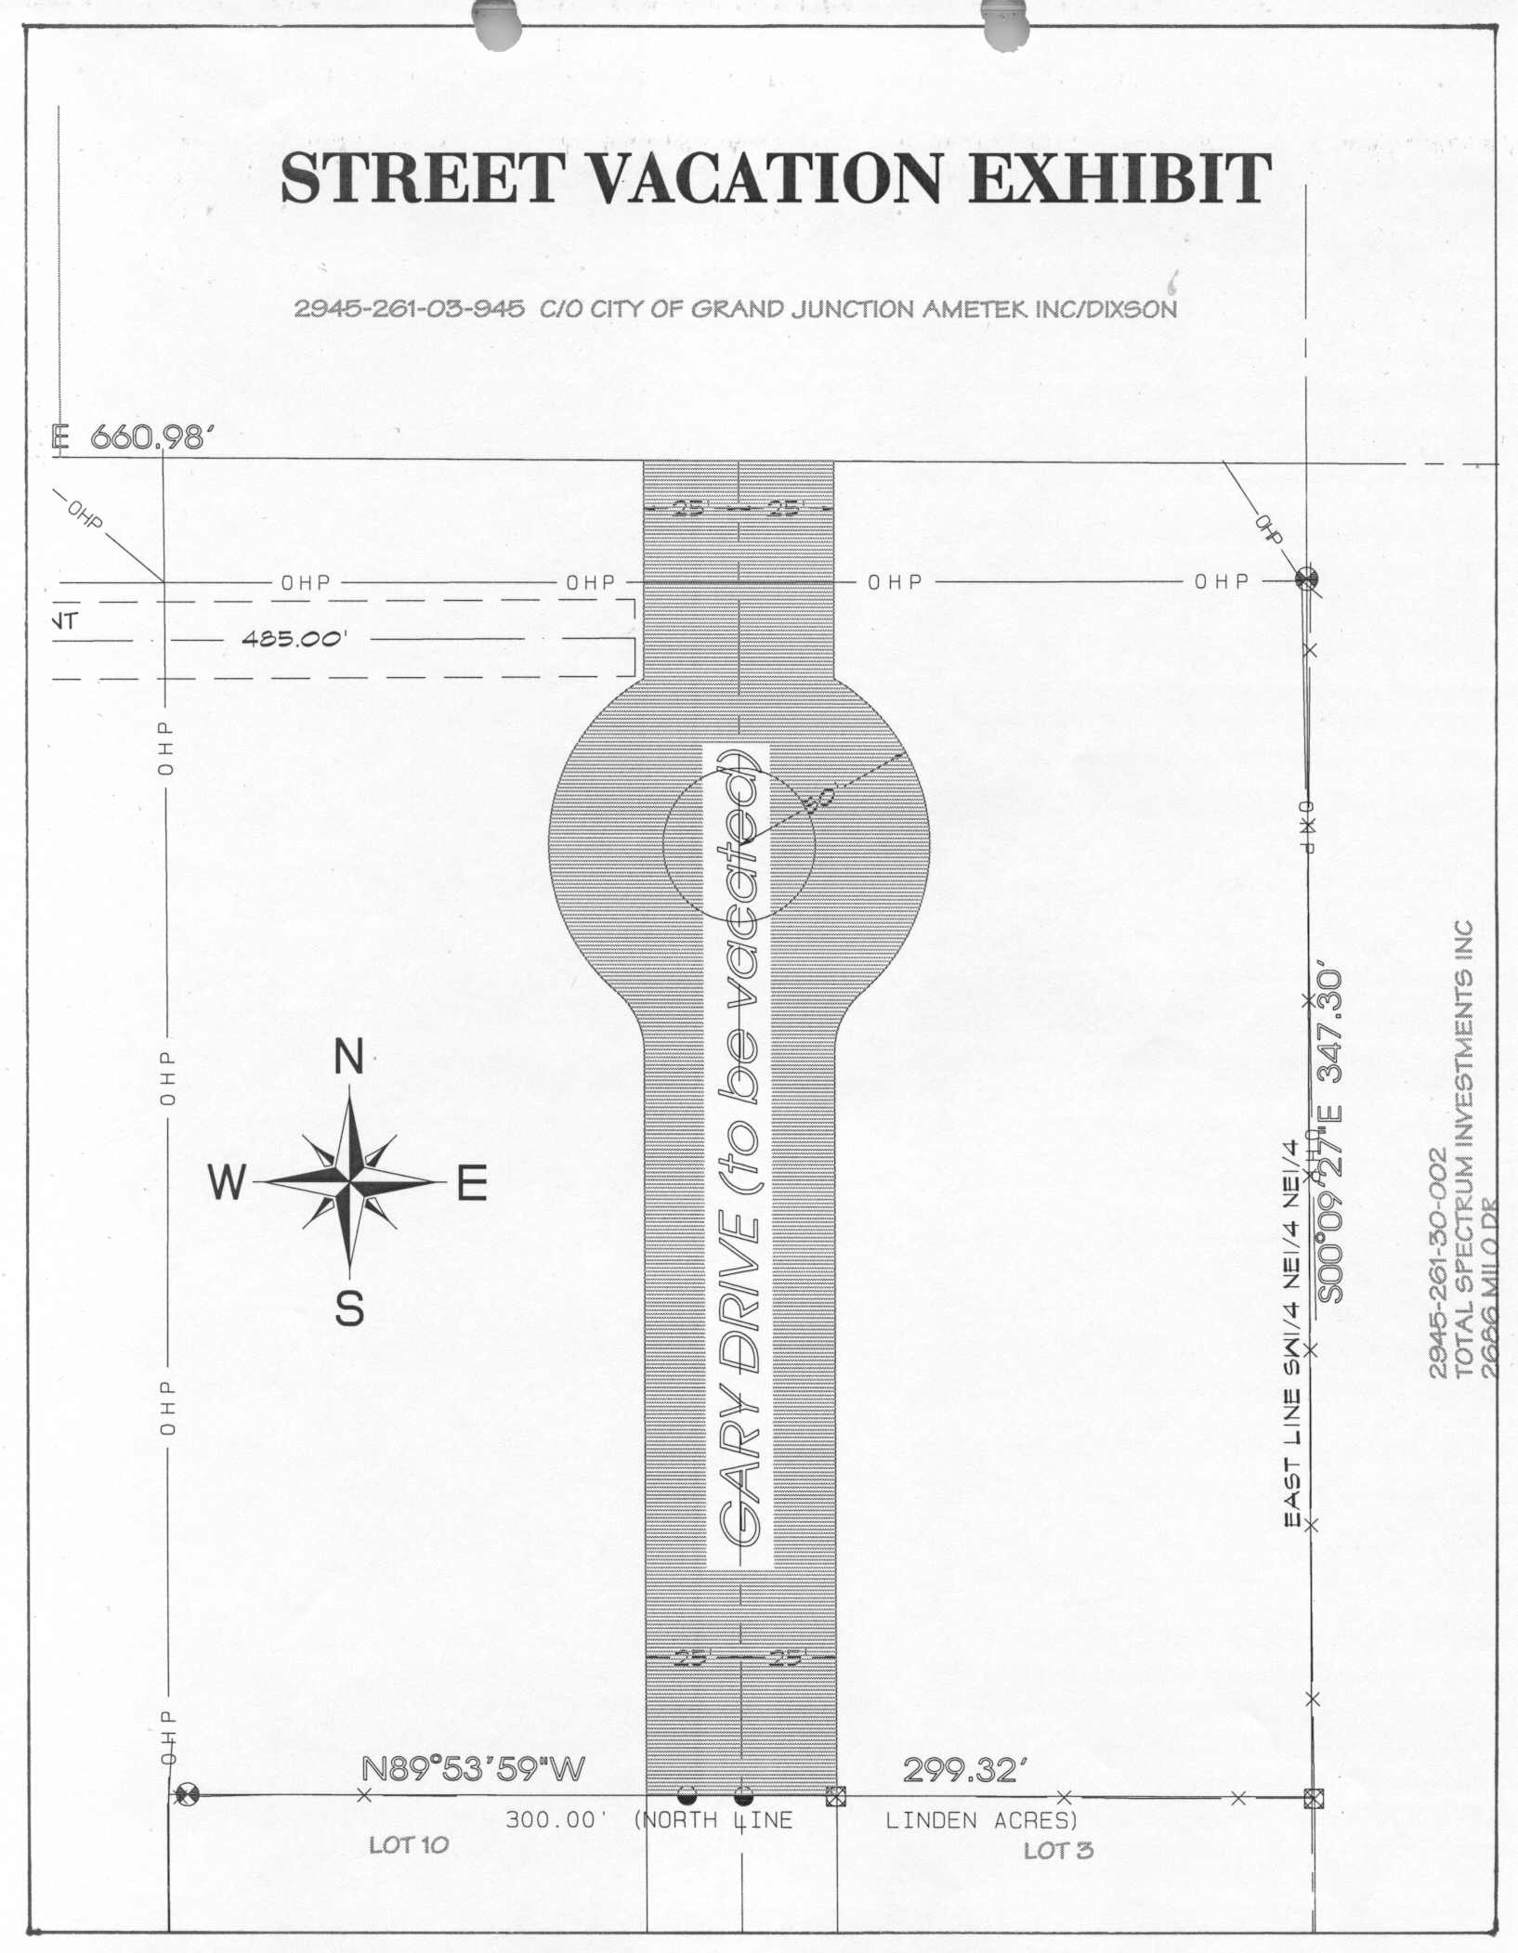

Street Vacation Exhibit “A”

