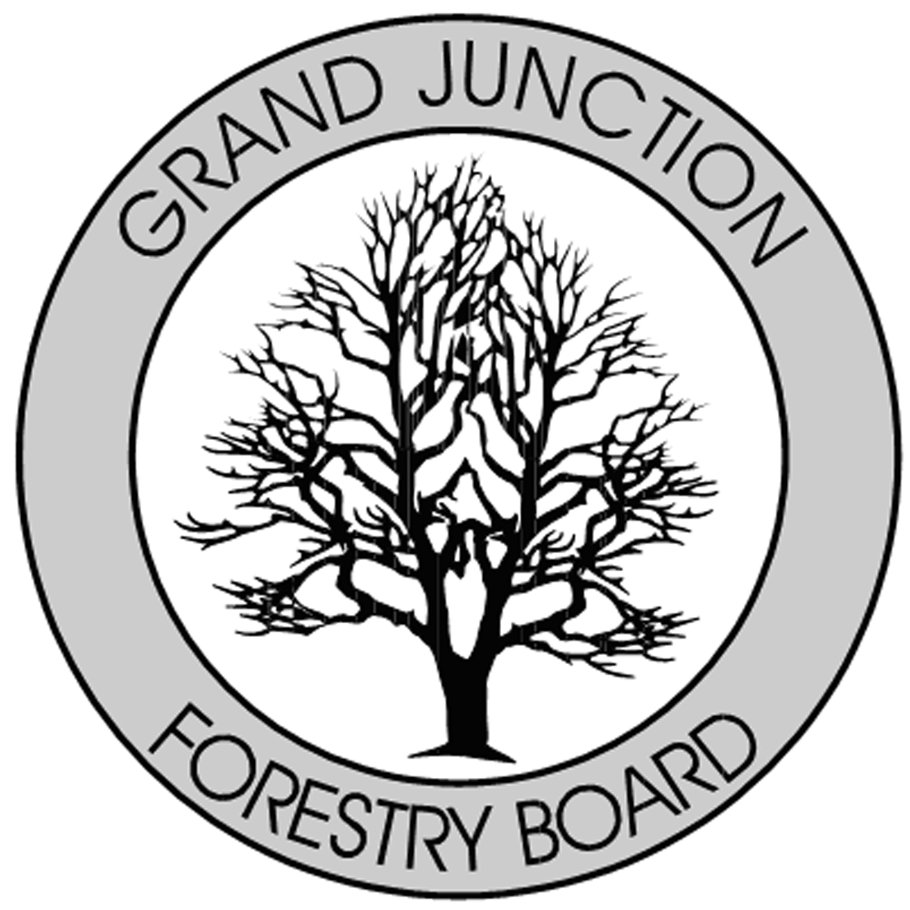

FORESTRY ADVISORY BOARD
AGENDA
Hawthorne Park
Hawthorne Park 400 Gunnison Ave, Grand Junction, CO 81501
Wednesday July 11, 2018
8:00 AM

- Call to Order – Meeting Hawthorne Park

- Approve Minutes from the June, 2018 Forestry Advisory Board Meeting

- 2017 Arborist, Vince Urbina – Plaque Appreciation

- Training Update / Upcoming Schedule ISA Training

- City of Grand Junction Forestry Update - Website

- New Business

- Adjourn

- Next Forestry Advisory Board Meeting: Thursday, August 2, 2018

If you have any questions please contact Chair, Kamie Long at 248-7325 or Randy Coleman, Forestry Supervisor at 254-3821

