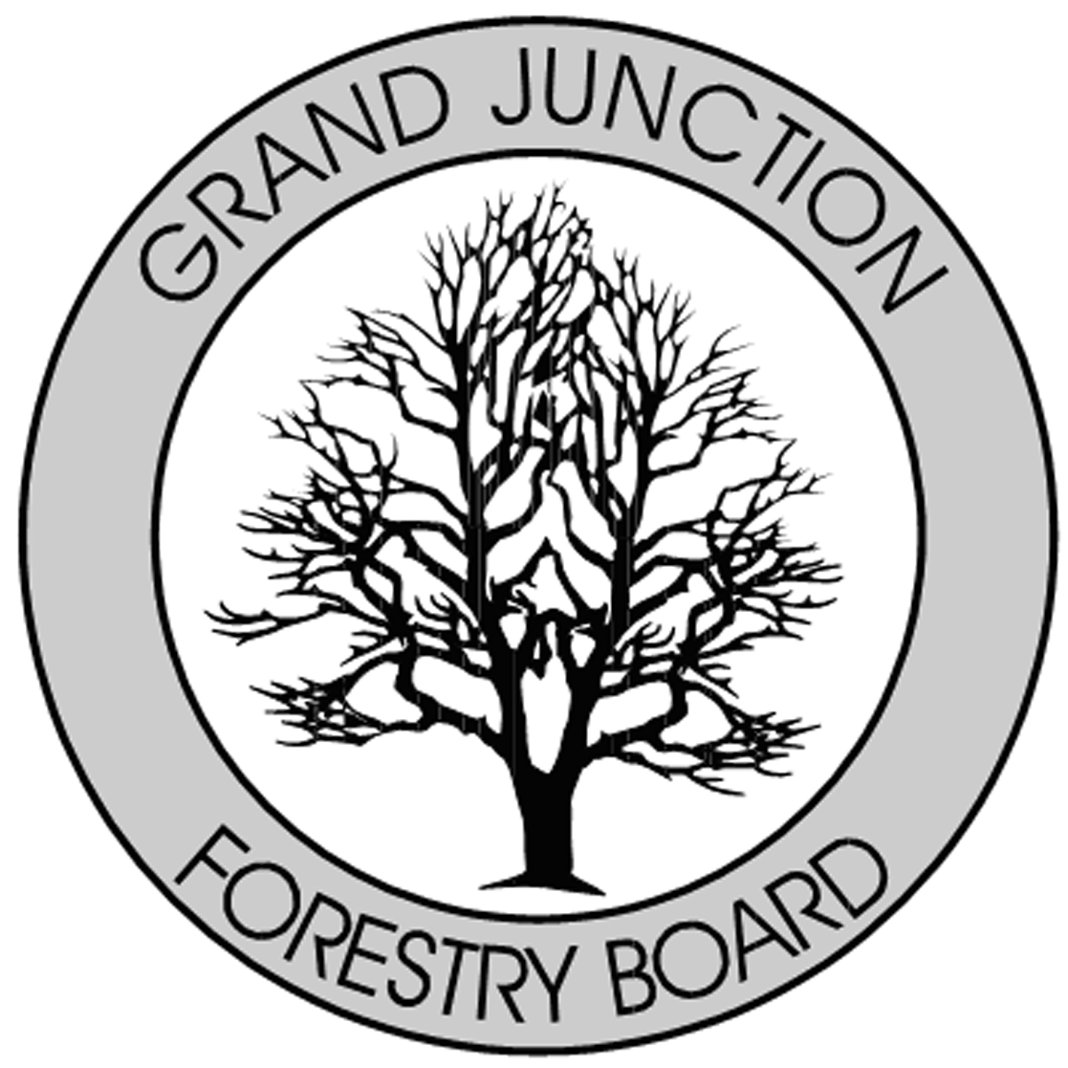

FORESTRY ADVISORY BOARD
AGENDA
Parks Operations
2529 High Country Court, Grand Junction, CO 81501
Thursday June 7, 2018
8:00 AM

- Call to Order

- Approve Minutes from the April 6 and May 1, 2018 Forestry Advisory Board Meeting

- Welcome Guest – Mike Heinz

- Re-Cap Demo Day/ Take a Kid to a Park Day May 19th

- City of Grand Junction Forestry Update

- New Business

- Adjourn

- Next Forestry Advisory Board Meeting: Thursday, July 5th, 2018

If you have any questions please contact Chair, Kamie Long at 248-7325 or Randy Coleman, Forestry Supervisor at 254-3821

