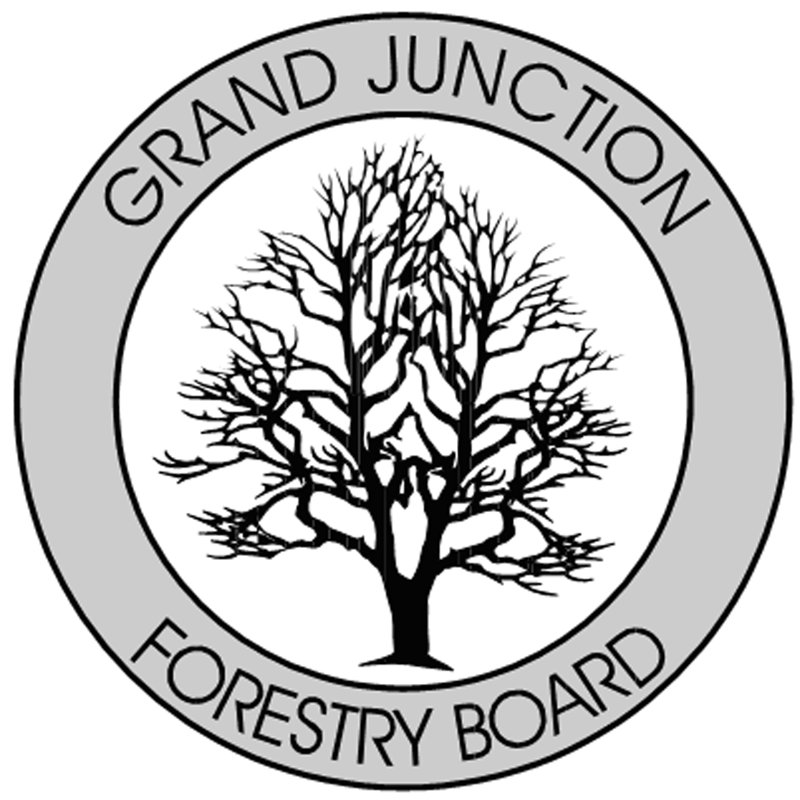

FORESTRY ADVISORY BOARD
AGENDA
Parks Operations
2529 High Country Court, Grand Junction, CO 81501
Thursday, March 1, 2018
8:00 AM

- Call to Order

- Approve Minutes from the January 11, 2018 and February 8, 2018 Forestry Advisory Board Meeting

- Arbor Day

- City of Grand Junction Forestry Update

- New Business

- Adjourn

- Next Forestry Advisory Board Meeting: Thursday, April 5, 2018

If you have any questions please contact Chair, Kamie Long at 248-7325 or Randy Coleman, Forestry Supervisor at 254-3821

