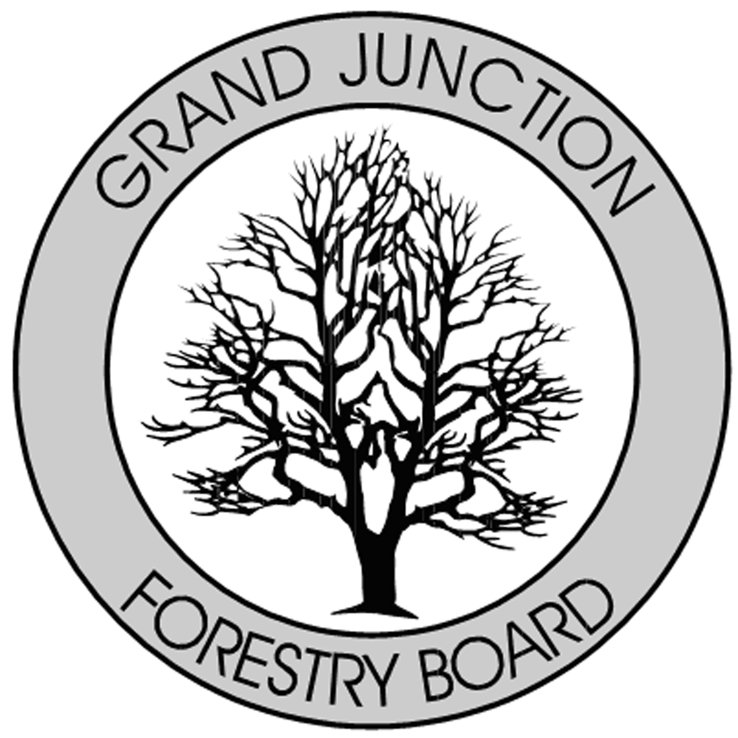

FORESTRY ADVISORY BOARD
AGENDA
Parks Operations
2529 High Country Court, Grand Junction, CO 81501
Thursday August 1st, 2019
8:00 AM

- Call to Order

- Approve Minutes from the July, Forestry Advisory Board Meeting.

- Forestry Updates

- ROW tree permits & fees
- Grand Valley Canopy update on website
- Arbor Fest 2019 and Arbor Day
- New Director for Parks and Recreation
- New Director for Parks and Recreation - Ken Sherbenou
--Ken most recently comes from the Montrose Recreation District, where he served as Executive Director for approximately 9 years. Ken holds a Master of Public Administration degree from the University of Colorado and is a Certified Parks and Recreation Executive. Ken’s anticipated start date is August 5th.

- New Business

- Adjourn

- Next Forestry Advisory Board Meeting: Thursday September 12th, 2019

If you have any questions please contact Chair, Kamie Long at 248-7325 or Robert Davis, Forestry Supervisor at 254-3825

