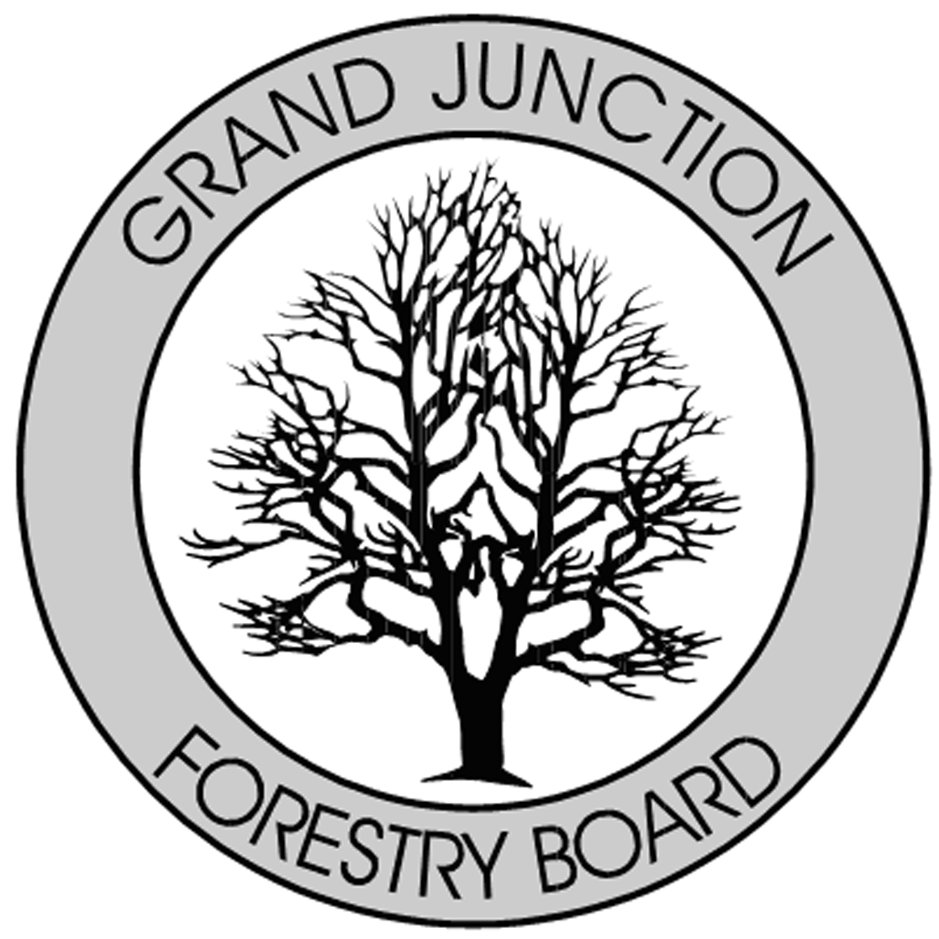

FORESTRY ADVISORY BOARD
AGENDA
Parks Operations
2529 High Country Court, Grand Junction, CO 81501
Thursday December 5th, 2019
8:30 AM

- Call to Order

- Approve Minutes for September, Forestry Advisory Board Meeting.

- Forestry Updates

  - Tree City USA application and growth award submitted
  - New Forestry Board Applicants
    - Bennett Boeschenstein
    - Justin Mays
    - Kamie Long
  - Colorado Tree Coalition Grant
    - Establishing MGB
  - CTC Xcel Energy Grant
    - Shading structures
  - Arbor Day 2020
    - Arbor Fest 2020
    - 4/25/2020
  - Pesticide orders
  - Grand Valley Canopy Website

- New Business

- Adjourn

- Next Forestry Advisory Board Meeting: Thursday November 7th, 2019

If you have any questions please contact Chair, Kamie Long at 248-7325 or Robert Davis, City Forester at 254-3825

