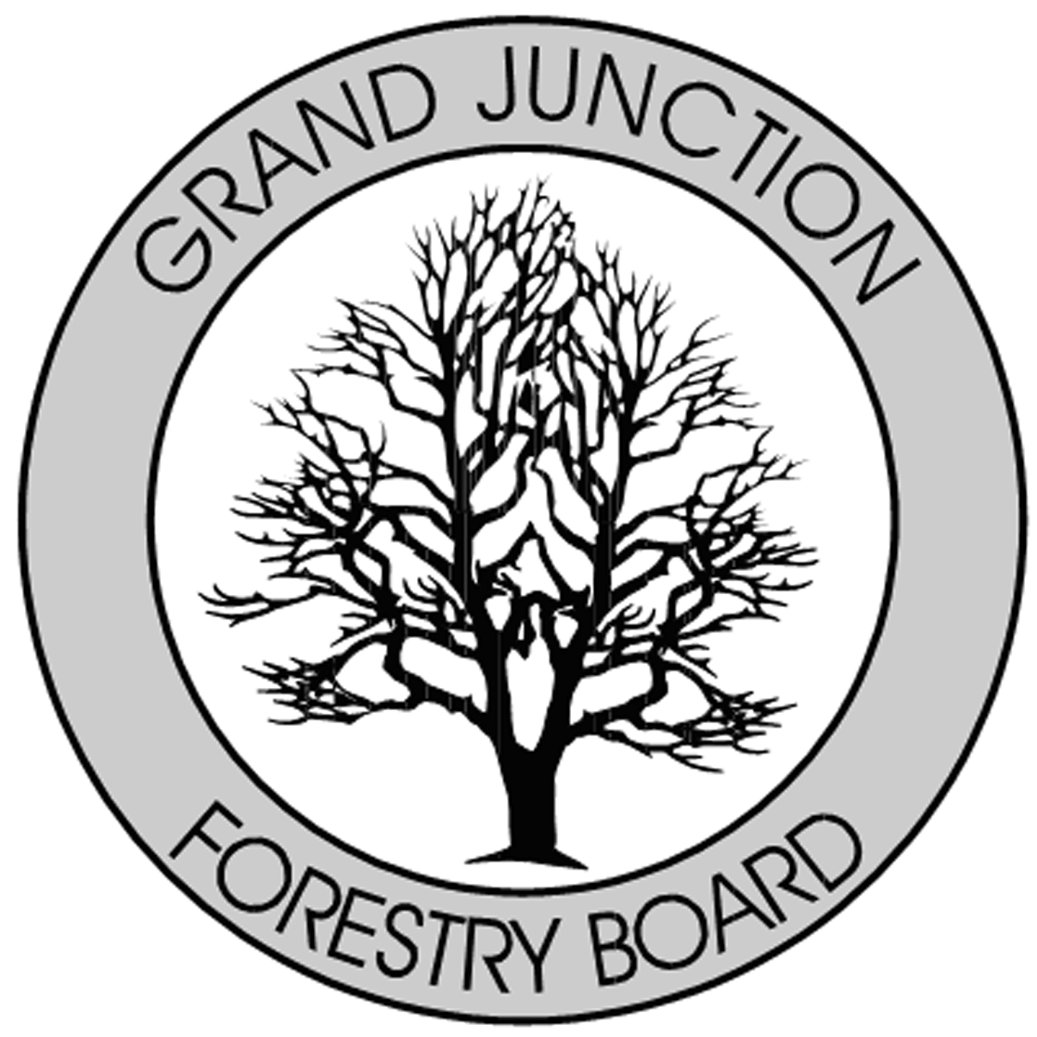

FORESTRY ADVISORY BOARD
AGENDA
Parks Operations
2529 High Country Court, Grand Junction, CO 81501
Thursday, January 10, 2019
8:00 AM

- Call to Order

- Approve Minutes from the December Forestry Advisory Board Meeting

- ISA – test and training update. Schedule dates for upcoming training/testing.

- Forestry Update

- New Business

- Adjourn

- Next Forestry Advisory Board Meeting: Thursday February 7th, 2019

If you have any questions please contact Chair, Kamie Long at 248-7325 or Randy Coleman, Forestry Supervisor at 254-3821

