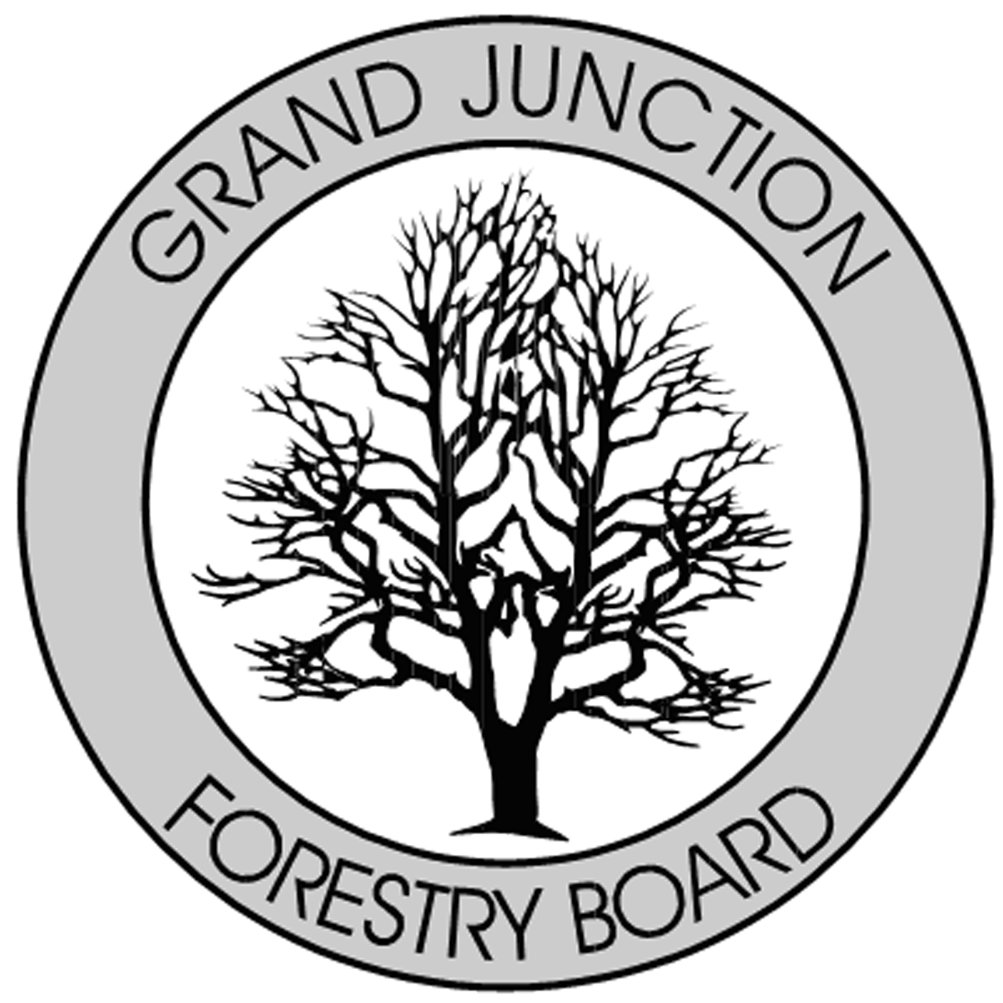

FORESTRY ADVISORY BOARD
AGENDA
Parks Operations
2529 High Country Court, Grand Junction, CO 81501
Thursday July 11, 2019
8:00 AM

- Call to Order

- Approve Minutes from the June, Forestry Advisory Board Meeting.

- Forestry Updates

- New Business

- Adjourn

- Next Forestry Advisory Board Meeting: Thursday August 1st, 2019

If you have any questions please contact Chair, Kamie Long at 248-7325 or Robert Davis, Forestry Supervisor at 254-3825

