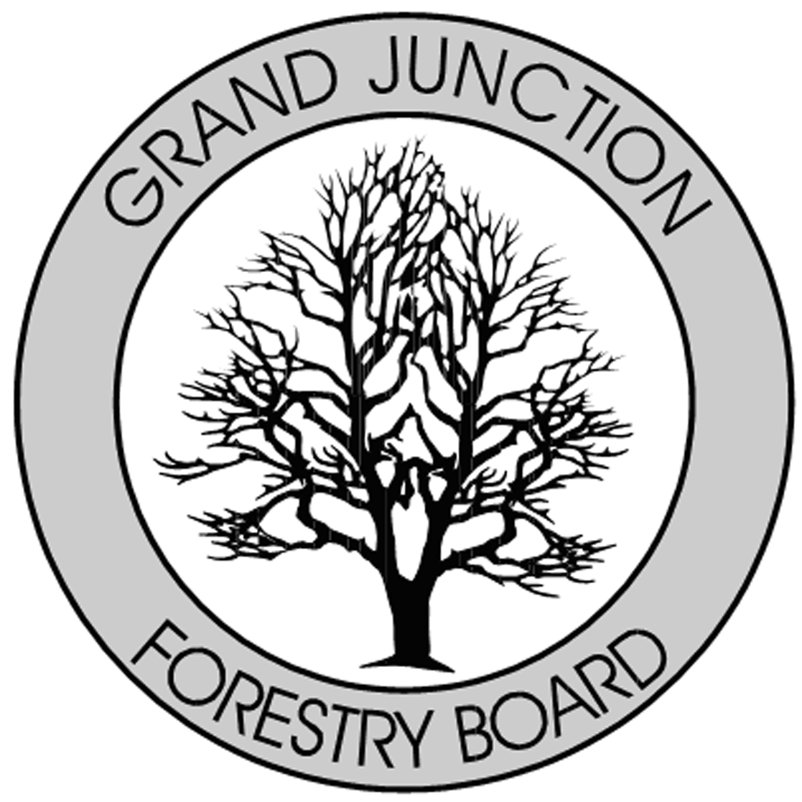

FORESTRY ADVISORY BOARD
AGENDA
Parks Operations
2529 High Country Court, Grand Junction, CO 81501
Thursday June 13th, 2019
8:00 AM

- Call to Order

- Approve Minutes from the May Forestry Advisory Board Meeting

- Introduction to new City Forester, Robert Davis.

- Forestry Updates

- New Business

- Adjourn

- Next Forestry Advisory Board Meeting: Thursday July 11th, 2019 (4th of July-1st Thurs)

If you have any questions please contact Chair, Kamie Long at 248-7325 or Robert Davis, Forestry Supervisor at 254-3825

