ORDINANCE NO. 3720

AN ORDINANCE AMENDING PART OF CHAPTER 32 OF THE CITY OF GRAND JUNCTION CODE OF ORDINANCES RELATING TO COMMERCIAL ACTIVITIES IN THE DOWNTOWN AND AUTHORIZING PUBLICATION IN PAMPHLET FORM

Recitals.

Publication Distribution Machines (often called newspaper vending machines) on or adjacent to public sidewalks are a valuable method of distributing news and other information to the public; however, they may constitute an obstruction on public property and their often indiscriminate location on sidewalks and elsewhere can obstruct pedestrians and other users of the sidewalk. Newspaper vending machines can be unsightly and can distract drivers. Furthermore, commercial activities should not claim a right to physical occupation of the public sidewalk by proprietary structures in an unregulated manner. Even public utilities which have a high degree of autonomy from local regulation still must not interfere with the primary functions of the streets and sidewalks for which they have easements.

In accordance with Chapter 32 of the Grand Junction Code of Ordinances the Downtown Development Authority (“DDA”) has been delegated authority over commercial activities occurring on the Downtown Shopping Park on Main Street. Because of the serpentine street, the trees, flowers and planters, sidewalk dining and other frequent use of downtown for special events, the DDA has determined that the form, placement and other regulation of Publication Distribution Machines in the downtown area is an important and necessary step. The City Council has further determined that, at present, the problems caused by unregulated Publication Distribution Machines are most prevalent in the downtown area of the City.

The continued vitality of the City’s downtown has made downtown sidewalks increasingly congested, and thus, attractive locations for those who wish to disseminate information. There are many instances where the unregulated placement of these machines, whether individually or grouped together have interfered with access to fire hydrants and parking meters, blocked access from vehicle parking to the sidewalk, interfered with bus stops, obstructed views in the corner sight triangle and added to the difficulties that persons with mobility problems face in navigating the sidewalk and sidewalks. Further, significant portions of the downtown are undergoing historic renovation and the unregulated placement and appearance of proprietary Publication Distribution Machines interferes with the historic appearance of the area.

Because of the tipping danger, wind, vandalism and other forces that tend to move Publication Distribution Machines and other racks and devices serving a similar function in the distribution of Publications, Publication Distribution Machines shall be required to be consolidated into News Box Banks and firmly affixed to the ground and have a suitable cover so that the materials are not scattered about. Accordingly, this Ordinance is intended to regulate the design and placement of News Box Banks within the sidewalk Right-of-Way in the downtown area of the City. Because the amount of space which can be devoted to News Box Banks is limited and thus of necessity, a method of allocating that space must be devised. The City will allocate fairly the responsibilities and privileges to users of the Right-of-Way.

The City Council has carefully considered what the best method of allocating public property for News Box Banks might be and has determined that the use of News Box Banks including supplemental Joint Use News Boxes will best fit the circumstances of the downtown Commercial Area. This Ordinance will serve to cause Publication Distribution Machines to be consolidated into News Box Banks placed in a few orderly and carefully chosen locations which will cause a balance to be struck between the competing needs of downtown uses and those who would serve them with Publications.

The Council intends by its adoption of this Ordinance and accordingly directs the DDA or its designee in its implementation of this Ordinance, to avoid doing anything which could be construed as censorship of the content of the Publications placed in News Box Banks or of vesting standard less or un-reviewable discretion in any public official which could be used to affect the content of the Publications that appear in News Box Banks or otherwise interfere with rights guaranteed under the First Amendment. This Ordinance and any other provisions of the Code shall be interpreted so as to avoid any such unconstitutional application or effect.

Chapter 32, Section 62 is amended by the addition of the following definitions.

As used in this Ordinance the following terms have the following meanings unless the context requires otherwise:

“Director” means the Executive Director of the Grand Junction Downtown Development Authority (DDA) or his designee.

“Downtown Commercial Area” means the area within the DDA boundary bounded on the north by Grand Avenue, including locations on the north side of Grand Avenue, on the south by Pit kin Avenue, on the west by First Street and on the East by 8th Street.

“Use agreement” means the written agreement between the DDA or its designee and a Publisher for the use of a slot, if available, in a Joint Use News Box.

Every news box placed in a News Box Bank shall be either a Joint Use News Box or Single User News Box. The approved color for News Boxes is Chicago Blue as shown on the last page of Appendix A attached hereto. The approved color for News Boxes may be changed by the Director at his discretion in the event that Chicago Blue becomes unavailable or is deemed inappropriate for use.

(a) “Joint Use News Box” means a box which is owned by the DDA or its designee and installed in a News Box Bank, and is comprised of a box divided into multiple slots, which slots will allow the placement of multiple issues of a single Publication in each slot and will protect the Publications from the elements. The Publications may be obtained by opening a door without payment by the customer for the Publication. Slots in Joint Use News Boxes must be used by Monthly Publications and may be used by Weekly Publications which have not installed a Single User News Box for the location where the Publisher wishes to distribute its Publication. It is anticipated that the slots in Joint Use News Boxes will not allow for the face-up or face-out display of Publications. The Director shall provide information in the window of each Joint Use News Box which informs interested parties of the Publications distributed in the slots of each Joint Use News Box. Users of Joint Use News Boxes shall be charged fees as hereinafter described.

(b) “Single User News Box” means one unit in a News Box Bank, which unit is owned by a Publisher and installed in a Space in a News Box Bank with the permission of the Director. The model of a Single User News Box shall be as determined by the Director. A Single User News Box is designed to hold a Publication and protect it from the elements, which Publication may be obtained by opening a door, whether after depositing money in a device which unlocks the door or without payment by the customer, if any, for the Publication.

“News Box Bank” or “Bank” means a structure, the location of which is determined by the Director, consisting of multiple Single User News Boxes and Joint Use News Boxes installed on a News Box Bank Pedestal. The approved color for News Box Banks is Chicago Blue, and the approved model is the Boulevard model as shown on the last page of Appendix A. The approved color and model of News Box Banks may be changed by the Director at his discretion in the event that Chicago Blue or the Boulevard model is/are unavailable or is/are deemed inappropriate for use.

“News Box Bank Pedestal” or “Pedestal” means the leg(s) and/or base upon which Single User News Boxes and Joint Use News Boxes may be installed, which is owned by the DDA and affixed to the ground.

“Publication” means a periodical which:

- Is published in different issues with sufficiently different content or format so that each issue can be readily distinguished from previous or subsequent issues; and

- Is formed of printed sheets. The sheets may be die cut or deckle-edged, and may be made of paper, cellophane, foil or other similar materials.

(c) `“Daily Publication” means a Publication which is published at least one hundred (100) times per calendar year.

(d) “Monthly Publication” means a Publication which is published between twelve (12) and forty-nine (49) times per calendar year.

(e) “Weekly Publication” means a Publication which is published between fifty (50) and ninety-nine (99) times per calendar year.

“Publication Distribution Machine” means a machine used to distribute Publications which is placed or maintained on the public Right-of-Way within the Downtown Commercial Area as described above by a person other than the Director. Where prohibited, the term refers to the machine without regard for whether the Publication contained in the machine is a “Publication” within the meaning of this section or even whether there is any printed or other material within the machine, or the cost, if any, of any printed or other material within the machine.

“Publisher” means the person who pays to have a Publication printed or otherwise causes a Publication to be printed or otherwise reproduced.

“Right-of-Way” means a public street from property line to property line and includes public alleys, paths and/or breezeways. It also includes an easement or other right which the City has acquired from the property owner for the purpose of locating News Box Banks.

“Space” means the area of a News Box Bank in which a Single User News Box is placed.

Sections 32-72 et. seq. are created to read as follows.

  - Location of News Box Banks.

- The City Council, in accordance with the authority given to the DDA for the administration of commercial activities in the downtown authorizes the Director of the DDA to survey the area within and on the periphery of the Downtown Commercial Area to determine the locations of existing Publication Distribution Machines, the locations which are suitable for News Box Banks and the appropriate type of News Box Banks to be used, including size, model and color. The Director shall use in evaluating each location and type of News Box Bank, criteria which include but shall not be limited to a determination of the effect on pedestrian and emergency access on, to and from streets and sidewalks, and public transportation, required maintenance of public facility infrastructure, vehicular safety and the effect of the location, mass and bulk of News Box Banks on the streetscape, aesthetics of each block and specifically the Director shall consider sidewalk width, sidewalk dining, parking (parking meter) access, including access by persons with disabilities, access to bicycle parking, access to fire hydrants, access to bus stops, access to benches and trash receptacles, maintenance access to street trees, planters, utility and signal poles, access generally from the street to the sidewalk and the sidewalk to the street, blocking of views at intersections, alleys and driveways, distance from intersections and driveways and alleys, distance from buildings and the visibility of public art. The Director shall determine the appropriate location for News Box Banks on each block after taking into consideration the current location and number of Publication Distribution Machines.

(b) The Council has, after holding a public hearing, considered the determinations of the Director as to the locations of News Box Banks and type of News Box Banks which shall be used. The proposed locations for News Box Banks are in the proximity of the following businesses or facilities:
1. United States Post Office, Main Branch, 241 North 4th Street;
2. Crystal Café, 314 Main Street;
3. Rockslide Brew Pub, 401 Main Street;
4. Greyhound Bus Station, 230 South Fifth Street;
5. Main Street Café, 504 Main Street;
6. Main Street Bagels Bakery & Café, 559 Main Street; and
7. Talley’s BQ & Biscuit Factory, 623 Main Street.
City Council hereby ratifies the locations and adopts this Ordinance including Appendix A as reasonable place and manner regulations of News Box Banks.

(c) Future News Box Bank type(s) and location(s) may be determined by the Director.

(d) Should any News Box Bank require temporary or permanent removal because of construction or reconfiguration of streets, sidewalks or other portions of the Right-of-Way, the Director is directed to provide a replacement(s) location if the removal is reasonably expected to exceed 30 days, located as conveniently to the removed Bank as is reasonably practical.

32-73 Installation of News Box Banks.

(a) The DDA may develop a system through the issuance of a Request for Proposal (“RFP”) for the management, ownership, installation, fees, maintenance and other activities to be performed or accomplished at the Director’s discretion, associated with the administration of this Ordinance. For the purposes of interpreting, construing and applying this Ordinance, if a contract is awarded following or pursuant to an RFP, the person or entity to which an RFP is awarded is considered the designee or agent of the Director.

- The Director shall install News Box Bank Pedestals as funds are appropriated so that owners of existing Publication Distribution Machines can remove those machines. The Director shall install Pedestals on a per location basis and no owner of an existing Publication Distribution Machine within that location shall fail to remove it within fourteen calendar days thereafter. Any Publication Distribution Machine within the Right-of-Way after installation of News Bank Pedestal(s) is declared to be a public nuisance and may be summarily removed by the Director. The Director shall require full payment by the owner of the reasonable cost of removal and storage of the machine(s), plus fifteen percent for administration, before releasing the machine(s).

(c) The Director shall install News Box Bank Pedestals to accommodate Publishers in the order and priority set forth in section 32-77 of this Ordinance.

(d) Prior to installing News Box Bank Pedestals the Director shall consult with the City Manager or his designee and shall in addition follow these standards:

  - The Banks on each side of any block of Main Street shall not exceed (10) linear feet.
  - No Bank shall be longer than ten (10) linear feet. The Director may, in his discretion, install two Banks of less than ten (10) feet within fifty (50) feet of each other which, combined shall not exceed ten (10) linear feet.
  - The front of all News Box Banks shall face away from the street.
  - Except where vehicle parking or stopping is prohibited, News Box Banks shall not be installed within two (2) feet of the vertical face of the curb or of any other designated parking space or loading zone. News Box Bank Pedestals shall not be installed, and shall not overhang, any stamped, brick path embedded within a sidewalk.
  - No Bank shall be closer than five (5) feet to a fire hydrant.
  - No Bank shall be closer than five (5) feet to a bus stop sign and no Bank shall be installed in such a way as to interfere with access to buses at designated bus stops.
  - No Bank shall be closer than five (5) feet to a crosswalk.
  - No Bank shall be installed on or over a tree grate.
  - No Bank shall be closer than three (3) feet to any existing structure. Planters or other public walls or facilities are not a structure for purposes of this requirement.
  - No Bank shall intrude into any intersection, alley, and driveway sight triangles.

32-74 News Box Use.

- On and after May 1, 2005, no person shall mechanically (via a Publication Distribution Machine) distribute any Publication or other material on the public Right-of-Way within the boundaries of the Downtown Commercial Area other than in accordance with this Ordinance.

(b) Spaces in which Single User News Boxes are installed on News Box Bank Pedestals are not proprietary and users shall not assert ownership other than as provided or allowed in this Ordinance; slots in Joint Use News Boxes are not proprietary or exclusive and are available for use by Use Agreement as provided in this Ordinance.

(c) Slots in Joint Use News Boxes, if available, must be used by Publishers of Monthly Publications and may be used by Publishers of Weekly Publications who do not own a Single User News Box for the location where the Publisher wishes to distribute its Publication. If a slot is not available in a Joint Use News Box for a Monthly Publication, the applicant shall be placed on a waiting list or may purchase a Single User News Box and place it in available space. Space(s) and/or slot(s) are determined on a first come first serve basis. The Director may impose a waiting list fee in order to assure the bona fides of Publisher(s) requesting a Space(s) or slot(s).

(d) Publishers who distribute their Publication(s) in a Joint Use News Box(es) shall pay an initial user fee of ONE HUNDRED DOLLARS ($100) per location and a monthly fee of TWENTY DOLLARS ($20) per month for each slot used by that Publisher in a Joint Use News Box in each location. Monthly fees must be paid for a full year in advance on May 1st of each year.

(e) Publishers who distribute their Publication(s) in Single User News Boxes shall be solely responsible for the entire expense of purchasing, stocking and maintaining their own Single User News Box for each location; however, they are not required to pay an initial or a monthly fee.

(f) Subject to the provisions of section 32-77 of this Ordinance, a Space in a News Box Bank may be available to any Publisher of a Daily Publication or Weekly Publication that desires to place that Publisher’s Single User News Box in accordance with the terms of this Ordinance. Unless otherwise allowed by the Director, only one Publication may be placed within a Single User News Box. In order to be eligible to place a Single User News Box in a News Box Bank, the applicant must be the Publisher of the Publication placed within a Single User News Box or an agent of the Publisher. Where the applicant is an agent, the applicant shall so indicate and the Single User News Box shall be used only for the distribution of the Publication(s) of such Publisher and no other.

(g) Publishers shall purchase and will thereafter own their Single User News Boxes designed to accommodate and distribute the Publisher’s publication(s) from the Space(s) provided by the DDA. The Director shall specify the type, location and other terms of attachment of the Single User News Box to the News Box Bank Pedestal. Installation of Single User News Boxes shall be performed by the Publishers, the Director or the Director’s agent, at the Director’s discretion.

(h) A Publisher shall not place anything on the exterior of its Single User News Box other than its individual logo and the City and/or Downtown Partnership logo(s) or other identifying wording and/or contact information, except that those Publishers whose Publications occupy “large capacity” Single User News Boxes (Boxes which hold approximately twice as many Publications as a standard Box) may place rack cards on their large capacity Boxes.

(j) If the Single User News Box allows, the user may place a copy of the Publication found in the Box inside the face plate so that it is visible, but the user may not place anything other than such Publication in that location.

(k) The Director shall not permit the placing of any advertising (other than rack cards on large capacity Single User News Boxes) on the outside of the News Box Banks. The Director may use any side of a News Box Bank other than the front face (where access to the Publications is gained), at no cost, for designs or graphics designed to enhance the identity of the City and/or the DDA or for other artwork approved by the Director, or as a location for a directory or map showing where public and/or private services may be found. This exception shall not be construed to permit the Director to place or permit paid advertisements nor to cause the Boxes or Banks to become any kind of public forum for the purposes of exercising free speech.

32-75 Obligations of Users.

- Each Publisher shall maintain its own Single User News Boxes. A Publisher may be responsible for the maintenance of multiple Publishers’ Single User News Boxes if mutually agreed to by the affected Publishers. Maintenance shall include, without limitation, the maintenance in good working order of all mechanical workings of each Publisher’s Single User News Boxes, including, without limitation, the window and face plate, the coin mechanism, the coin tray and the lock, if any. All Publishers shall ensure that their respective Boxes or slots are kept free, both inside each Box and on the exterior surface of each Box, of all trash, refuse, garbage, litter, debris and graffiti.

- A Publisher may supply and affix its logo to its Single User News Boxes. The identifying picture or wording shall be no larger than four (4) inches high by twenty-two (22) inches wide for a Single User News Box, provided the logo does not extend over the edges of the front of the News Box. The identification shall be white text on a black background and shall be attached by self-stick tape on the front of the Box.

- The Director or his agent may rescind the right to use a Space(s) containing Single User News Box or slot(s) in a Joint Use News Box if the news box is not stocked with the Publisher’s Publication for a period of thirty days or if the user has failed to maintain the Box or slot for thirty days or if any payment due under this Ordinance is delinquent. The Director shall not rescind use rights without notice to the user and an opportunity for a hearing. One seven-day opportunity to cure shall be extended in any calendar year prior to revocation.

- A Publisher or authorized user of a Single User News Box, a Joint Use News Box or a slot therein or a Space in a News Box Bank shall indemnify, defend and hold the DDA and the City and the respective officers and employees thereof harmless for any damage(s), loss or injury, direct or consequential, arising out of the use, misuse, placement, existence, operation maintenance or letting of the same. A Publisher may insure its interest therein. The City and the DDA rely on and will assert the provisions of the Colorado Governmental Immunity Act as the same now exist or may be amended. The Colorado Governmental Immunity Act does not protect a Publisher and the Publisher shall not assert or claim protection under or by virtue of the Act.

32-76 Joint Use News Box Use Agreement - Term, Expiration and Revocation.

- A Use Agreement for a Joint Use News Box is valid for one year unless prepaid for more than one year in which case the Use Agreement shall be valid for up to three (3) years. A Use Agreement expires if not renewed before expiration. Except for emergencies, unanticipated construction, changes in the location of benches and/or transit stops and other situations in which relocation is necessary in the public interest, locations shall not be changed by the Director during any term but with notice on or before renewal a user may be relocated during the following year.

- If a user surrenders a Use Agreement in writing, the Director shall refund the unused prepayment pro rata based on the number of whole calendar years remaining.

- No Use Agreement may be assigned or transferred except incidental to the sale of the Publication from one Publisher to another and no user shall be deemed to possess any equity in the Use Agreement, although an existing user has priority in renewing, subject to the provisions of section 32-77 of this Ordinance. It shall be grounds for revocation of a Use Agreement for any user to attempt profit from any scarcity of slots in Joint Use News Boxes. No refund shall be made if a Use Agreement is rescinded, revoked or expires.

(d) Subject to the provisions of section 32-77 of this Ordinance, upon failure to renew, revocation or expiration of a Use Agreement, the Director may remove the Joint Use News Box(es) or close the applicable slot(s), remove the contents thereof and may hold the same as abandoned property and issue a new Use Agreement(s) to another Publisher(s).

32-77 Joint Use News Box Priority and Waiting List.

(a) A Use Agreement is available on a first come, first served basis based on date of receipt of a written request, during normal business hours at the DDA offices. In the event of limited availability the allocation of slot(s) shall be determined by lot.

(b) If no slot satisfactory to the applicant is available, the applicant may be placed on a waiting list and shall pay a waiting list fee. The waiting list shall be structured so that it is specific to each location. The waiting list fee does not reduce the Use Agreement fee.

32-78 Inapplicability of Other Code Sections.

Given the First Amendment implications of this Ordinance, the Zoning and Development Code and Section 127 of the Charter concerning Revocable Permits shall not have applicability to the installation and administration of News Boxes by the Director pursuant to this Ordinance, however, the right to occupy a Space(s) and/or slot(s) is revocable, subject to the terms of this ordinance.

Section 32-63 is amended by the addition of the following subparagraphs (d) through (h):

- For the purposes of this section of the ordinance, a Permit Fee, as otherwise provided, established or required in Chapter 32 shall not be applicable to Single User News Box. Fees for Joint Use News Boxes shall be set to cover the DDA’s administrative, capital and installation and maintenance costs.

- Fees shall be payable in accordance with the terms of this Ordinance prior to installation and use of Joint Use News Boxes. Fees may be decreased or increased by the DDA Board to cover the DDA’s administrative costs, the capital costs and installation cost for the Joint Use News Boxes and the annual maintenance cost.

- The capital and installation costs are determined on the basis of an amortization schedule determined by the Director and may be adjusted, based on replacement cost and to accrue a fund therefor and to reflect actual installation costs.

- The maintenance cost will be based on the DDA’s experience with commercial activity permit administration and may be adjusted in future years.

- Fees shall be set by a resolution of the DDA Board and will remain in effect until amended. Fees must be submitted, if applicable, with the application for or renewal of a Use Agreement.

All other provisions of Chapter 32 shall remain in full force and effect.

INTRODUCED, PASSED ON FIRST READING, APPROVED AND ORDERED PUBLISHED IN PAMPHLET FORM ON THE 17TH DAY OF NOVEMBER 2004.

PASSED ON SECOND READING, APPROVED AND ORDERED PUBLISHED IN PAMPHLET FORM ON THE 16TH DAY OF FEBRUARY, 2005.

/s/ Bruce Hill
Bruce Hill
President of the Council

Attest:

/s/ Stephanie Tuin
Stephanie Tuin,
City Clerk

APPENDIX A
NEWS BOX BANK LOCATIONS
AND
SAMPLE NEWS BOX BANK

News Box Banks are proposed to be located at the following sites…

U.S. POST OFFICE, MAIN BRANCH
241 North 4th Street

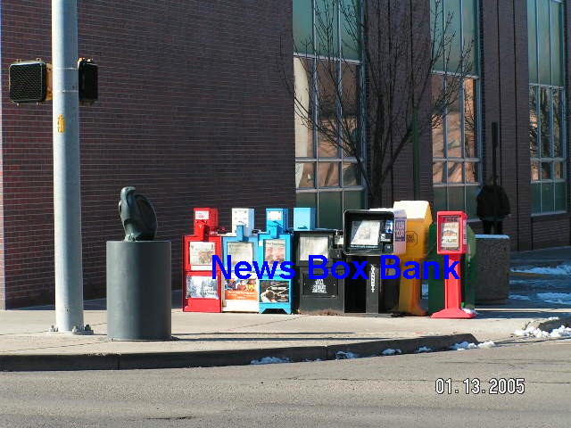

Page 2
CRYSTAL CAFÉ
314 Main Street

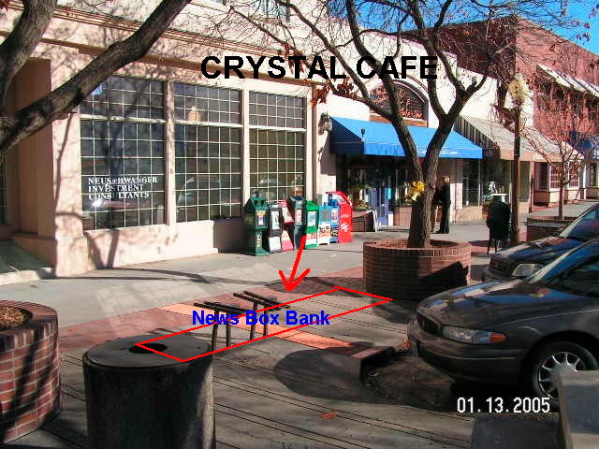

Page 3
ROCKSLIDE BREW PUB
401 Main Street

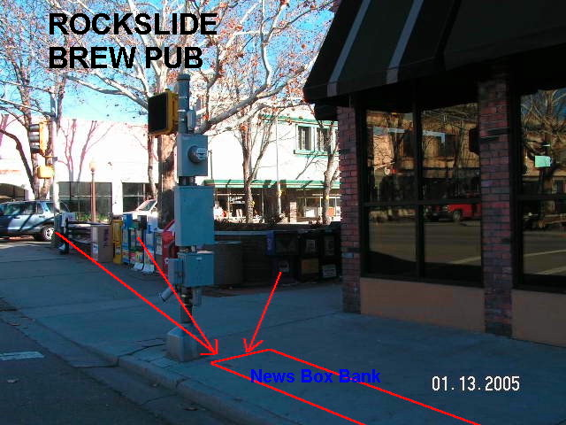

Page 4
GREYHOUND BUS STATION
230 South Fifth Street

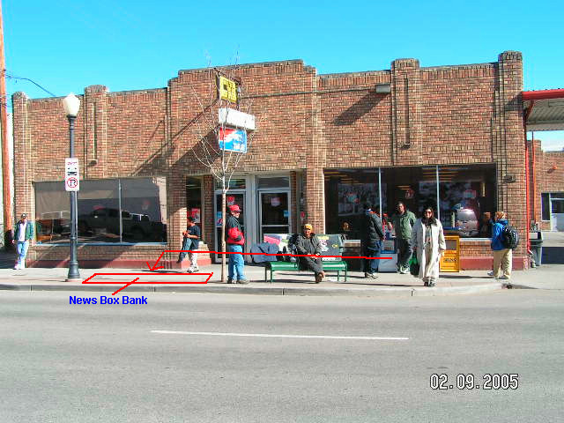

Page 5
MAIN STREET CAFÉ/HAGGLE OF VENDORS
504 Main Street

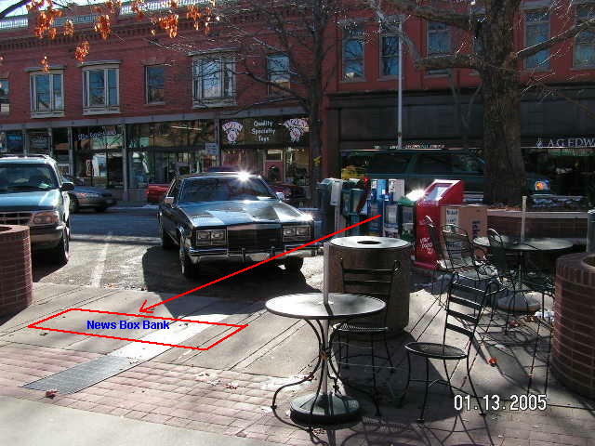

Page 6
MAIN STREET BAGELS BAKERY & CAFÉ
559 Main Street

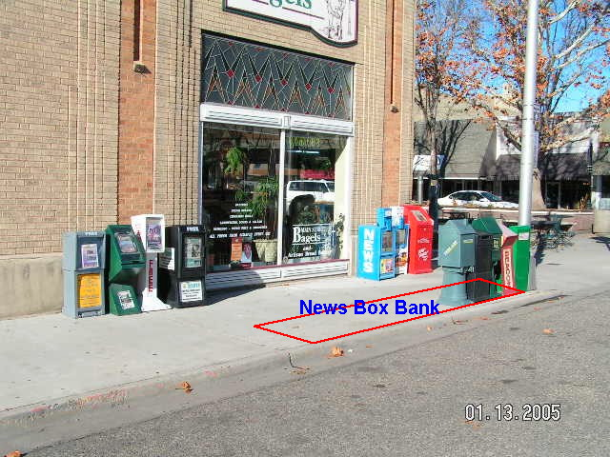

PAGE 7
TALLEY’S BQ & BISCUIT FACTORY
623 Main Street

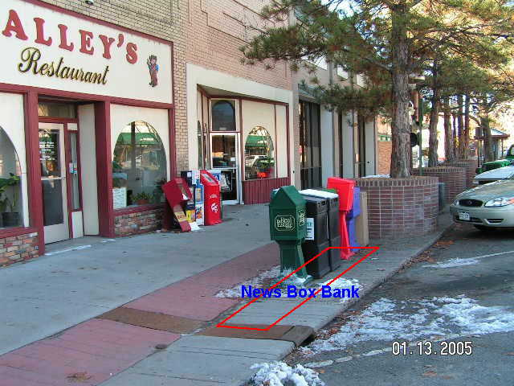

Page 8

EXAMPLE OF NEWS BOX BANK
COLOR: CHICAGO BLUE
MODEL: THE BOULEVARD
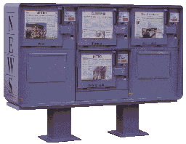

Page 9

The requirements in this part of the definition are drawn from the United States Postal Service manual part of regulations which distinguish publications which are eligible for special mailing rates from those which are not. A deckle edge is a rough, untrimmed edge.

