CITY OF GRAND JUNCTION, COLORADO

ORDINANCE NO. 3729

AN ORDINANCE VACATING A PORTION OF UNDEVELOPED RIGHT-OF-WAY
ALONG G ROAD AND THE ARCADIA NORTH SUBDIVISION LOCATED AT 2540 G ROAD

Recitals.

A vacation of a portion of the undeveloped right-of-way along G Road has been requested by the adjoining property owner. The vacation request is a result
of the Arcadia North Subdivision’s proposal to develop 10 single family lots on 2.88 acres of vacant land, zoned RSF-4. The request to vacate is specifically for that dedication made in the Quit Claim Deed to Mesa County and recorded in the Mesa County Clerk & Recorder's records at Book 131 Page 145, less any portion of the described land in the deed actually lying within the G Road right-of-way otherwise dedicated for right-of-way purposes. The legal description prepared by the City Surveyor reflects this (Exhibit B).

The City Council finds that the request is consistent with the Growth Plan, the Grand Valley Circulation Plan and Section 2.11 of the Zoning and Development Code.

The Planning Commission, having heard and considered the request, found the criteria of the Code to have been met, and recommends that the vacation be approved.

BE IT ORDAINED BY THE CITY COUNCIL OF THE CITY OF GRAND JUNCTION THAT:

The following described dedicated right-of-way, as shown on “Exhibit A”, for G Road is hereby vacated:

Dedicated right-of-way to be vacated:
A certain parcel of land lying in the Southeast Quarter of the Southwest Quarter (SE ¼ SW ¼) of Section 34, Township 1 North, Range 1 West of the Ute Principal Meridian, City of Grand Junction, County of Mesa, State of Colorado and being more particularly described as follows:

ALL of that certain parcel of land describe in Book 131, Page 145, Public records of Mesa County, Colorado, LESS HOWEVER, any portion of the above described land lying within the right of way for G Road, as same is described in Book 2451, Pages 823 through 825, inclusive, and Book 1659, Pages 622 and 623, Public Records of Mesa County, Colorado.

Introduced on first reading this 16th day of February, 2005 and ordered published.

Adopted on second reading this 2nd day of March, 2005.

/s/ Bruce Hill
Mayor

ATTEST:

/s/ Stephanie Tuin
City Clerk

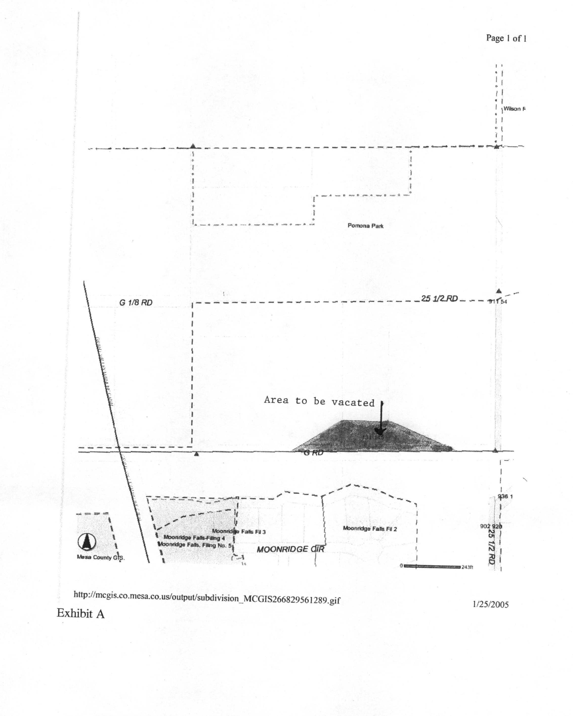

Exhibit B

VACATION OF RIGHT 0F WAY

A certain parcel of land lying in the Southeast Quarter of the Southwest Quarter (SE ¼ SW ¼) of Section 34, Township 1 North, Range 1 West of the Ute Principal Meridian, City of Grand Junction, County of Mesa, State of Colorado and being more particularly described as follows:

ALL of that certain parcel of land describe in Book 131, Page 145, Public records of Mesa County, Colorado, LESS HOWEVER, any portion of the above described land lying within the right of way for G Road, as same is described in Book 2451, Pages 823 through 825, inclusive, and Book 1659, Pages 622 and 623, Public Records of Mesa County, Colorado.

