CITY OF GRAND JUNCTION, COLORADO

ORDINANCE NO. 3730

AN ORDINANCE VACATING A RIGHT-OF-WAY LOCATED
ADJACENT TO 237 S. 7th STREET

Recitals:

A request to vacate the southern portion of the north/south alley between 6th Street and 7th Street adjacent to Ute Avenue has been submitted by the City of Grand Junction. The City will reserve and retain a Multi-Purpose Easement on, along, over, under, through and across the entire area of the right-of-way to be vacated. Approval of the right-of-way vacation is conditioned upon the closure of one access point adjacent to subject property on Ute Avenue within one year of City Council approval and will require a Development Improvements Agreement with security to be posted prior to recordation of the vacation.

The City Council finds that the request to vacate the herein described right-of-way is consistent with the Growth Plan and Section 2.11 of the Zoning and Development Code.

The Planning Commission, having heard and considered the request, found the criteria of the Zoning Code to have been met, and recommends that the vacation be approved as requested subject to the condition that the City shall reserve and retain a Multi-Purpose Easement, on, along, over, under, through and across the entire area of the hereinafter described right-of-way and closure of one access point along Ute Avenue will occur within one year of approval.

NOW, THEREFORE, BE IT ORDAINED BY THE CITY COUNCIL OF THE CITY OF GRAND JUNCTION THAT:

1. The following described right-of-way is hereby vacated:

All that portion of the North-South alley in Block 127 of the City of Grand Junction lying south of the East-West alley in said Block 127, and more particularly described as follows:

Commencing at the city street monument at the intersection of Sixth Street and Colorado Avenue whence the city street monument at the intersection of Seventh Street and Colorado Avenue bears N90°00’00”E and all other bearings are relative thereto; thence N90°00’00”E 309.8 feet to the extension of the west line of said North-South alley; thence south along said west line 205.0 feet to the south line of said East-West alley and the Point of Beginning; thence south along said west line 125.0 feet to the northerly right-of-way line of Ute Avenue; thence east along said northerly right-of-way 15.0 feet to the east line of said North-South alley; thence north along said east line 125.0 feet to the south line of said East-West alley; thence west along said south line to the point of beginning, as described herein and depicted on Exhibit “A” attached here to and incorporated herein by reference. Said alleys being in block 127 of the City of Grand Junction, Colorado, and shown on the plats thereof.

2. The City hereby reserves and retains a Multi-Purpose Easement on, long, over, under, through and across the entire area of the above described right-of-way, for the use and benefit of the City and for the use and benefit of the Public Utilities, as approved by the City, as a Multi-Purpose Easement for the installation, operation, maintenance, repair and replacement of existing and future utilities and appurtenances related thereto, as approved by the City, including, but not limited to, electric lines, cable television lines, natural gas pipelines, sanitary sewer lines, storm sewers and storm water drainage facilities, water lines, telephone lines, and also for the installation, operation, maintenance, repair and replacement of traffic control facilities. Street lighting, landscaping, trees and grade structures, as approved by the City, together with the right of ingress and egress for workers and equipment to survey, maintain, operate, repair, replace, control and use said Easement, and to remove objects interfering therewith, including the trimming of trees and bushes as may be required to permit the operation of standard utility construction and repair machinery.

Introduced for first reading on this 2nd day of March, 2005

PASSED and ADOPTED this 16th day of March, 2005

ATTEST:

/s/ Bruce Hill
President of City Council

/s/ Stephanie Tuin
City Clerk

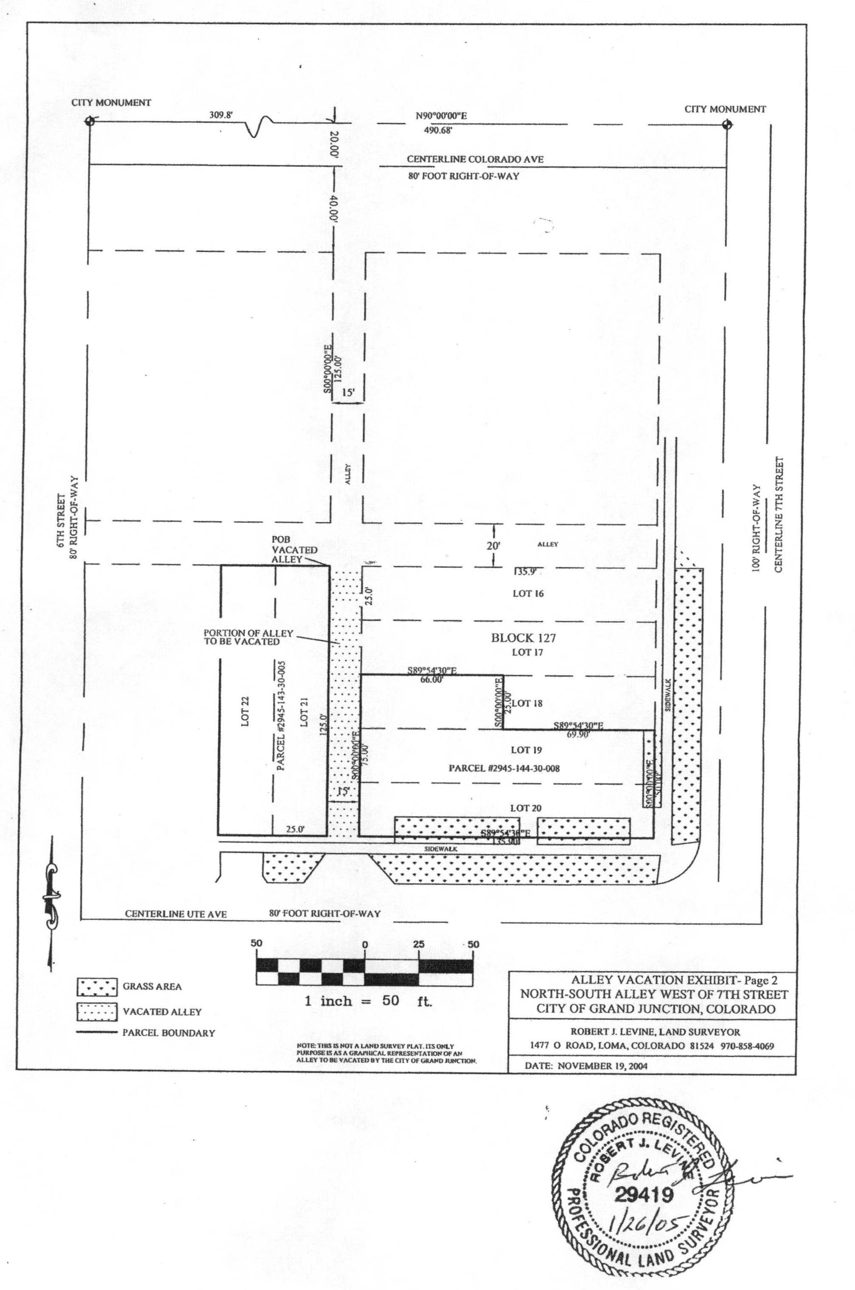
Exhibit “A”

