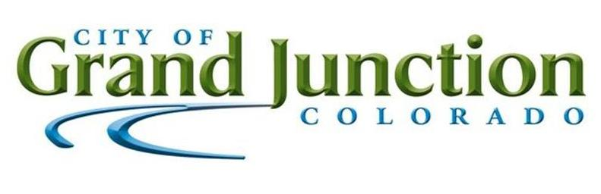

**Purchasing Division**

## ADDENDUM NO. 1

**DATE: February 4, 2022**

**FROM: City of Grand Junction Purchasing Division**

**TO: All Offerors**

**RE: Nitrile Gloves IFB-5021-22-KH**

Offerors responding to the above referenced solicitation are hereby instructed that the requirements have been clarified, modified, superseded and supplemented as to this date as hereinafter described.

Please make note of the following clarifications:

1. **Q:** What is the min. length? Is there a specific color? Is the 5.5mil measurement take in the fingertip? Is this also an exam grade glove? (Items #5-8)

**A:** The City’s current gloves go just past the wrist.  Color does not matter. Gloves shall be 5.5 mil throughout including the fingertip.  Yes, on the exam grade.

1. **Q:** I was wondering if you could clarify the term of this contract. Or is it a one-time order?

**A:** This purchase is a one-time purchase.

1. **Q:** We need to get more information on the Powder free 5.5 mil Nitrile gloves. We need to know the length of the glove wanted and a part number if we can get it.

**A:** Please reference answer to question #1 for length of glove. The City does not have a part number as we are wanting to get bids on different brands as long as they meet specification.

1. **Q:** Will you expect to have all the product delivered at one time or would you expect to take delivery of a set amount each month/week? My concern is that for the quantity of gloves you’re requesting, lead times for a complete order will be very long, possibly taking multiple months to acquire all the requested gloves.

**A:** The City would like to make one big order since it is grant funded and need to close out the grant.

1. **Q:** What are the makes/models of gloves you are currently purchasing and at what price?

**A:** The City has tried many kinds of gloves. We normally order whatever is in stock if it meets specifications. (Items #5-8)

1. **Q:** Are there just 2 delivery locations? Is there a loading dock/forklift at each, or is a liftgate and/or inside delivery necessary?

**A:** Correct, there will only be the two delivery locations. The delivery location for items #1-4 does have a loading dock and forklift. The delivery location for items #5-8 will be an inside delivery.

1. **Q:** Can you give us an idea of how many cases of gloves are ordered at a time and at what frequency? Monthly, quarterly, etc.

**A:** Please reference answer to question #2.

1. **Q:** Please explain why Bid # IFB-5021-22-KH Items 1-4 are restricted to the *Kimberly Clark*brand and prohibits countless vendors from participation. Please provide any unique features or requirements of the specification exclusively provided by the Kimberly Clark gloves that competing products do not comply or offer.

**A:** The City is doing a brand name only for items 1-4 due to failed past experiences of other brand name or equal too brands. The City encourages the vendor to submit a bid for items 5-8 since these are not brand name specific.

1. **Q:** I read Grand Junction’s request for bids for items #5-8 5.5mil nitrile gloves, and would like to offer my MEGA Gloves nitrile gloves which are 4.2mil (which is .0013 inch thinner than 5.5mil)

**A:** The City will only be accepting 5.5 mil nitrile gloves at this time.

1. **Q:** My company would like to inquire if you are accepting partial bids due to the fact that we don’t sell line items 1-4 under that particular brand.

**A:** It is not mandatory to bid all line items. Please put no bid on items you are not bidding

The original solicitation for the project noted above is amended as noted.

All other conditions of subject remain the same.

Respectfully,

Kassy Hackett, Buyer

City of Grand Junction, Colorado