CITY OF GRAND JUNCTION, COLORADO

ORDINANCE NO. 3823

AN ORDINANCE VACATING A RIGHT-OF-WAY LOCATED AT
1531, 1559 AND 1561 HIGH STREET

Recitals:

A request to vacate the right-of-way located at 1531, 1559 and 1561 High Street adjacent to Highway 50 has been submitted by the City of Grand Junction. The City will reserve a 20’ wide sanitary sewer easement on, along, over, under, through and across the subject property for the construction of a gravity sanitary sewer line. Approval of the right-of-way vacation is conditioned upon the vacation ordinance to be recorded concurrently with a proposed subdivision replat of subject property, which cannot occur until existing Colorado Department of Transportation right-of-way encumbering the property has been purchased.

The City Council finds that the request to vacate the herein described right-of-way is consistent with the Growth Plan and Section 2.11 of the Zoning and Development Code.

The Planning Commission, having heard and considered the request, found the criteria of the Zoning Code to have been met, and recommends that the vacation be approved as requested subject to the conditions listed above.

NOW, THEREFORE, BE IT ORDAINED BY THE CITY COUNCIL OF THE CITY OF GRAND JUNCTION THAT:

1. The following described right-of-way is hereby vacated and depicted as Exhibit A and incorporated herein.

Beginning at a found original inscribed rail whence the SW corner of Section 23, T 1 S, R 1 W of the Ute Meridian bears S 34°16'46" W a distance of 2065.32 feet for a basis of bearings; thence N 06°43'05" W a distance of 271.00 feet; thence N 56°28'05" W a distance of 117.00 feet; thence N 17°59'43" E a distance of 31.14 feet; thence S 56°28'05" E a distance of 139.25 feet; thence S 06°43'05" E a distance of 259.19 feet; thence S 14°35'51" W a distance of 84.77 feet to a point on a non-tangent curve to the left having a radius of 1738.70 feet, a central angle of 45°19’00” and a chord that bears N 05°50’26” W a distance of 53.27 feet to the Point of Beginning.

- The City hereby reserves and retains a 20’ wide sanitary sewer easement on, long, over, under, through and across the subject property, for the use and benefit of the City and for the use and benefit of the Public Utilities, as approved by the City, as a perpetual easement for the installation, operation, maintenance, repair and replacement of sanitary sewer facilities, as approved by the City, together with the right of ingress and egress for workers and equipment to survey, maintain, operate, repair, replace, control and use said Easement, and to remove objects interfering therewith, including the trimming of trees and bushes as may be required to permit the operation of standard utility construction and repair machinery.

Introduced for first reading on this 17th day of August, 2005

PASSED and ADOPTED this 7th day of September, 2005

ATTEST:

/s/ Bruce Hill
President of City Council

/s/ Stephanie Tuin
City Clerk

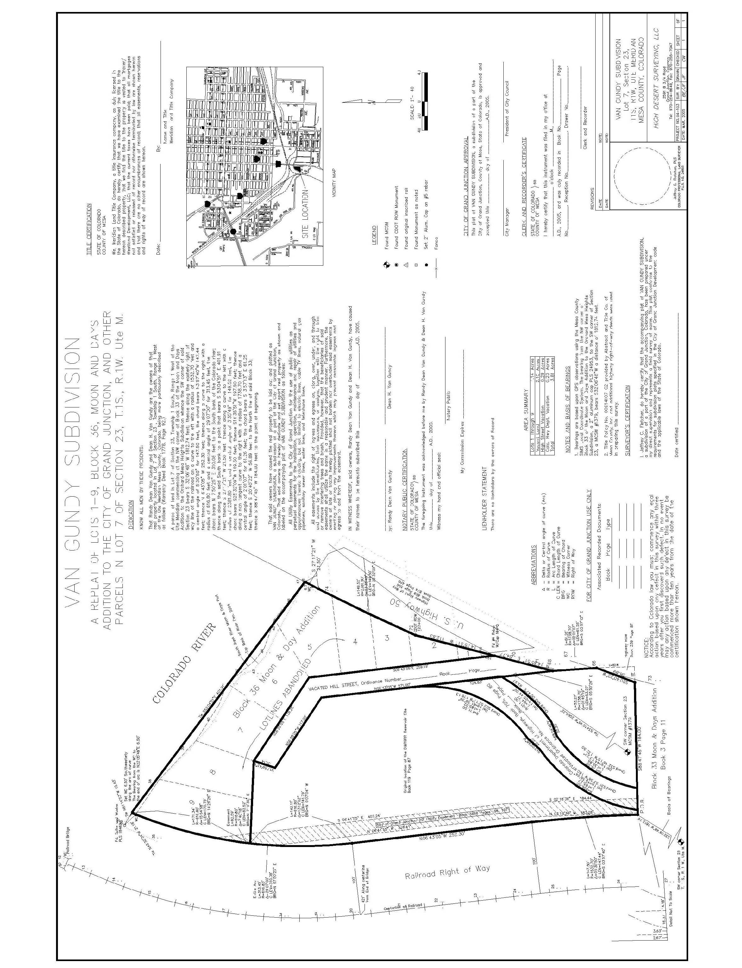
Exhibit “A”

