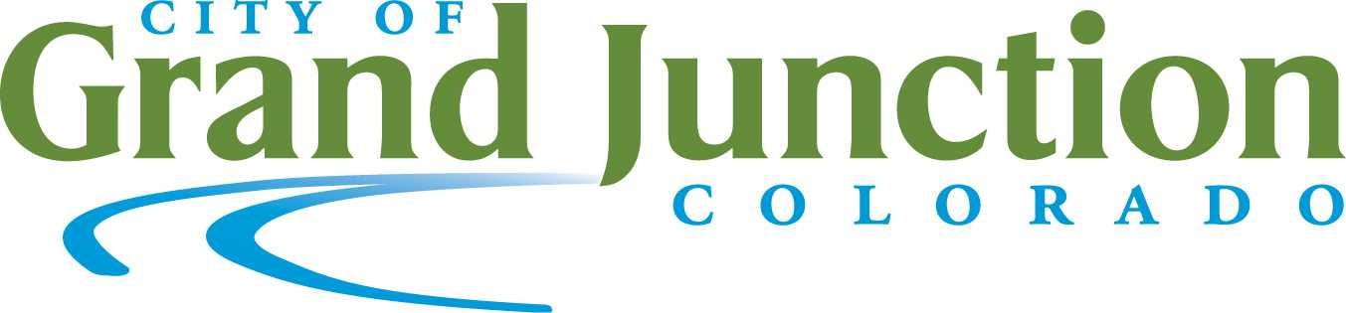
EMPLOYEE CHANGE FORM
Employee Name: |  |  |  |  |  |  |  | Employee ID :
Effective Date of Change:
HR will contact the appropriate benefit providers to notify them of any changes.
NAME CHANGE
To change your name you must include a copy of your new Social Security Card (as mandated by Federal Law) with this form.
Old Name:
New Name:
ADDRESS CHANGE
Please enter new mailing address below.
Phone Number:
EMERGENCY CONTACT CHANGE
Name: |  |  |  |  |  |  |  |  |  | Phone Number:
Employee Signature |  |  |  |  |  |  |  |  |  |  | Date
FOR HR USE ONLY
Benefit Provider |  |  |  |  | Date Notified |  | Initials
Rocky Mountain Health Plans
Delta Dental
ICMA-RC

