**CITY OF GRAND JUNCTION**

**RESOLUTION NO. 39-13**

**A RESOLUTION VACATING A PUBLIC UTILITY EASEMENT**

**LOCATED AT 502/530/550 GRAND AVENUE**

**(MESA COUNTY PUBLIC LIBRARY)**

RECITALS:

A vacation of the dedicated public utility easement has been requested by the property owners.

The east/west alley located in Block 73, City of Grand Junction contained a public sewer line and XCEL power lines. A utility easement was retained as part of the vacation of a portion of the east/west alley located south of Lots 5-11 and north of Lots 22-28 in 1973. Subsequently, the building was expanded over the top of the easement with the utilities still in place. With the current expansion/remodel of the library, all utilities will be relocated, eliminating the need for the easement. The XCEL Energy lines will be relocated on the site and the sewer line rerouted within the N 6th Street right-of-way.

The City Council finds that the request is consistent with the Comprehensive Plan, the Grand Valley Circulation Plan and Section 21.02.100.c of the Zoning and Development Code, as long as the conditions described below are met.

The Planning Commission, having heard and considered the request, found the criteria of the Code to have been met, and recommends that the vacation be approved.

NOW, THEREFORE BE IT ORDAINED BY THE CITY COUNCIL OF THE CITY OF GRAND JUNCTION THAT:

The following described dedicated public utility easement is hereby vacated subject to the listed conditions:

1. Applicants shall pay all recording/documentary fees for the Vacation Resolution, any easement documents and dedication documents.

The following public utility easement is shown on “Exhibit A” as part of this vacation of description.

Dedicated public utility easement to be vacated:

As parcel of land being part of the vacated alley, Ordinance No. 1467, Book 1003, Page 161, City of Grand Junction, Mesa County, Colorado, being more particularly described as follows:

Beginning at the Southeast corner of Lot 11, Block 73, City of Grand Junction; thence North 00°02'28" East, a distance of 10.00 feet; thence North 89°56'02" West, a distance of 157.61 feet; thence South 00°02'28" West, a distance of 20.00 feet; thence South 89°56'02" East, a distance of 157.61 feet; thence North 00°02'28" East, a distance of 10.00 feet to the POINT OF BEGINNING.

Said parcel having an area of 3152 square feet, as described.

ADOPTED this 19th day of June, 2013.

ATTEST:

/s/ Sam Susuras

President of City Council

/s/ Stephanie Tuin

City Clerk

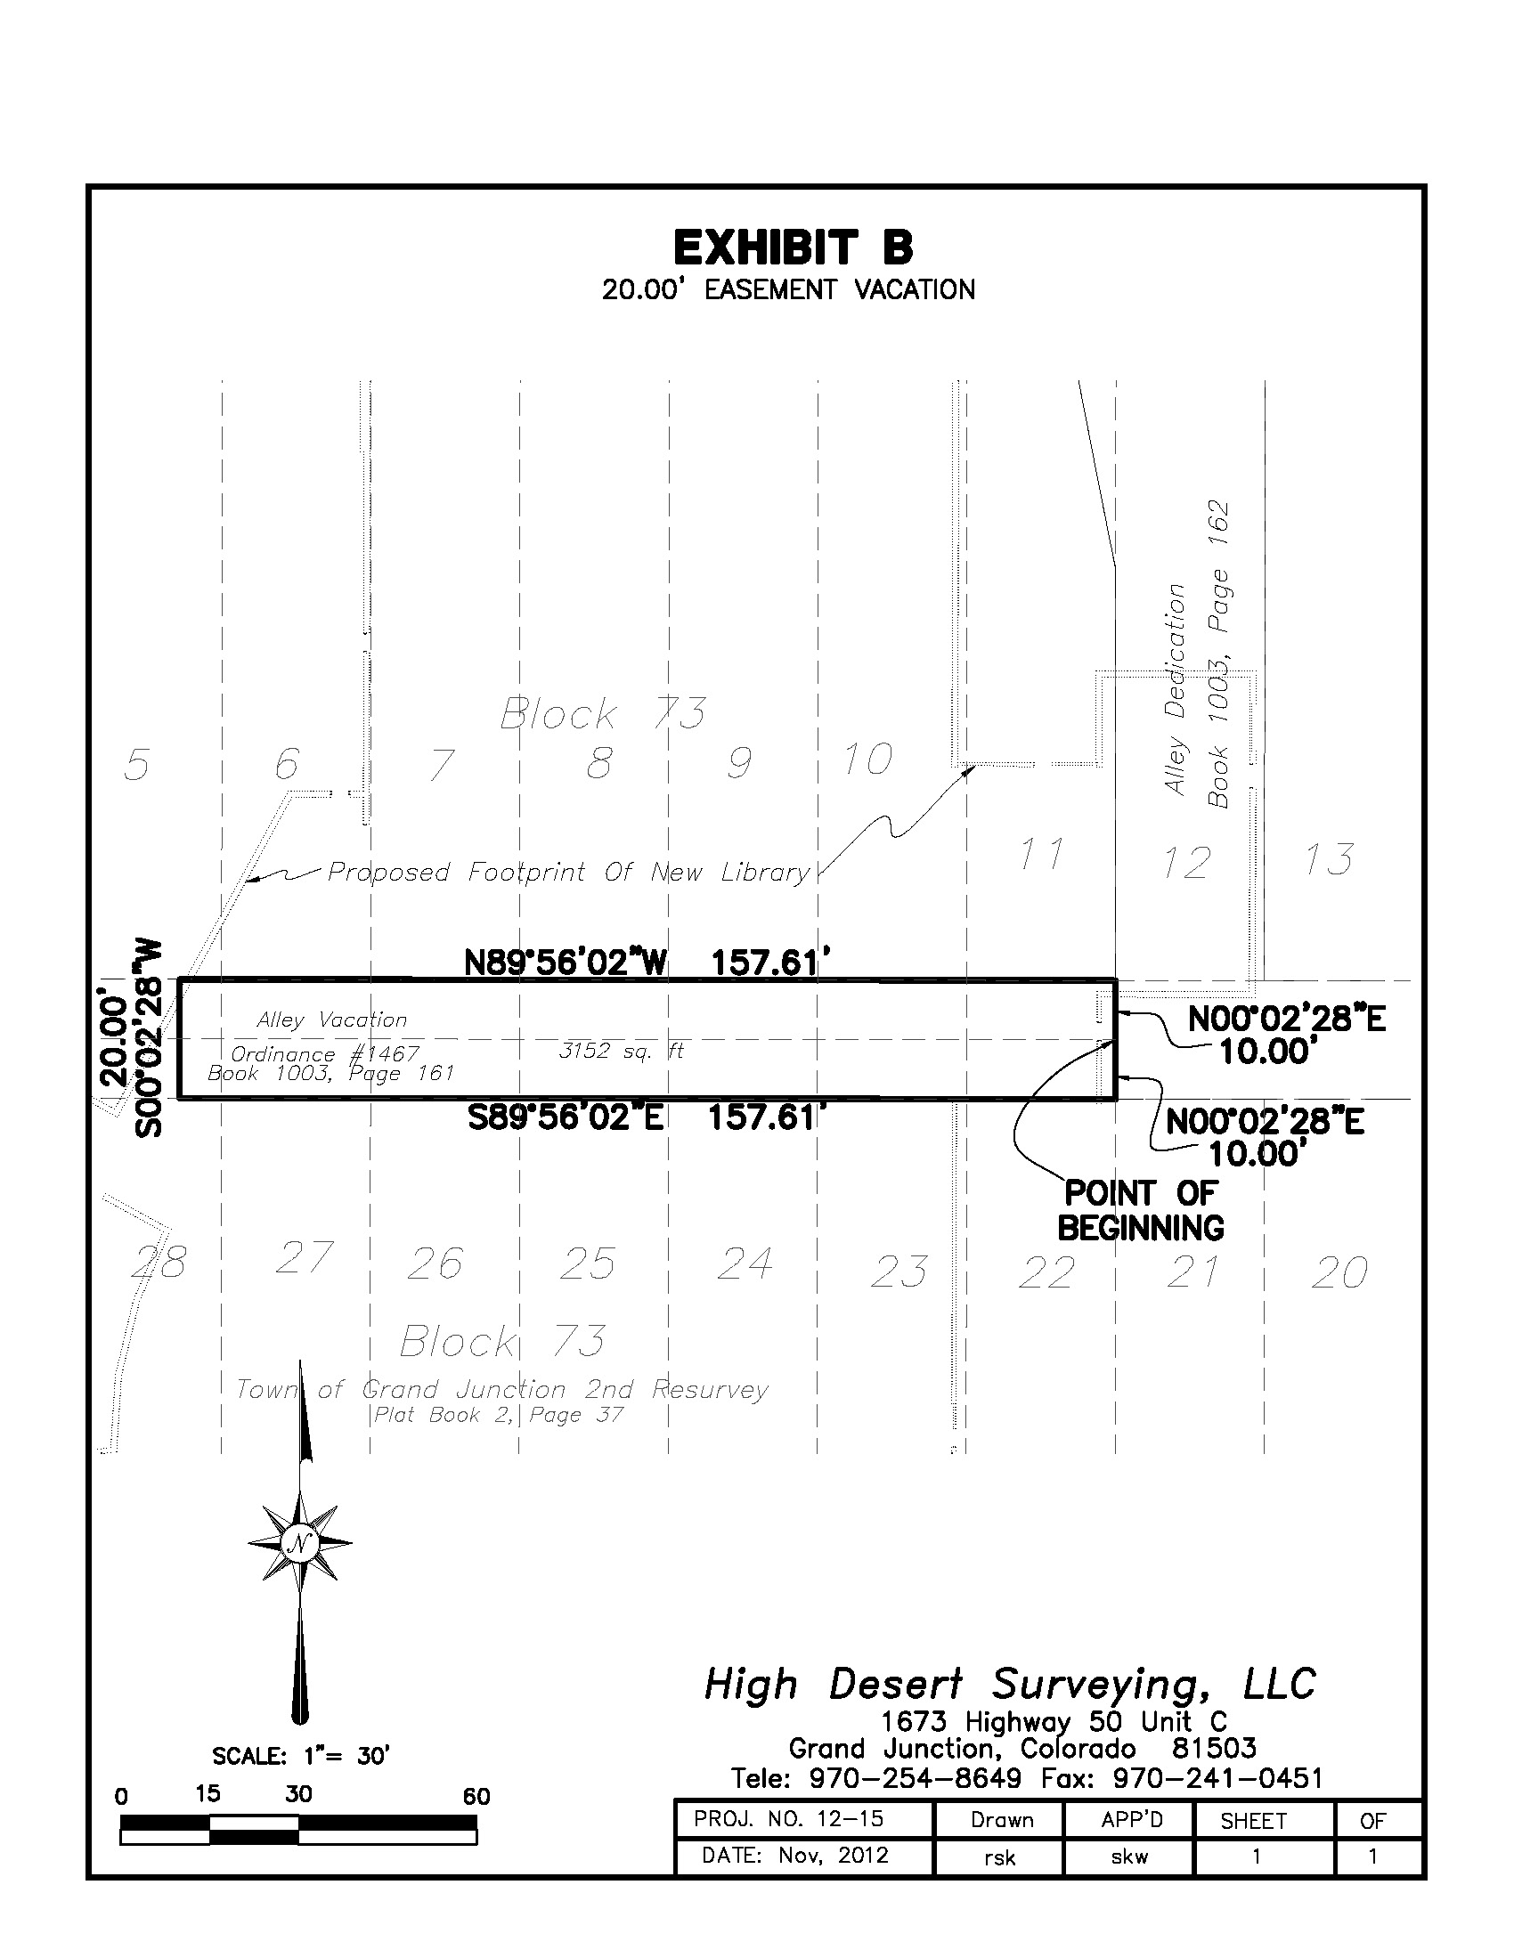

**A**