CITY OF GRAND JUNCTION

ORDINANCE NO. 3889

AN ORDINANCE AMENDING THE PD ZONING FOR LAND LOCATED WEST OF HILLVIEW DRIVE IN THE RIDGES KNOWN AS 10 OVERLOOK

Recitals:

The proposed 10 Overlook subdivision was originally a part of the Ridges PUD (Planned Unit Development), and later incorporated as a part of the Redlands Mesa PD (Planned Development). The proposal is to develop 1.96 acres adjacent to the Redlands Mesa Golf Course into 6 single family lots. The Planning Commission and City Council hereby find that the request is in compliance with the Zoning and Development Code.

NOW, THEREFORE, BE IT ORDAINED BY THE CITY COUNCIL OF THE CITY OF GRAND JUNCTION, COLORADO:

That the land described below is hereby zoned PD (Planned Development) with the allowed uses being a maximum of 6 single-family homes, with a default zoning of RSF-4, subject to the approved Preliminary Plan (attached as exhibit A).

Legal Description:

A parcel of land situated in Golf Block 12 of Redlands Mesa Filing 1, a plat recorded in Mesa County at Reception No. 1957570, and being situated in the east half of the northwest quarter of Section 20, Township 1 South, Range 1 West of the Ute Meridian, County of Mesa, State of Colorado, being more particularly described as follows:

Beginning at the northern boundary point common to Hillview Drive as platted and recorded at Reception No. 1246291 as a Replat of portions of The Ridges Filing No. Five;
Thence along the common boundary of the aforementioned subdivisions the following six (6) courses:
- 104.65 feet southwesterly, southerly, southeasterly and easterly along the arc of a 50.00 foot radius curve concave to the northeast, through a central angle of 119°55'32", with a chord bearing South 25°03'53" East, a distance of 86.57 feet to a point of cusp on a curve, from which the radius point bears North 52°12'04" West;
- Thence southwesterly and westerly a distance of 283.58 feet along the arc of said curve concave to the northwest, having a radius of 444.99 feet and a central angle of 36°30'48" to a point of reverse curvature;
- Thence 130.87 feet along the arc of a 150.00 foot radius curve to the left, through a central angle of 49°59'21", with a chord bearing South 49°19'02" West, a distance of 126.76 feet;
- Thence South 24°19'20" West tangent to said curve, a distance of 97.00 feet;
- Thence North 65°40'40" West, a distance of 50.00 feet to a point on a 20.00 foot radius non-tangent curve to the right, whence the radius point bears North 65°40'40" West;
- 19.37 feet along the arc of said curve, through a central angle of 55°30'22", with a chord bearing South 52°04'31" West, a distance of 18.62 feet;
Thence North 39°34'43" West, a distance of 101.78 feet;
Thence North 15°35'24" East, a distance of 99.70 feet;
Thence North 39°17'39" East, a distance of 85.78 feet;
Thence North 50°10'13" East, a distance of 41.88 feet;
Thence North 69°09'47" East, a distance of 63.88 feet;
Thence North 74°29'06" East, a distance of 101.98 feet;
Thence North 40°12'28" East, a distance of 136.77 feet;
Thence North 89°54'09" East, a distance of 28.54 feet;
Thence South 68°50'18" East, a distance of 72.62 feet to the Point of Beginning.

Containing 1.957 acres, more or less.

INTRODUCED for FIRST READING and PUBLICATION this 5th day of April, 2006.

PASSED on SECOND READING this 19th day of April, 2006.

ATTEST:

/s/ Stephanie Tuin /s/ Bruce Hill
City Clerk President of City Council

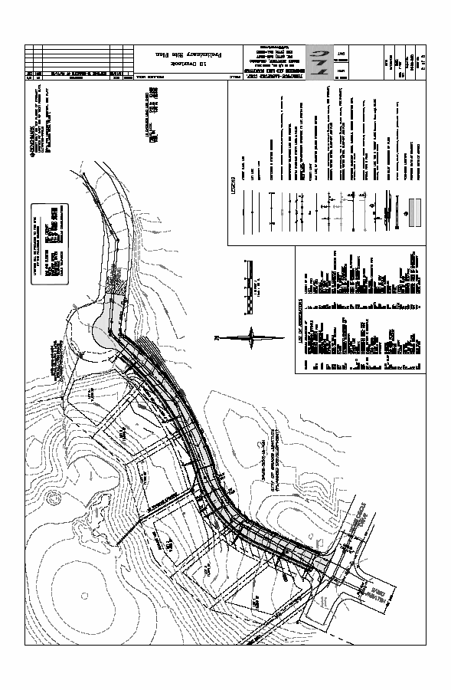
Exhibit A

