CITY OF GRAND JUNCTION

ORDINANCE NO. 3892

AN ORDINANCE VACATING RIGHT-OF-WAY FOR AN ALLEYWAY
IN THE VICINITY OF 1018 SOUTH 5TH STREET SOUTH OF 4TH AVENUE BETWEEN 5TH AND 7TH STREETS
KNOWN AS THE VAN GUNDY NORTH PROJECT

Recitals

A vacation of a north-south alley way located as described above is requested. The alley is not developed for vehicular traffic but is used as a rail spur and a City sewer line is located within it underground. The properties surrounding it are concurrently being platted into a single parcel to be used for one use. The rail spur will be retained for private use but the alley is not needed since it will dead end at the southern end at the Riverside Parkway once it is constructed.

The City Council finds that the vacation is consistent with the Growth Plan and meets the criteria of section 2.11 of the Zoning and Development Code.

The Planning Commission, having heard and considered the request, found the criteria of the Code to have been met and recommended that the vacation be approved subject to the condition that the vacation not be effective unless and until a Simple Subdivision Plat is recorded that dedicates a sewer easement to the City within the vacated right-of-way.

NOW THEREFORE, BE IT ORDAINED BY THE CITY COUNCIL OF THE CITY OF GRAND JUNCTION THAT:

The following described dedicated public right-of-way is hereby vacated:

A parcel of land being a portion of the alley in Block 1 of SOUTH FIFTH STREET SUBDIVISION as recorded in Book 7, Page 19 recorded at the Mesa County Clerk and Recorder’s Office on November 29, 1946 lying in the Northwest Quarter of Section 23, Township 1 South, Range 1 West of the Ute Meridian, City of Grand Junction, Mesa County, Colorado being more particularly described as follows:

COMMENCING at the Center Quarter corner of Section 23 (a found 3”Brass Cap “MCSM C1/4 S23”), WHENCE the East Quarter Corner of Section 23 (a found 3 ½”Aluminum Cap “D-H SURVEYS INC LS42306”), bears S89°36'03"E (Basis of Bearing-assumed) a distance of 2638.76 feet;
THENCE N18°07'38"W a distance of 991.86 feet to the POINT OF BEGINNING;

THENCE N30°36'27"W, a distance of 34.26 feet;
THENCE N00°51'43"W, along the easterly line of Lots 18 & 17, a distance of 300.77 feet;
THENCE S89°59'58"E, along the south right-of-way line of 4th Avenue, a distance of 17.00 feet; THENCE S00°51'43"E, along the easterly line of Lots 22 & 21, a distance of 330.27 feet to the POINT OF BEGINNING.

Containing 0.123 Acres (5,364 Sq.Ft.), more or less.

See Alley Vacation Exhibit attached hereto and incorporated by this reference as if fully set forth.

The vacation shall be subject to and contingent upon the City’s approval of a Simple Subdivision per section 2.2.E.4. of the Zoning and Development Code.

The vacation shall be subject to and contingent upon dedication of an easement for the existing sanitary sewer line within the alley.

Introduced on first reading this 15th day of March, 2006 and ordered published.

Adopted on second reading this 3rd day of May, 2006.

ATTEST:

/s/ Stephanie Tuin /s/ Bruce Hill
City Clerk President of Council
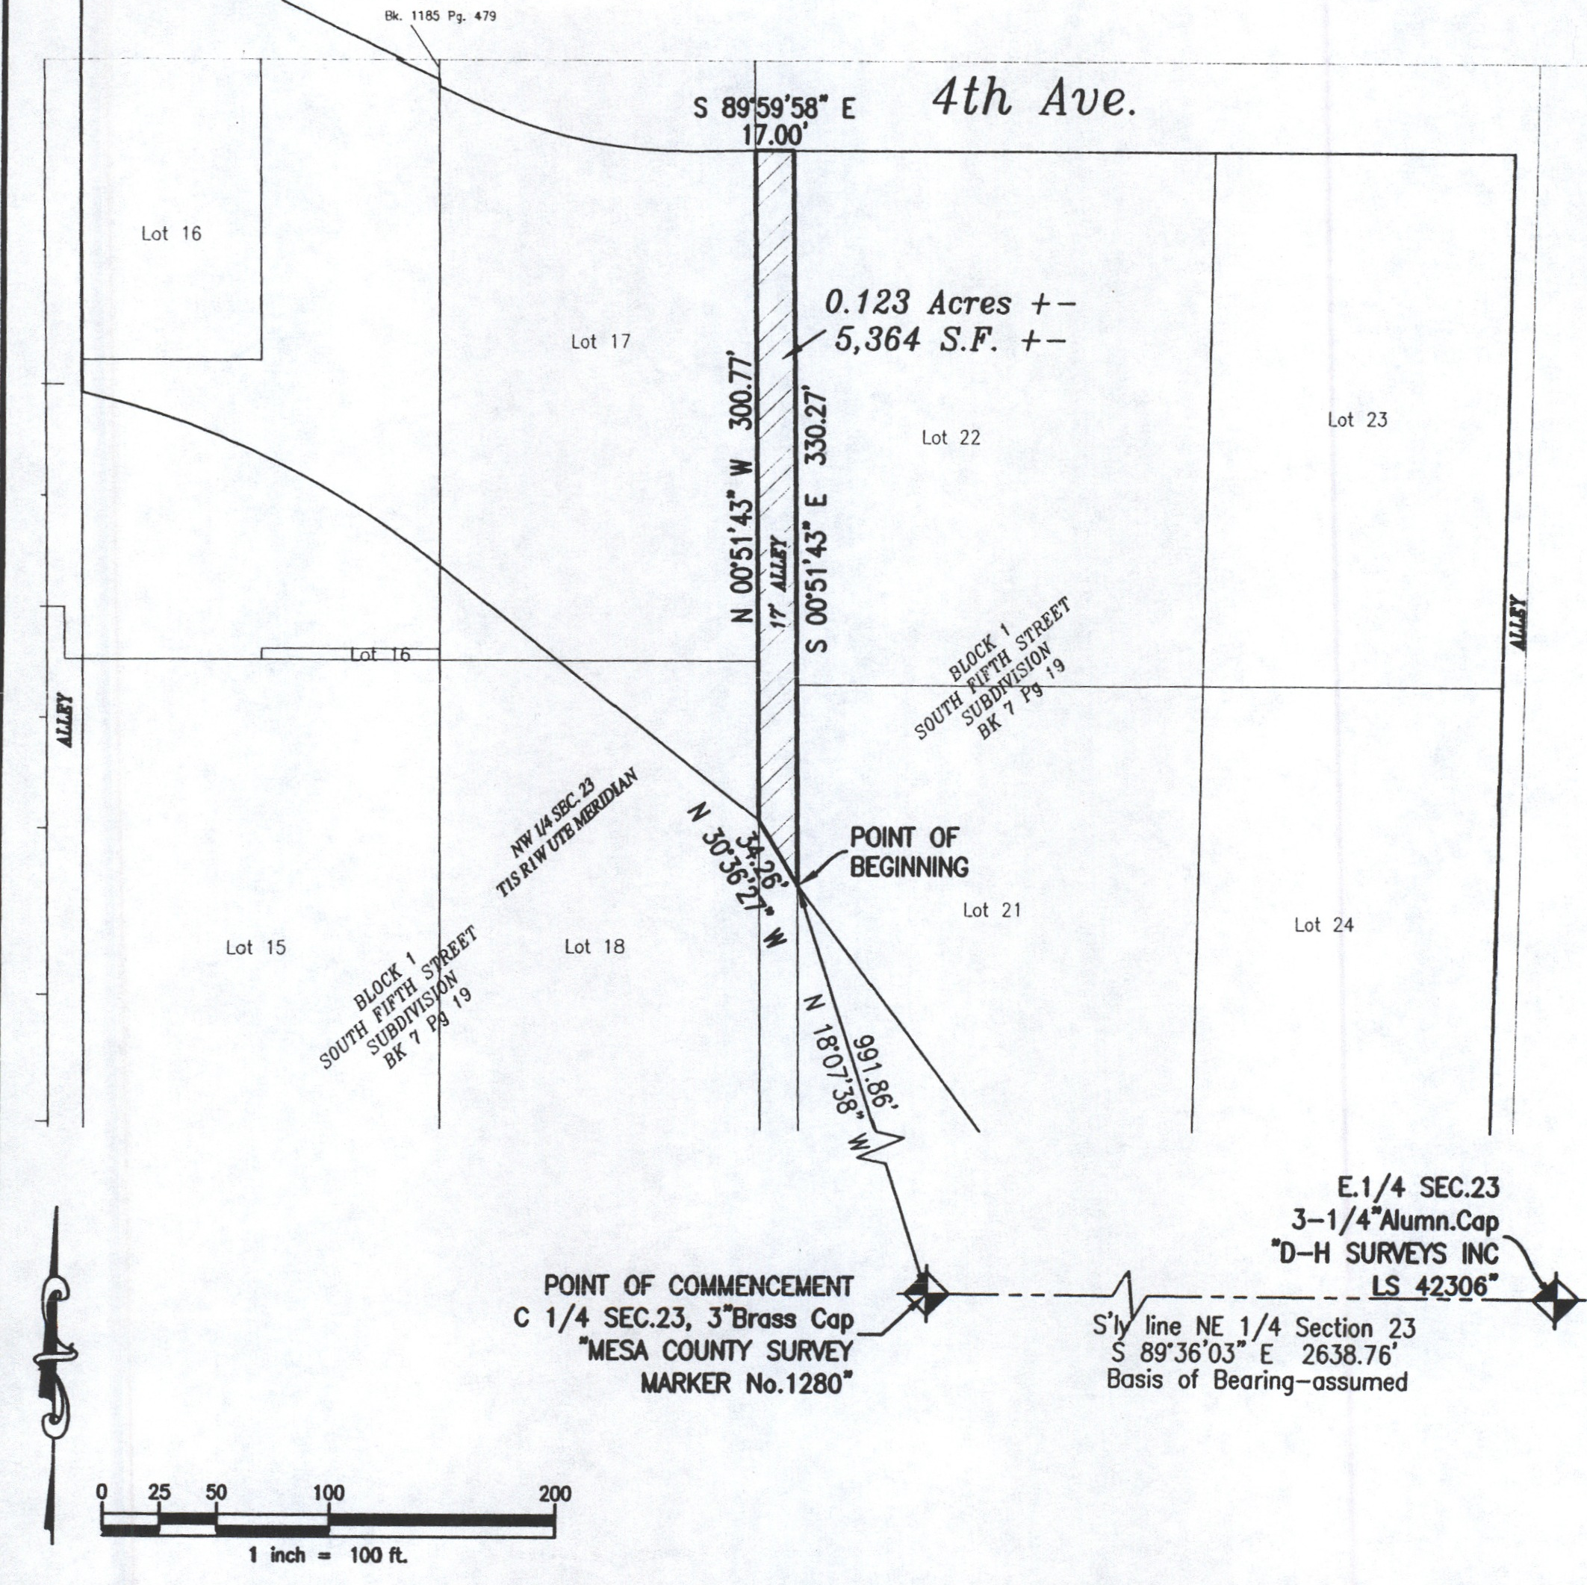

ALLEY VACATION EXHIBIT

