CITY OF GRAND JUNCTION

ORDINANCE NO. 3898

AN ORDINANCE VACATING RIGHTS-OF-WAY FOR AN ALLEYWAY

LOCATED AT THE EASTERN 250’ OF THE EAST/WEST ALLEY AND THE NORTH/SOUTH ALLEY BETWEEN 6TH AND 7TH STREETS AND PITKIN AND SOUTH AVENUES

RECITALS:

A vacation of the dedicated right-of-way for has been requested by the adjoining property owners.

The City Council finds that the request is consistent with the Growth Plan, the Grand Valley Circulation Plan and Section 2.11 of the Zoning and Development Code. The utilities within the right-of-way to be vacated are to be relocated and new easements dedicated. This ordinance is not effective until the existing utilities are relocated and accepted and the new easement deeds recorded.

The Planning Commission, having heard and considered the request, found the criteria of the Code to have been met, and recommends that the vacation be approved.

NOW, THEREFORE BE IT ORDAINED BY THE CITY COUNCIL OF THE CITY OF GRAND JUNCTION THAT:

The following described dedicated right-of-way for is hereby vacated subject to the listed conditions:

- Applicants shall pay all recording/documentary fees for the Vacation Ordinance, any easement documents and dedication documents.
- The vacating ordinance is not effective until the utilities are relocated, inspected and accepted; and, required utility easements are dedicated and deeds are recorded.

The following right-of-way is shown on “Exhibit A” as part of this vacation of description.

Dedicated right-of-way to be vacated:

A part of the alleys in Block 149 of the Grand Junction Colo. Second Division Survey as Amended, recorded in the Mesa County records, January 22, 1909 at Reception No. 80773; said vacation being described as follows:

Beginning at the southeast corner of Lot 15 of said Block 149;
Thence South 00°04'34" West, a distance of 20.00 feet to the southeast corner of the east-west alley in said Block 149;
Thence along the south line of said alley, North 89°50'18" West, a distance of 205.87 feet;
Thence North 00°02'59" East, a distance of 20.00 feet to the north line of said alley;
Thence South 89°50'18" East, a distance of 55.52 feet to the southeast corner of Lot 10 of said Block 149;
Thence North 00°03'43" East, a distance of 125.89 feet to the northeast corner of said Lot 10;
Thence South 89°49'01" East, a distance of 15.00 feet to the northwest corner of Lot 11 of said Block 149;
Thence South 00°03'43" West, a distance of 125.88 feet to the southwest corner of said Lot 15;
Thence South 89°50'18" East, a distance of 135.36 feet to the Point of Beginning.

Containing 0.138 acres, more or less.

AND all of a ten foot road right-of-way described in a document recorded in Book 361 at Page 211; In the City of Grand Junction, Mesa County, Colorado.

Introduced for first reading on this 3rd day of May, 2006.

PASSED and ADOPTED this 17th May, 2006.

ATTEST:
/s/ James J. Doody
President of City Council

/s/ Stephanie Tuin
City Clerk
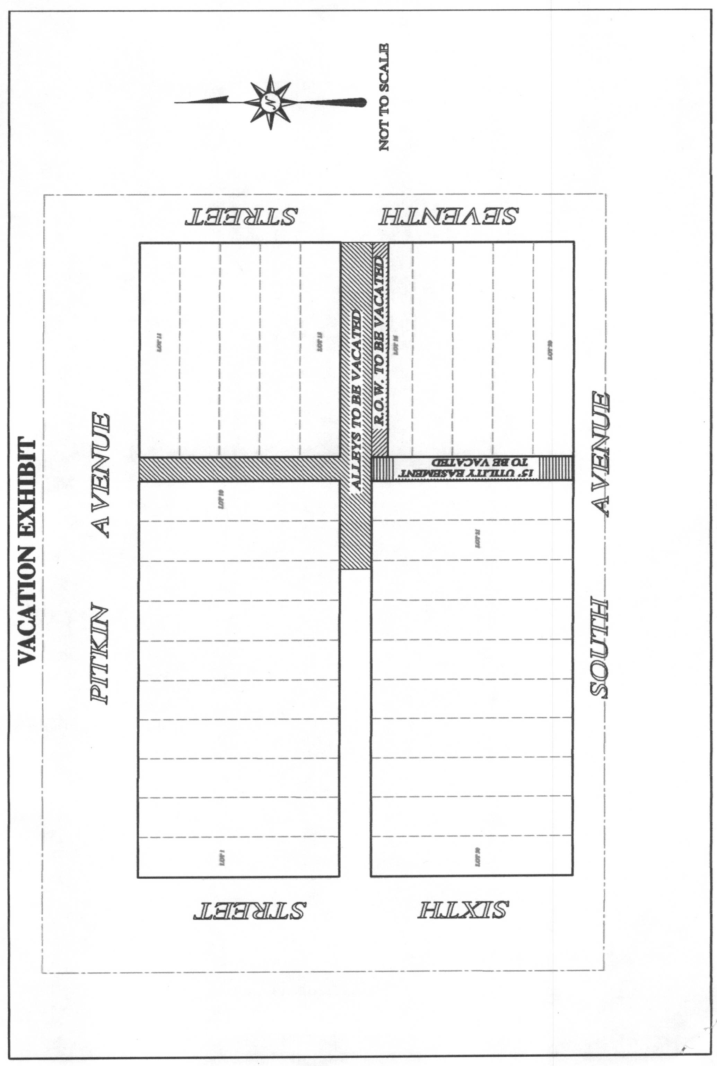
“A”

