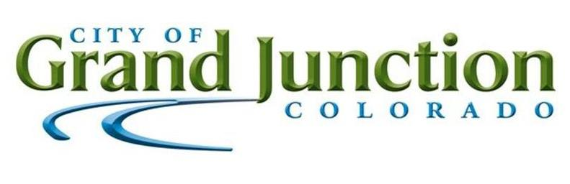

## **LEGAL NOTICE**

**Published:  *The Daily Sentinel***

DATE: November 16, 2022

November 20, 2022

**Solicitation**

IFB-5134-22-DD

24 Road Multi-modal Path Construction CDOT Project No. MTF-M555-035 (24077)

The City of Grand Junction Purchasing Division is inviting sealed competitive responses for this solicitation.Please see the solicitation documents for information. Responses will only be accepted **electronically** through the Rocky Mountain E-Purchasing System/BidNet Direct <https://www.bidnetdirect.com/vendors> , prior to **2:00pm December 22, 2022. Responses received after the time and date specified will not be considered.**

Solicitation documents are available by accessing <https://www.bidnetdirect.com/vendors> and selecting Rocky Mountain E-Procurement System, by accessing the City of Grand Junction website, [www.gjcity.org](http://www.gjcity.org) and selecting on “Bids” link, by contacting the Purchasing Division, 250 North 5th Street, Grand Junction CO 81501, or by calling telephone (970) 244-1546. The City reserves the right to accept or reject any or all offers received in response to this solicitation and to waive any irregularities as may be in the best interest of the City.

Dolly Daniels

Senior Buyer

City of Grand Junction