RESOLUTION NO. 47-13

A RESOLUTION ADOPTING THE 2013 LAS COLONIAS MASTER PLAN

Based on changing user group priorities and a renewed interest in developing the site, the 2008 Las Colonias Master Plan was revised. The plan was prepared by City staff and Ciavonne, Roberts, and Associates.

The plan has been reviewed by a group of local stakeholders and the community and was met with positive feedback regarding the conceptual plan. The plan was also reviewed by the Parks and Recreation Advisory Board on May 2, 2013 and was recommended for approval.

NOW, THEREFORE, BE IT RESOLVED BY THE CITY COUNCIL OF THE CITY OF GRAND JUNCTION THAT:

The 2013 Las Colonias Master Plan, prepared by City staff and Ciavonne, Roberts, and Associates, and recommended for approval by the Grand Junction Parks and Recreation Advisory Board, be adopted by the Grand Junction City Council.

Passed and adopted this 3rd day of July, 2013.

/s/ Sam Susuras
President of the Council
ATTEST:

/s/ Stephanie Tuin
City Clerk

June 2013
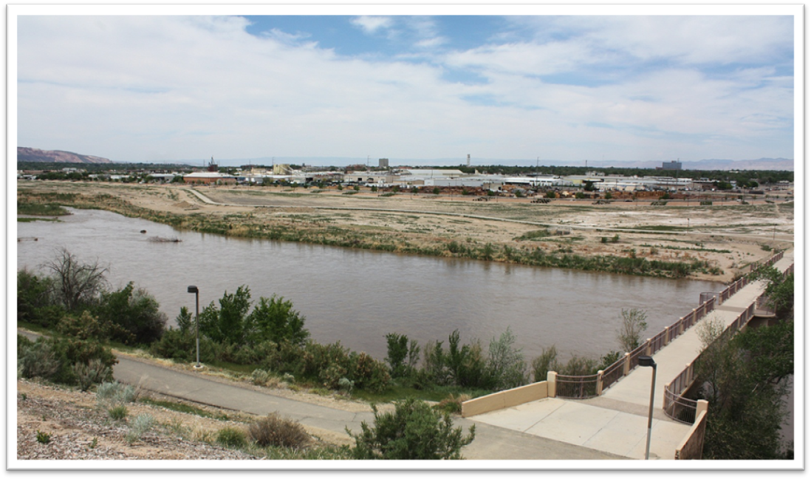
Las Colonias Park Master Plan

Introduction
Las Colonias Park, a 101 acre parcel on the edge of the Colorado River south of downtown, was deeded to the City of Grand Junction in 1997 from the State of Colorado after the mill tailings cleanup was completed. The site has cultural and historical significance because of “Las Colonias”, the colonies of people who worked in the orchards and sugar beet fields who once resided on the site. A naming contest was once held to find a name for the park, and it was determined it would be named after the colonies of people who resided there. After the sugar beet industry died, the site was used as a collection stockpile site for uranium mill tailings. Many residents refer to the site as the Climax Mill Tailing site.

The site is largely vacant, with the exception of a segment of the Riverfront Trail system that passes through the site. The Riverfront Trail System is an extensive trail network that extends through the valley along the Colorado River corridor, providing a valued amenity for recreationalists and commuters. Las Colonias Park is envisioned as a "jewel" in the “string of pearls” once envisioned for this area.

Las Colonias Park was originally master planned in 1998. Construction of the Riverside Parkway, which started in 2006, impacted that original master plan so it was revised in 2008. That master plan included a footprint for a 75,000 square foot civic facility as well as a dog park, natural areas, playgrounds, picnic areas, a festival area/amphitheater, and trails. In 2012, City Council directed Parks and Recreation to again revise the existing master plan.

Project Goals
A committee of City staff, comprised of Parks and Recreation, Engineering, Neighborhood Services, and Finance, was developed to work directly with Ciavonne, Roberts, & Associates. The project goals were to:

- Revise the 2008 master plan to address changing priorities among user and community groups.
- Maintain the overall passive theme of the first two master plans.
- Involve the stakeholders in the initial discussions to help determine a “roadmap” for the revision.
- Conduct additional community participation processes.
- Develop a conceptual design and phasing options.
- Develop cost estimates for development and ongoing maintenance.
- Develop and utilize an internal City employee team to lead the master planning process.
The committee worked very closely with representatives from the Department of Energy, Colorado Department of Public Health and Environment, US Fish and Wildlife, and US Army Corps of Engineers. These entities will remain closely involved in the project as approvals and permits will be required throughout the park’s development.

Stakeholder Involvement
A group of key stakeholders was convened to guide the master planning process in April of 2012. This group included representatives from the Riverfront Commission, Western Colorado Botanical Gardens, Tamarisk Coalition, Grand Valley Disc Golf Club, and Grand Junction Lions Club. This group rated components and phases of the 2008 master plan offering critical feedback about a direction the most recent revision should take. The group met routinely for the remainder of 2012. The following is a summary of their feedback and comments regarding the direction of the 2013 revision.

High
Parking – West
Disc Golf
Dog Park
Restroom Facilities – West
Amphitheatre
Medium
Additional Trails
Developed Vendor Area
Open Turf Area – Passive
Controlled Water Slue
Low
Kayak Park
Other Amenities Rated But Not Ranked High/Medium/Low
Playground
Educational Native Arboretum
Picnic Shelters – East
Picnic Shelters – Small Group
Sport Courts - Basketball, Volleyball, Etc.
Sport Fields - Soccer, Football, Etc.
Other - Revegetation w/Native Elements
Other - Large Open Festival Area
Safety Fencing During Run Off
Civic Center/Recreation Center
Boardwalk
Lighted Trails
Picnic Shelters – Large
Restroom Facilities - East

Comments
- Important that new vegetation doesn't create "campsites".
- Native grasses closer to river, but landscape for amphitheater, picnic, and park areas.
- Plant trees for shade.
- Area can't be all bluegrass.
- Improve condition of Watson Island to tie in with disc golf and new park complex. This would be a nice compliment and support of the new brewery.
- More public will use the park. Start the increase in usage on the west end near Watson Island and Botanical Gardens.
- Parking access is important for individual use and large amphitheater events.
- Dog parks always bring people.
- Water feature could be the "creek" with water flow that kids can play in or a water park/kayak park in the river.
- Need larger amphitheater in central GJ that will accommodate large event (4000-5000 people).
- Compliment to downtown - help keep/bring visitors and users to the great downtown area.
- Other park/civic development and development of Kannah Creek and the Botanical Gardens together with the other efforts will likely increase the desire of developers to begin projects.

Park Program Elements
The 2013 Las Colonias Master Plan includes many of the passive amenities found in the original and 2008 master plan; however, the locations, sizes, access points, and relativity to other amenities has been further refined and enhanced through this process. Major components include:

- A western entrance into the park with shared parking for Western Colorado Botanical Gardens and any future educational developments, an 18 hole disc golf course on Watson Island, additional trail connections, park shelter/restroom, and play features.
- An amphitheater with sloped lawn seating for small events of 1,000 or large event of 10,000 with a stage, multipurpose rooms, developed plaza areas for tickets, restrooms, and vendors, a park shelter/restroom with play features, and paved/native grass parking areas.
- A multipurpose/festival grounds area for informal neighborhood play or festival use as well as a park shelter/restroom.
- A wetlands area with several cascading ponds, trails, picnic tables, fenced dog park, and an irrigation system. Area includes several parking areas, a restroom/shelter, boat launch and parking, zip line, and several hundred additional native grass parking spaces. Irrigation includes an option to upgrade to a regional system to serve neighboring City owned properties currently on domestic water.

Public Process
A community meeting was held on April 10, 2013 at Two Rivers Convention Center with approximately 75 attendees. Participants reviewed the plans with staff that was present to answer questions and make notations. Written feedback was also available via a suggestion card.

In addition to the community meeting, presentations were made to the following groups:

Grand Junction Lions Club | Trail Hosts
Parks and Recreation Advisory Board | Arts and Culture Commission
Riverfront Commission | Grand River Mosquito Control District
Riverfront Foundation | Council on Aging
Urban Trails | Senior Recreation Center, Inc.
Master Gardeners | Western Colorado Conservation Corps
US Army Corps of Engineers | US Fish and Wildlife
Colorado Department of Public Health and Environment

The master planning process was discussed at two city council workshops on March 18, 2013 and April 29, 2013. It was recommended for approval by the Parks and Recreation Advisory Board on May 2, 2013.

Phasing and Construction Cost Estimates
This master plan is well suited for phasing, allowing the park to grow and be developed based on levels of funding and potential grants. The following phasing options are listed from west to east, and the order listed bears no significance. Cost estimates include general conditions, testing, construction contingency, and design fees.

Native Arboretum
- Complete loop through North Channel
- Collaboration with Tamarisk Coalition revegetation
- Develop interpretive signage for native plant species
- Collaboration with Botanical Gardens for maintenance
Cost Estimate: $92,000

Watson Island Disc Golf Course
- 18 hole disc golf course, more than likely relocated from Matchett Park to Watson Island
- Concrete tee pads and baskets in addition to some wood chip trails
Cost Estimate: $15,000

Trailhead Phase
- Defines Botanical Gardens boundary allowing controlled access
- Allows use of existing trail as connection to Riverfront Trail
- 90 paved parking spaces
Cost Estimate: $418,000

West Shelter Phase
- Restroom/Shelter and play features
- Pedestrian bridge across slough
- 140 paved parking spaces
- 115 native grass parking spaces
- Two trail connections, one through commercial property off of Struthers Avenue
Cost Estimate: $1.5 million

Amphitheater Phase
- Relocate existing trail
- Import fill from other on-property excavation
- Includes multiple sub-phases
Cost Estimate: $3.4 million

Middle Shelter Phase
- Relocate existing trail
- Import fill from other Construct one Parkway access
- Restroom/Shelter and play features
- 150 paved parking spaces
Cost Estimate: $1.5 million

Riparian Restoration/Backwater Area
- Excavation to create backwater area
Cost Estimate: $75,000

Overflow Parking Phase
- Relocate existing trail
- 250 paved parking spaces
- 500 native grass parking spaces
Cost Estimate: $981,000

Multipurpose/Festival Area Phase
- Relocate existing trail
- Restroom/Shelter
- Multipurpose grass area for festival or other use
- Includes multiple hookups for water and electric
Cost Estimate: $731,000

Ponds and Wetlands Phase
- Import fill from other excavation
- Sculpt ponds
- Road access to boat launch/maintenance
- Several small paved parking lots with 100 spaces
- 5 acre fenced dog park
- Irrigation for park and optional regional irrigation to Eagle Rim Park, Riverside Parkway, Botanical Gardens, and other properties to the west
Cost Estimate: $3 million

Grass Parking Phase
- 300 native grass, overflow parking spaces
- Overnight camping opportunities for large events
Cost Estimate: $130,000

Boat Launch Phase
- Restroom/Shelter
- Boat ramp
Cost Estimate: $712,000

Zipline Phase
- Possible private-public partnership with local company to operate
Cost Estimate: $403,000

Total Park Cost Estimate: $13 million

Maintenance Cost Estimates
Maintenance of the park as it is developed is critical to several phases because of the size, nature, and technical nature of the phase. All estimates were developed using 2013 data. All personnel costs include an estimate for benefits.

Native Arboretum/Watson Island Disc Golf Course/Trailhead/West Shelter
- One 40 week seasonal employee, $22,000, annual cost
- One service truck, $23,000, one-time expense
- One utility vehicle, $10,000, one-time expense
- Operational supplies and expenses, $17,000, annual cost

Total Annual Cost Estimate: $39,000
Total Start Up Cost Estimate: $33,000

Ponds and Wetlands/Backwater Area/ Multipurpose Area/Overflow Parking/Grass Parking
- One full-time equipment operator, $65,000, annual cost
- One 40 week seasonal employee, $22,000, annual cost
- One service truck, $23,000, one-time expense
- One storage building, $8,000, one-time expense
- Operational supplies and expenses, $15,000, annual cost

Total Annual Cost Estimate: $102,000
Total Start Up Cost Estimate: $31,000

Amphitheater/Middle Shelter/Boat Launch/Zipline
- One 40 week seasonal employee, $22,000, annual cost
- Mowing equipment, $75,000, one-time expense
- Operational supplies and expenses, $15,000, annual cost

Total Annual Cost Estimate: $37,000
Total Start Up Cost Estimate: $75,000

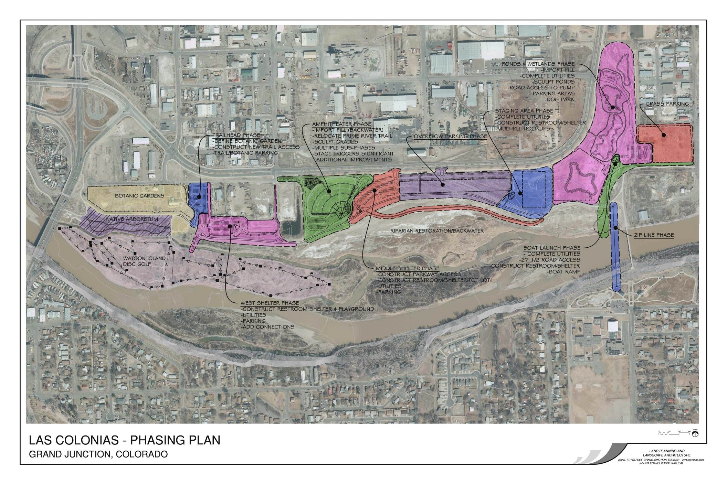
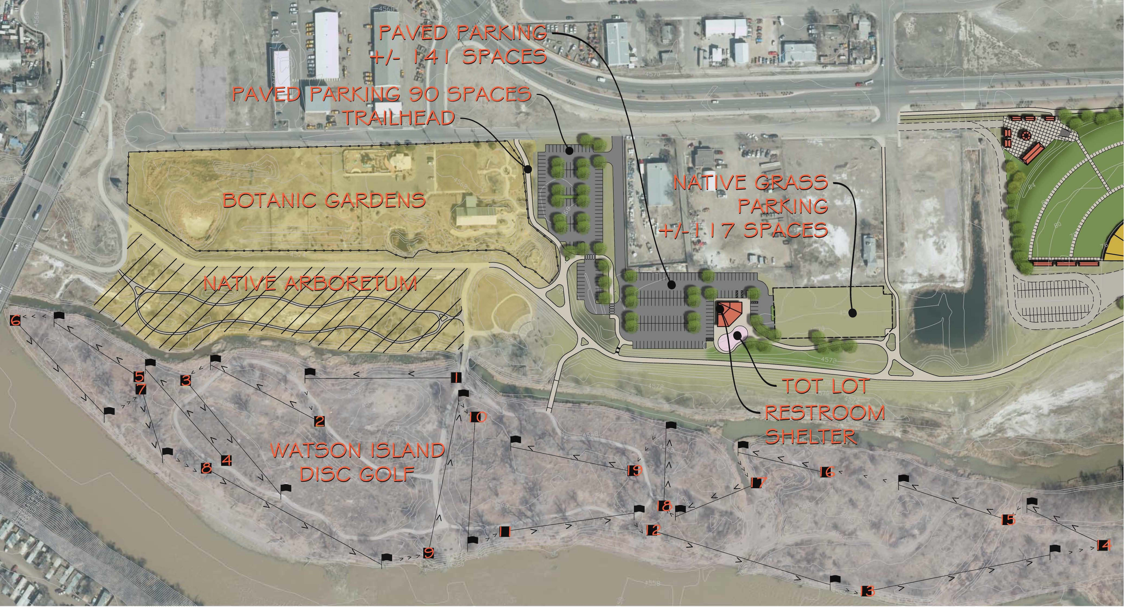
West Shelter/Trailhead/Watson Island
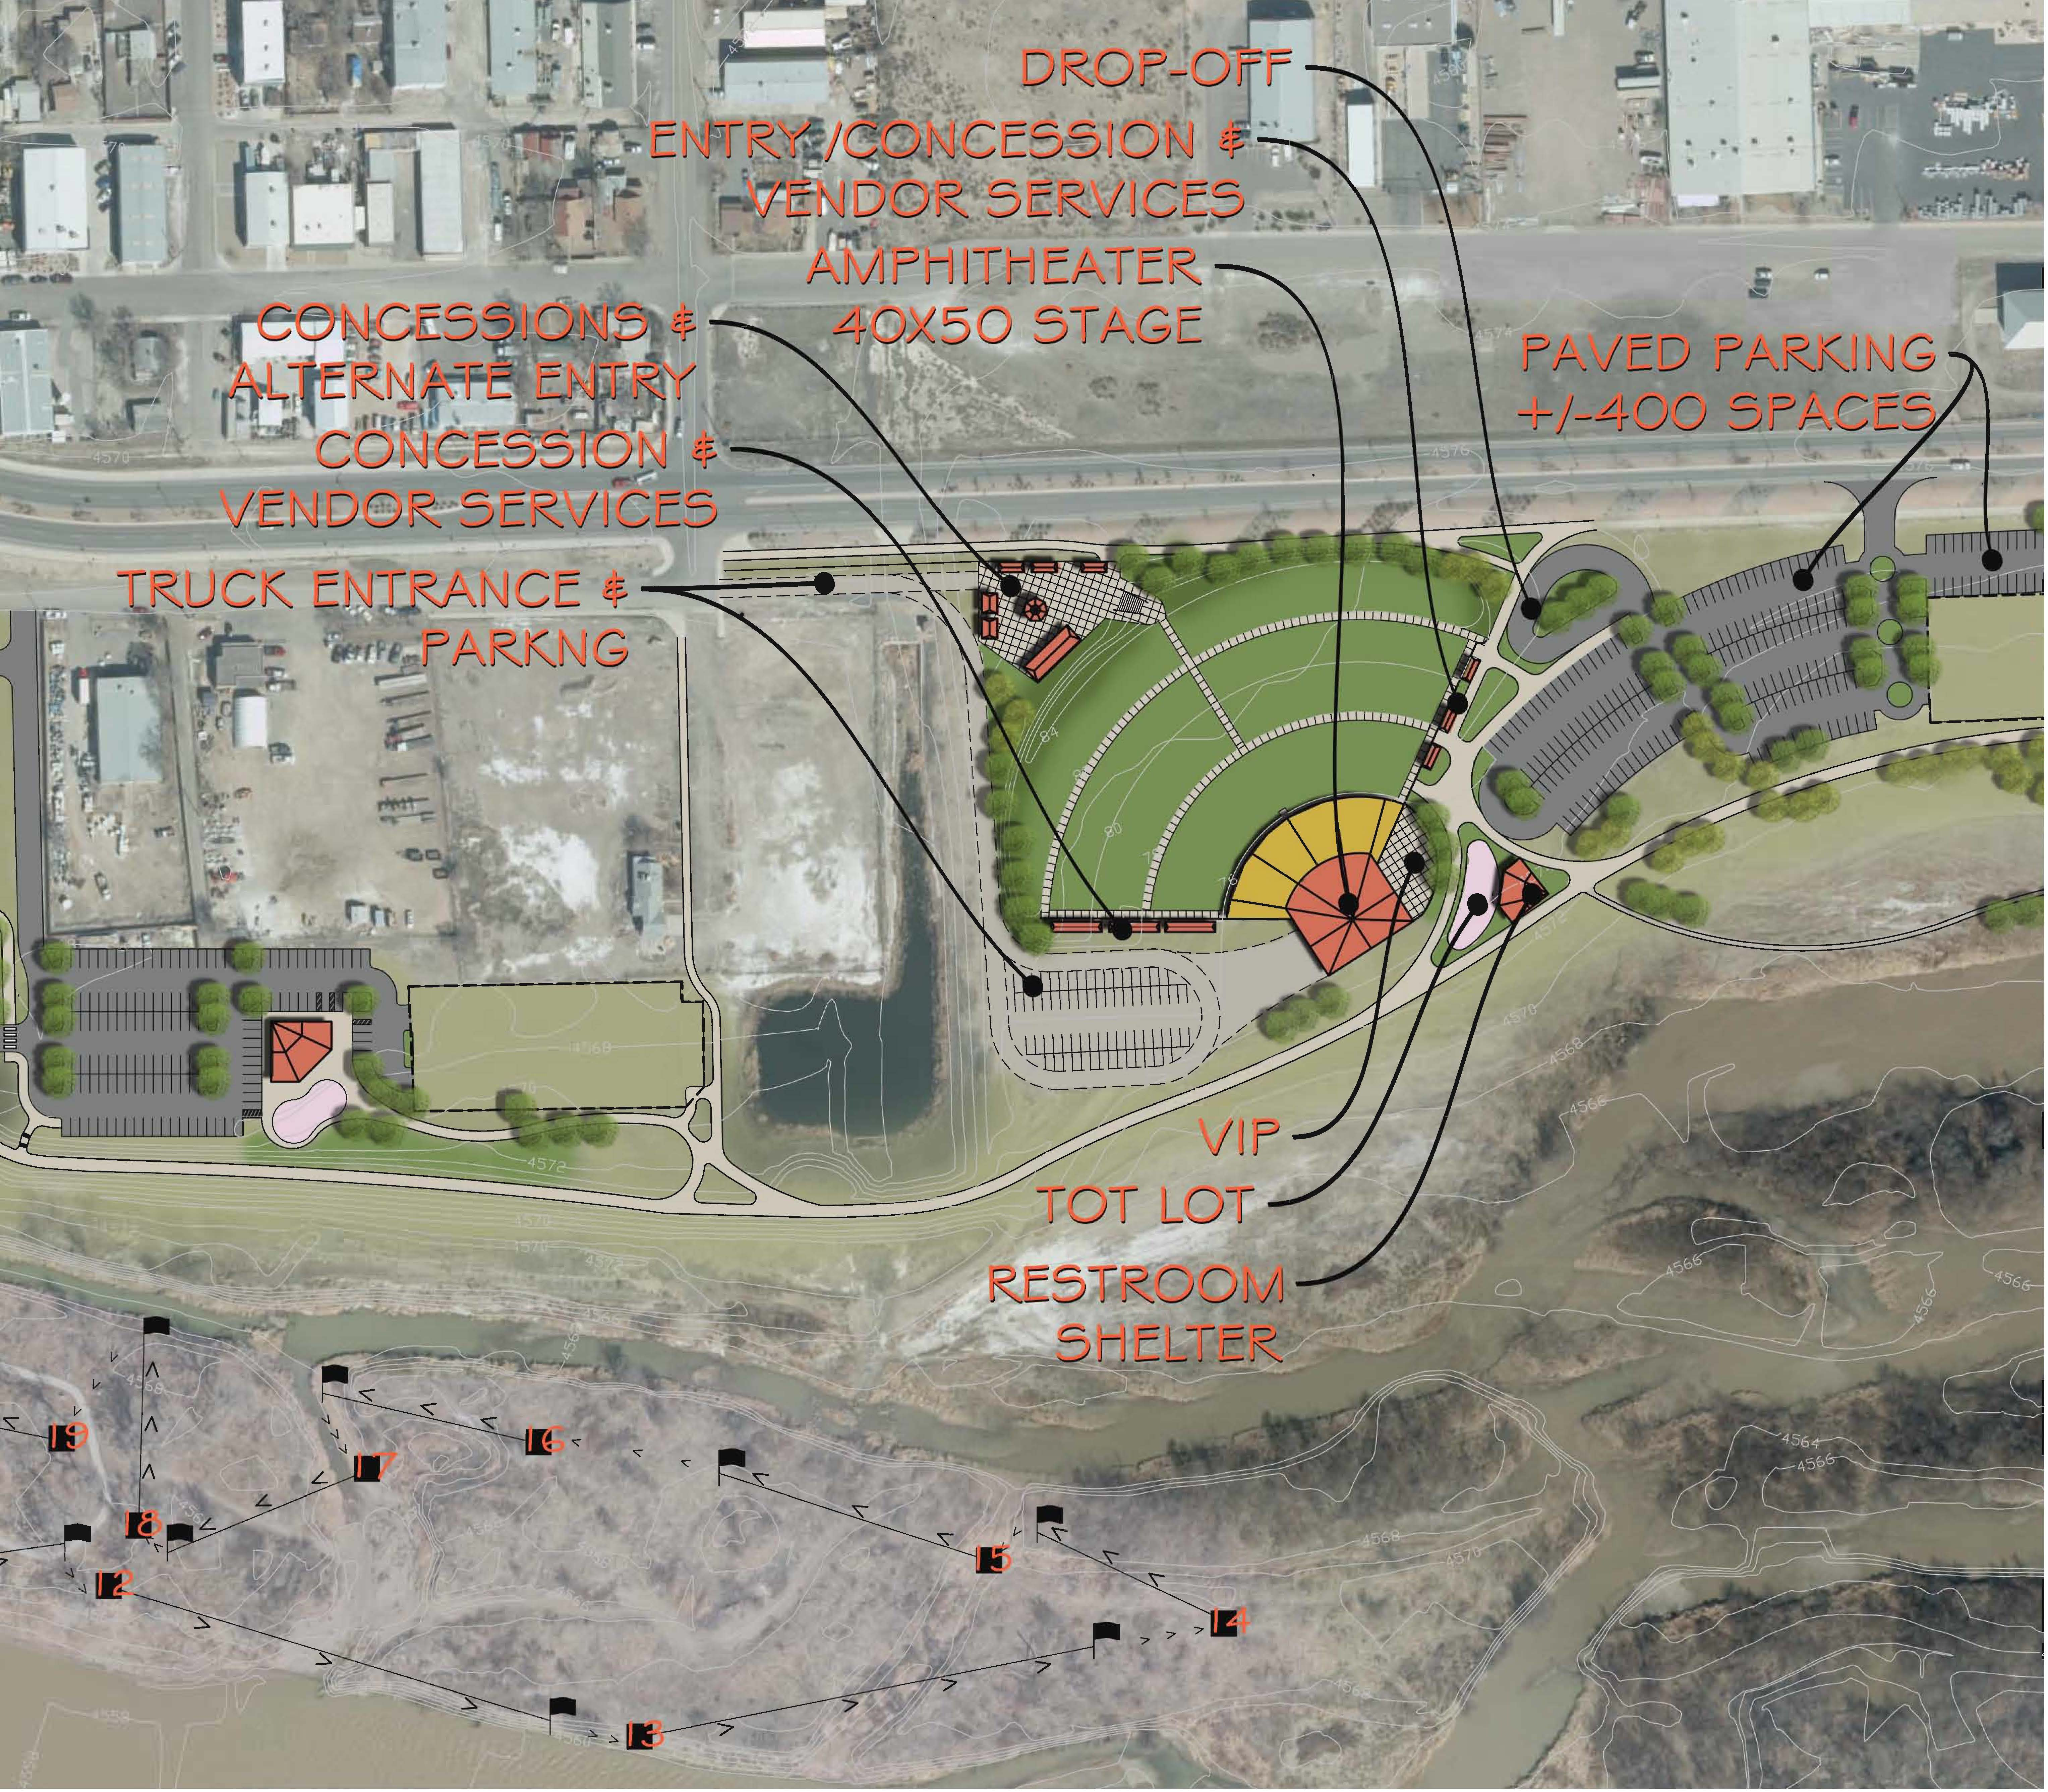
Figure 1 - Native Arboretum/Disc Golf/Trailhead/West Shelter Phases

Amphitheater
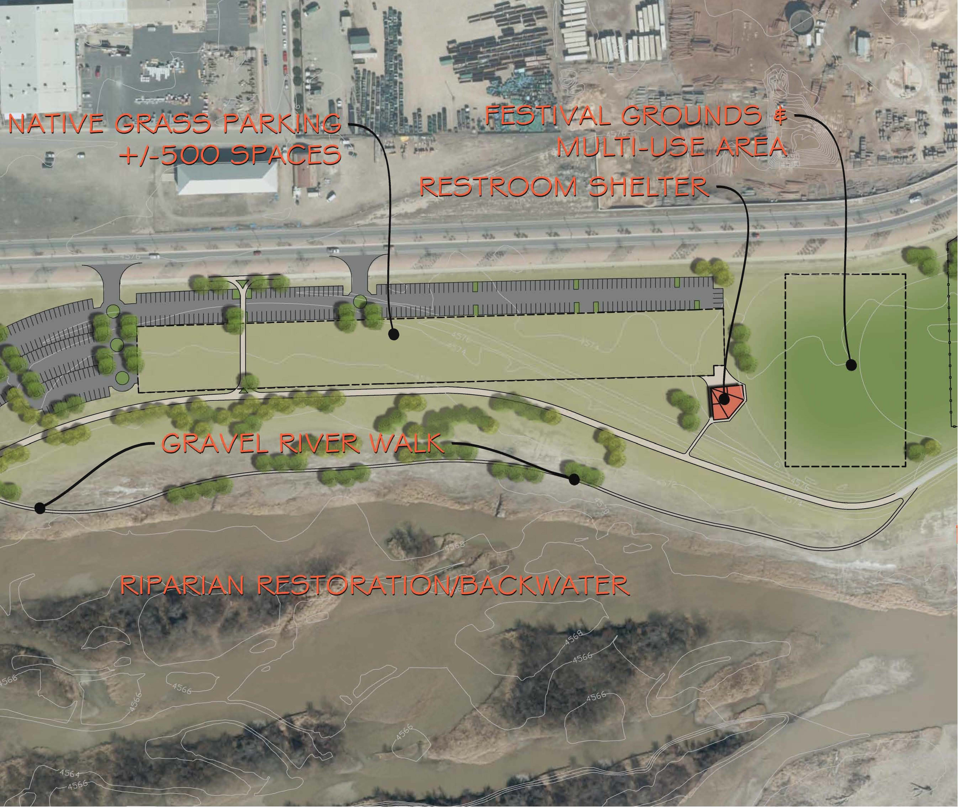
Figure 2 – Amphitheater Phase

Backwater and Multi Use Area

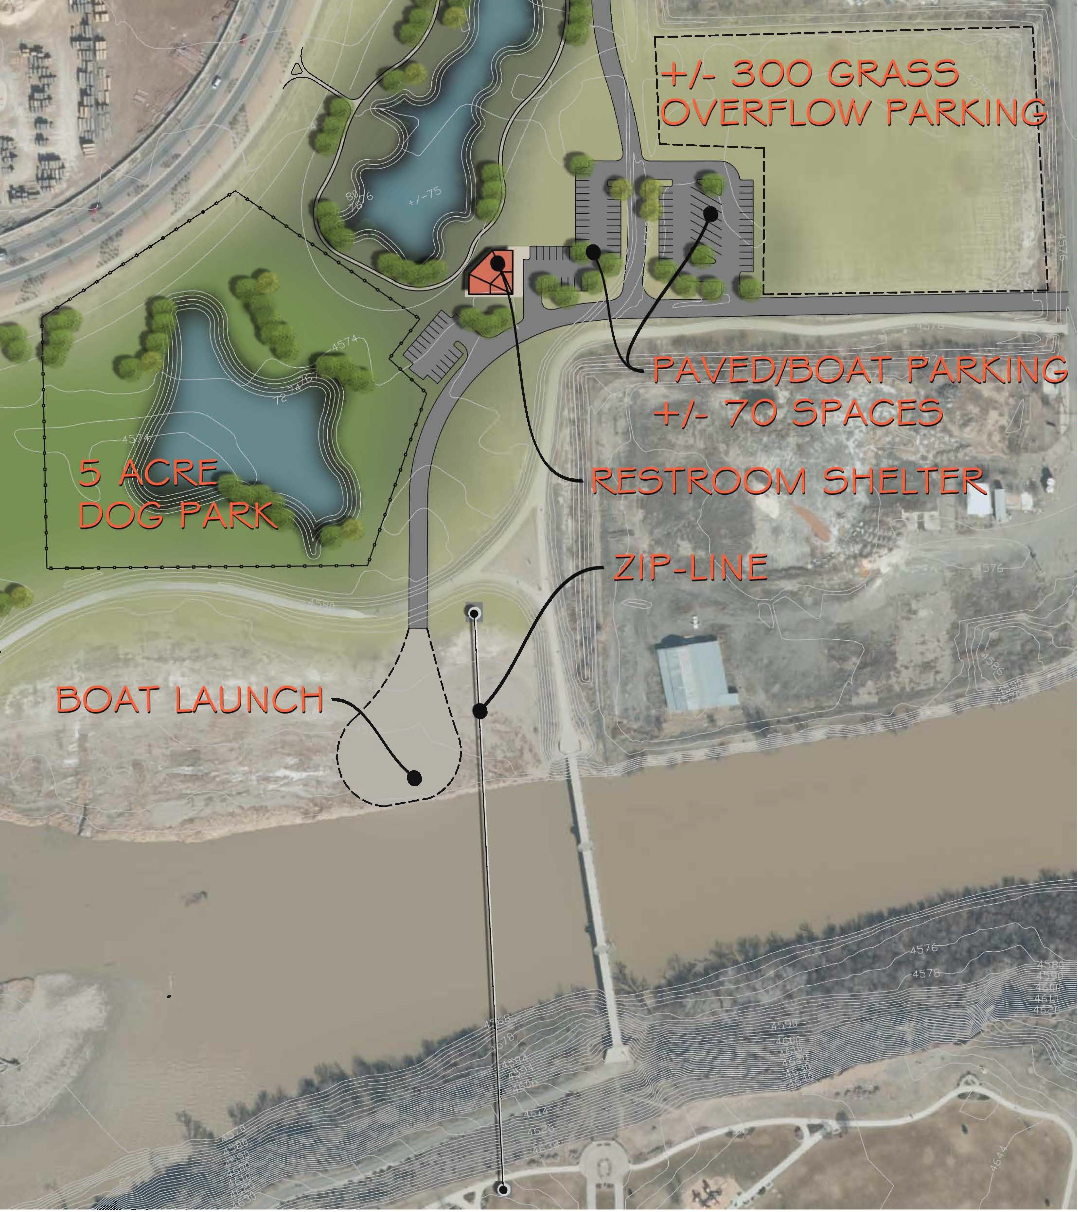

Figure 3 – Parking/Multipurpose Phase

Zipline/Boat Launch/Overflow Parking Wetlands and Dog Park
