CITY OF GRAND JUNCTION

ORDINANCE NO. 3928

AN ORDINANCE VACATING RIGHTS-OF-WAY FOR PORTIONS OF HOESCH STREET AND WEST GRAND AVENUE

RECITALS:

A vacation of the dedicated right-of-way for a portion of Hoesch Street and West Grand Avenue has been requested by the City of Grand Junction.

WDD Properties, LLLP, ("WDD") is the owner of some of the land to which the vacated right-of-way will revert. WDD has an application before the City to do a subdivision which will include the vacated right-of-way. The subdivision plat will also include a dedication of right-of-way from WDD to the City for the Riverside Parkway. The vacation of the right-of-way shall be conditioned upon a subdivision plat being recorded granting the right-of-way required for Riverside Parkway from the land owned by WDD with City approval.

Hoesch Street was originally dedicated as a public street in 1894 as a part of The Grand River Subdivision with a total of 18’. An additional 10’ was dedicated in 1980 as a part of the West Grand Subdivision. While the right-of-way width is now at 28’ it does not meet the 44’ minimum required for a commercial street. The street has approximately 23’ of pavement; minimum requirement for an alley is 20’. The street functions more like an alley rather than a street for purposes of circulation (trash truck traffic, rear yard access). It has been determined by the Public Works Department that this section of right-of-way is not needed as a full street and can adequately function as an alley.

The Planning Commission, having heard and considered the request, found the criteria of the Code to have been met, and recommends that the vacation.

The City Council finds that the request is consistent with the Growth Plan, the Grand Valley Circulation Plan and Section 2.11 of the Zoning and Development Code.
NOW, THEREFORE BE IT ORDAINED BY THE CITY COUNCIL OF THE CITY OF GRAND JUNCTION THAT:

The following described dedicated right-of-way is hereby vacated upon the recording of a plat dedicating the right-of-way determined necessary by staff for the Riverside Parkway:

The following right-of-way is shown on Exhibit “A” – “D” respectively as part of this vacation of description.

Dedicated right-of-way to be vacated:

“A” - A portion of West Grand Avenue between River Road (dedicated as West Street) and Hoesch Street as shown on THE GRAND RIVER SUBDIVISION, recorded at Reception Number 18387 in the Mesa County Clerk and Recorder's Office, lying in the SE1/4 of SEC 15, T1S, R1W of the UM, being more particularly described as follows: Commencing at the Center ¼ COR of said SEC 15, (a 3" aluminum cap stamped "MESA COUNTY SURVEY MARKER c1/4-S15-LS 32824-2003") whence the Center East1/16 COR of said SEC 15, (a brass cap stamped "E1/16-S15-543-2280")bears N89°39'30"E (Basis-of-Bearing Assumed) a DIS of 1323.42 ft; thence S83°34'07"E a DIS of 329.15 ft to a pt on the extension of the westerly line of Block 6 of said THE GRAND RIVER SUBDIVISION, being the POB; thence N00°03'54"E along the extension of the westerly line of said Block 6 a DIS of 17.73 ft; thence N71°57'55"E a DIS of 52.92 ft; thence S79°48'20"E a DIS of 24.03 ft; thence S40°26'24"E a DIS of 45.88 ft; thence S89°39'30"W along the northerly line of said Block 6 a DIS of 18.30 ft; thence N40°26'24"W a DIS of 25.56 ft; thence S89°59'42"W a DIS of 34.21 ft; thence S71°57'55"W a DIS of 36.44 ft to the POB. Containing 1660 sq ft (0.038 acres) more or less.
“B” - A portion of West Grand Avenue between River Road (dedicated as West Street) and Hoesch Street as shown on THE GRAND RIVER SUBDIVISION, recorded at Reception Number 18387 in the Mesa County Clerk and Recorder's Office, lying in the SE1/4 of SEC 15, T1S, R1W of the UM, being more particularly described as follows: Commencing at the Center ¼ COR of said SEC 15, (a 3" aluminum cap stamped "MESA COUNTY SURVEY MARKER C1/4-S15-LS 32824-2003") whence the Center East1/16 COR of said SEC 15, (a brass cap stamped "E1/16-S15-543-2280")bears N89°39'30"E (Basis-of-Bearing Assumed) a DIS of 1323.42 ft; thence S83°34'07"E a DIS of 329.15 ft to a pt on the extension of the westerly line of Block 6 of said THE GRAND RIVER SUBDIVISION, being the POB; thence N71°57'55"E a DIS of 36.44 ft; thence N89°59'42"E a DIS of 34.21ft; thence S40°4826'24"E a DIS of 25.56 ft; thence S89°39'30"W along the northerly line of said Block 6 DIS of 85.45 ft; thence N00°03'54"E along the extension of the westerly line of said Block 6 a DIS of 85.45 ft; thence N00°03'54"E along the extension of the westerly line of said Block 6 a DIS of 8.68 ft; to the POB. Containing 1327 sq ft (0.030 acres) more or less.

“C” - A parcel of land being a portion of Hoesch Street lying between West Grand Avenue and West White Avenue in the Southeast Quarter of Section 15, T1S, R1W of the Ute Meridian, City of Grand Junction, Mesa County, Colorado being more particularly described as follows: COMMENCING at the Center Quarter Corner of said Section 15 (3” aluminum cap stamped “T1S R1W C ¼ S 15 2003 NO. 1271-2 LS 23824”); WHENCE Center-East Sixteenth Corner of said Section 15 (a 2 ½” brass cap stamped “E1/16 S 15 543 2280”) bears N89°39’30”E (Basis of Bearing-assumed) a distance of 1323.42 feet; THENCE S71°21’23”E a distance of 529.72 feet to the southeast corner of Lot 1 Block 6 of THE GRAND RIVER SUBDIVISION, recorded May 2, 1894 in Plat Book 1 at Page 29 in the Mesa County Clerk and Recorder’s Office, being the POINT OF BEGINNING; THENCE N00°03’54”E along the easterly line of said Lot 1 a distance of 40.93 feet; THENCE S40°26’24”E along the southerly right-of-way line of the Riverside Parkway a distance of 42.43 feet; THENCE S00°23’25”E along the westerly line of Lot 1 of the WEST GRAND SUBDIVISION, recorded April 11, 1980 in Plat Book 12 at Page 250 in the Mesa County Clerk and Recorder’s Office, non-tangent with the following described curve a distance of 36.456 feet; THENC along the arc of a curve to the left, having a central angel of 89°13’58”, a radius of 28.00 feet, a chord bearing N45°00’22”W a distance of 39.33 feet, and an arc distance of 43.61 feet to the POINT OF BEGINNING. Containing 0.019 acres (849 sq ft) more or less.

“D” - A parcel of land being a portion of Hoesch Street lying between West White Avenue and Highway 340, in the Southeast Quarter of Section 15, T1S R1W of the Ute Meridian, City of Grand Junction, Mesa County, Colorado being more particularly described as follows: COMMENCING at the Center Quarter Corner of said Section 15 (3” aluminum cap stamped “T1S R1W C ¼ S 15 2003 NO. 1271-2 LS 23824”); WHENCE Center-East Sixteenth Corner of said Section 15 (a 2 ½” brass cap stamped “E1/16 S 15 543 2280) bears N89°39’30” (Basis of Bearing-assumed) a distance of 1323.42 feet; THENCE S51°55’35”E a distance of 660.03 feet the POINT OF BEGINNING; THENCE S00°16’56”W along the westerly line of Lot 2 of the WEST GRAND SUBDIVISION, recorded April 11, 1980 in Plat Book 12 at Page 250 in the Mesa County Clerk and Recorder’s Office, a distance of 82.42 feet; THENCE S56°43’45”W along the northerly right-of-way line of Highway 340 a distance of 21.60 feet to the southeast corner of Lot 1, of Block 5 of THE GRAND RIVER SUBDIVISION, recorded May 2, 1894 in Plat Book 1 at Page 29 in the Mesa County Clerk and Recorder’s Office; THENCE N00°16’56”E along the easterly line of said Lot 1 a distance of 94.28 feet; THENCE S89°57’36”E a distance of 18.00 feet to the POINT OF BEGINNING. Containing 0.037 acres (1590 sq ft), more or less.

HENCEFORTH, Hoesch Street is designated as an alley.

Introduced for first reading on this 19th day of June, 2006

PASSED and ADOPTED this 5th day of July, 2006.

ATTEST:
/s/ James J. Doody
President of City Council

/s/ Stephanie Tuin
City Clerk
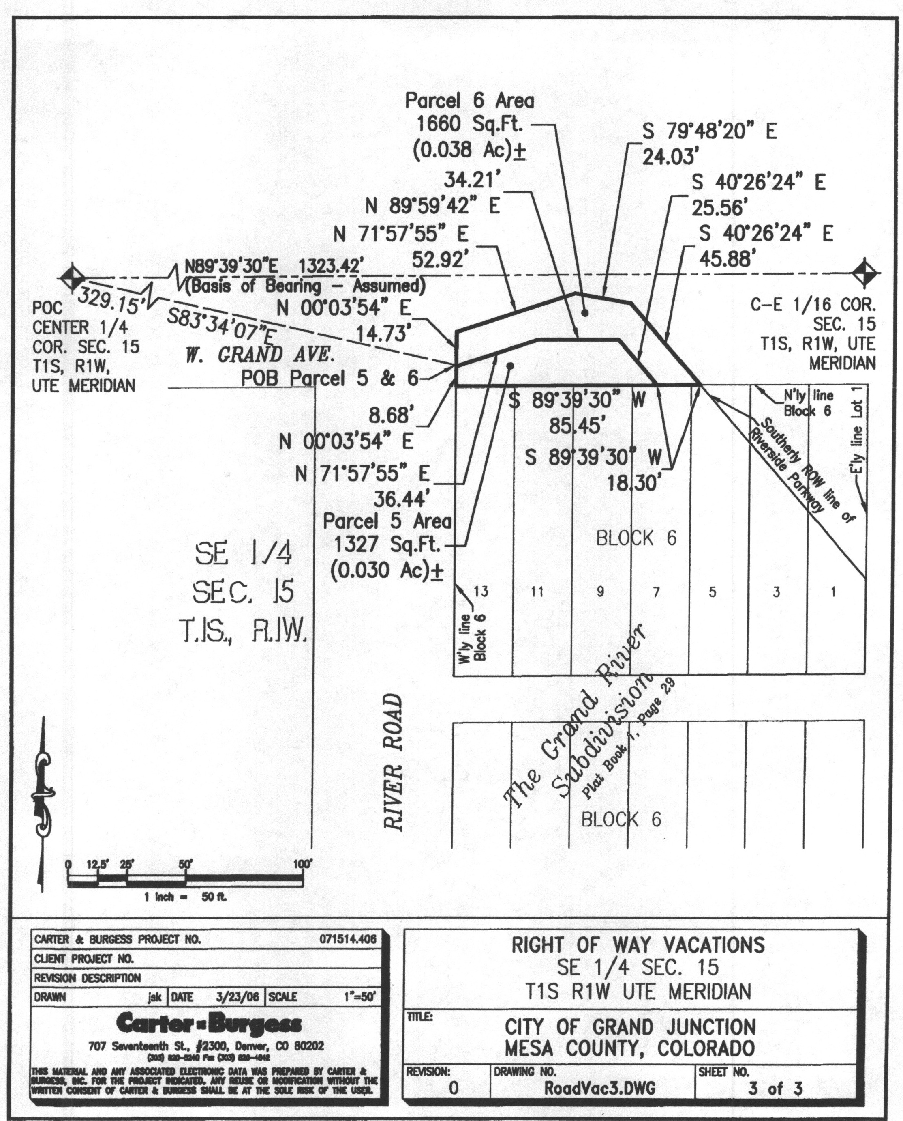
Exhibit “A”
Exhibit “B”
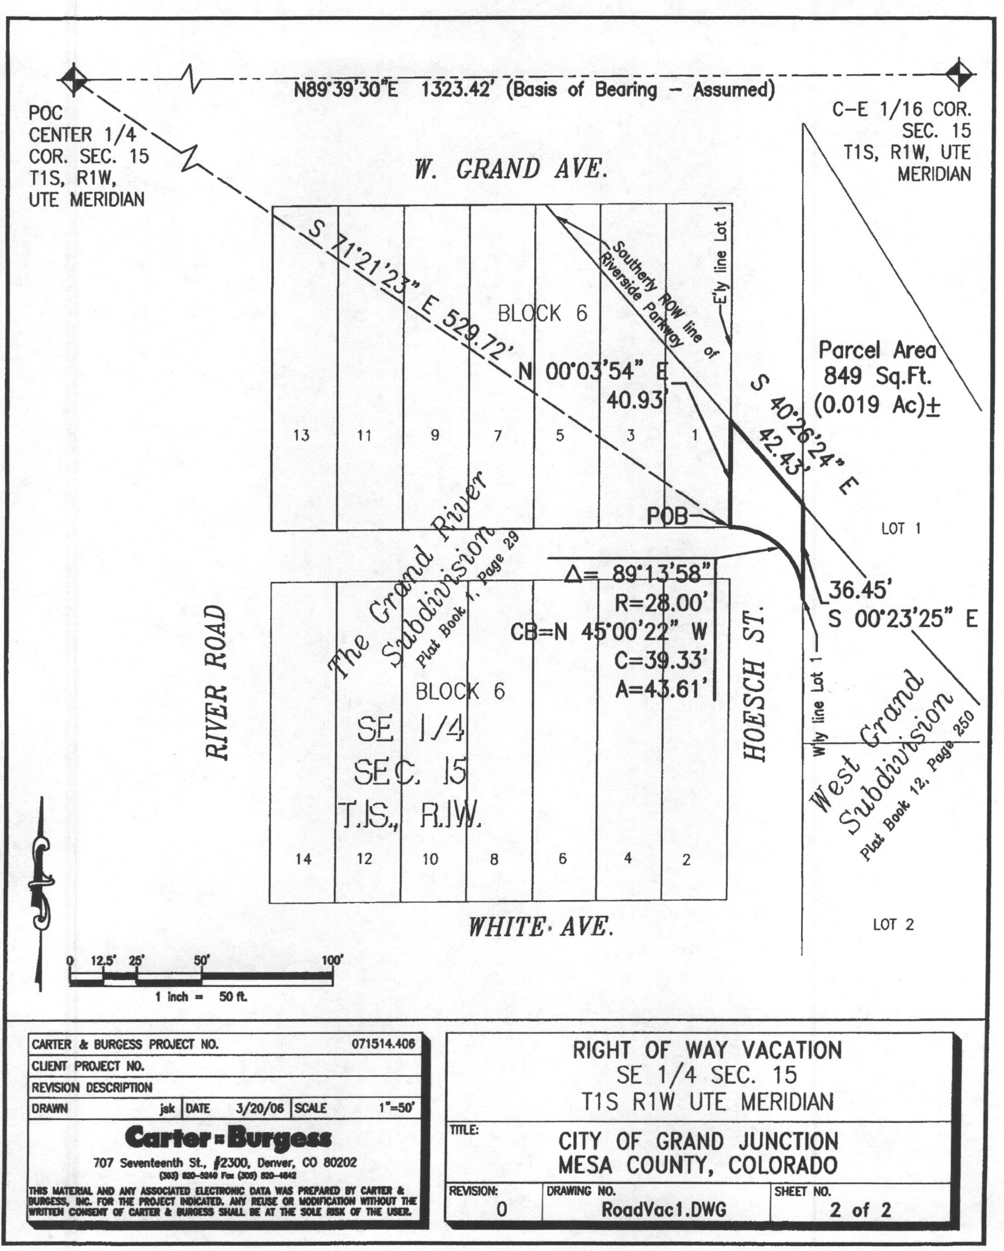
Exhibit “C”
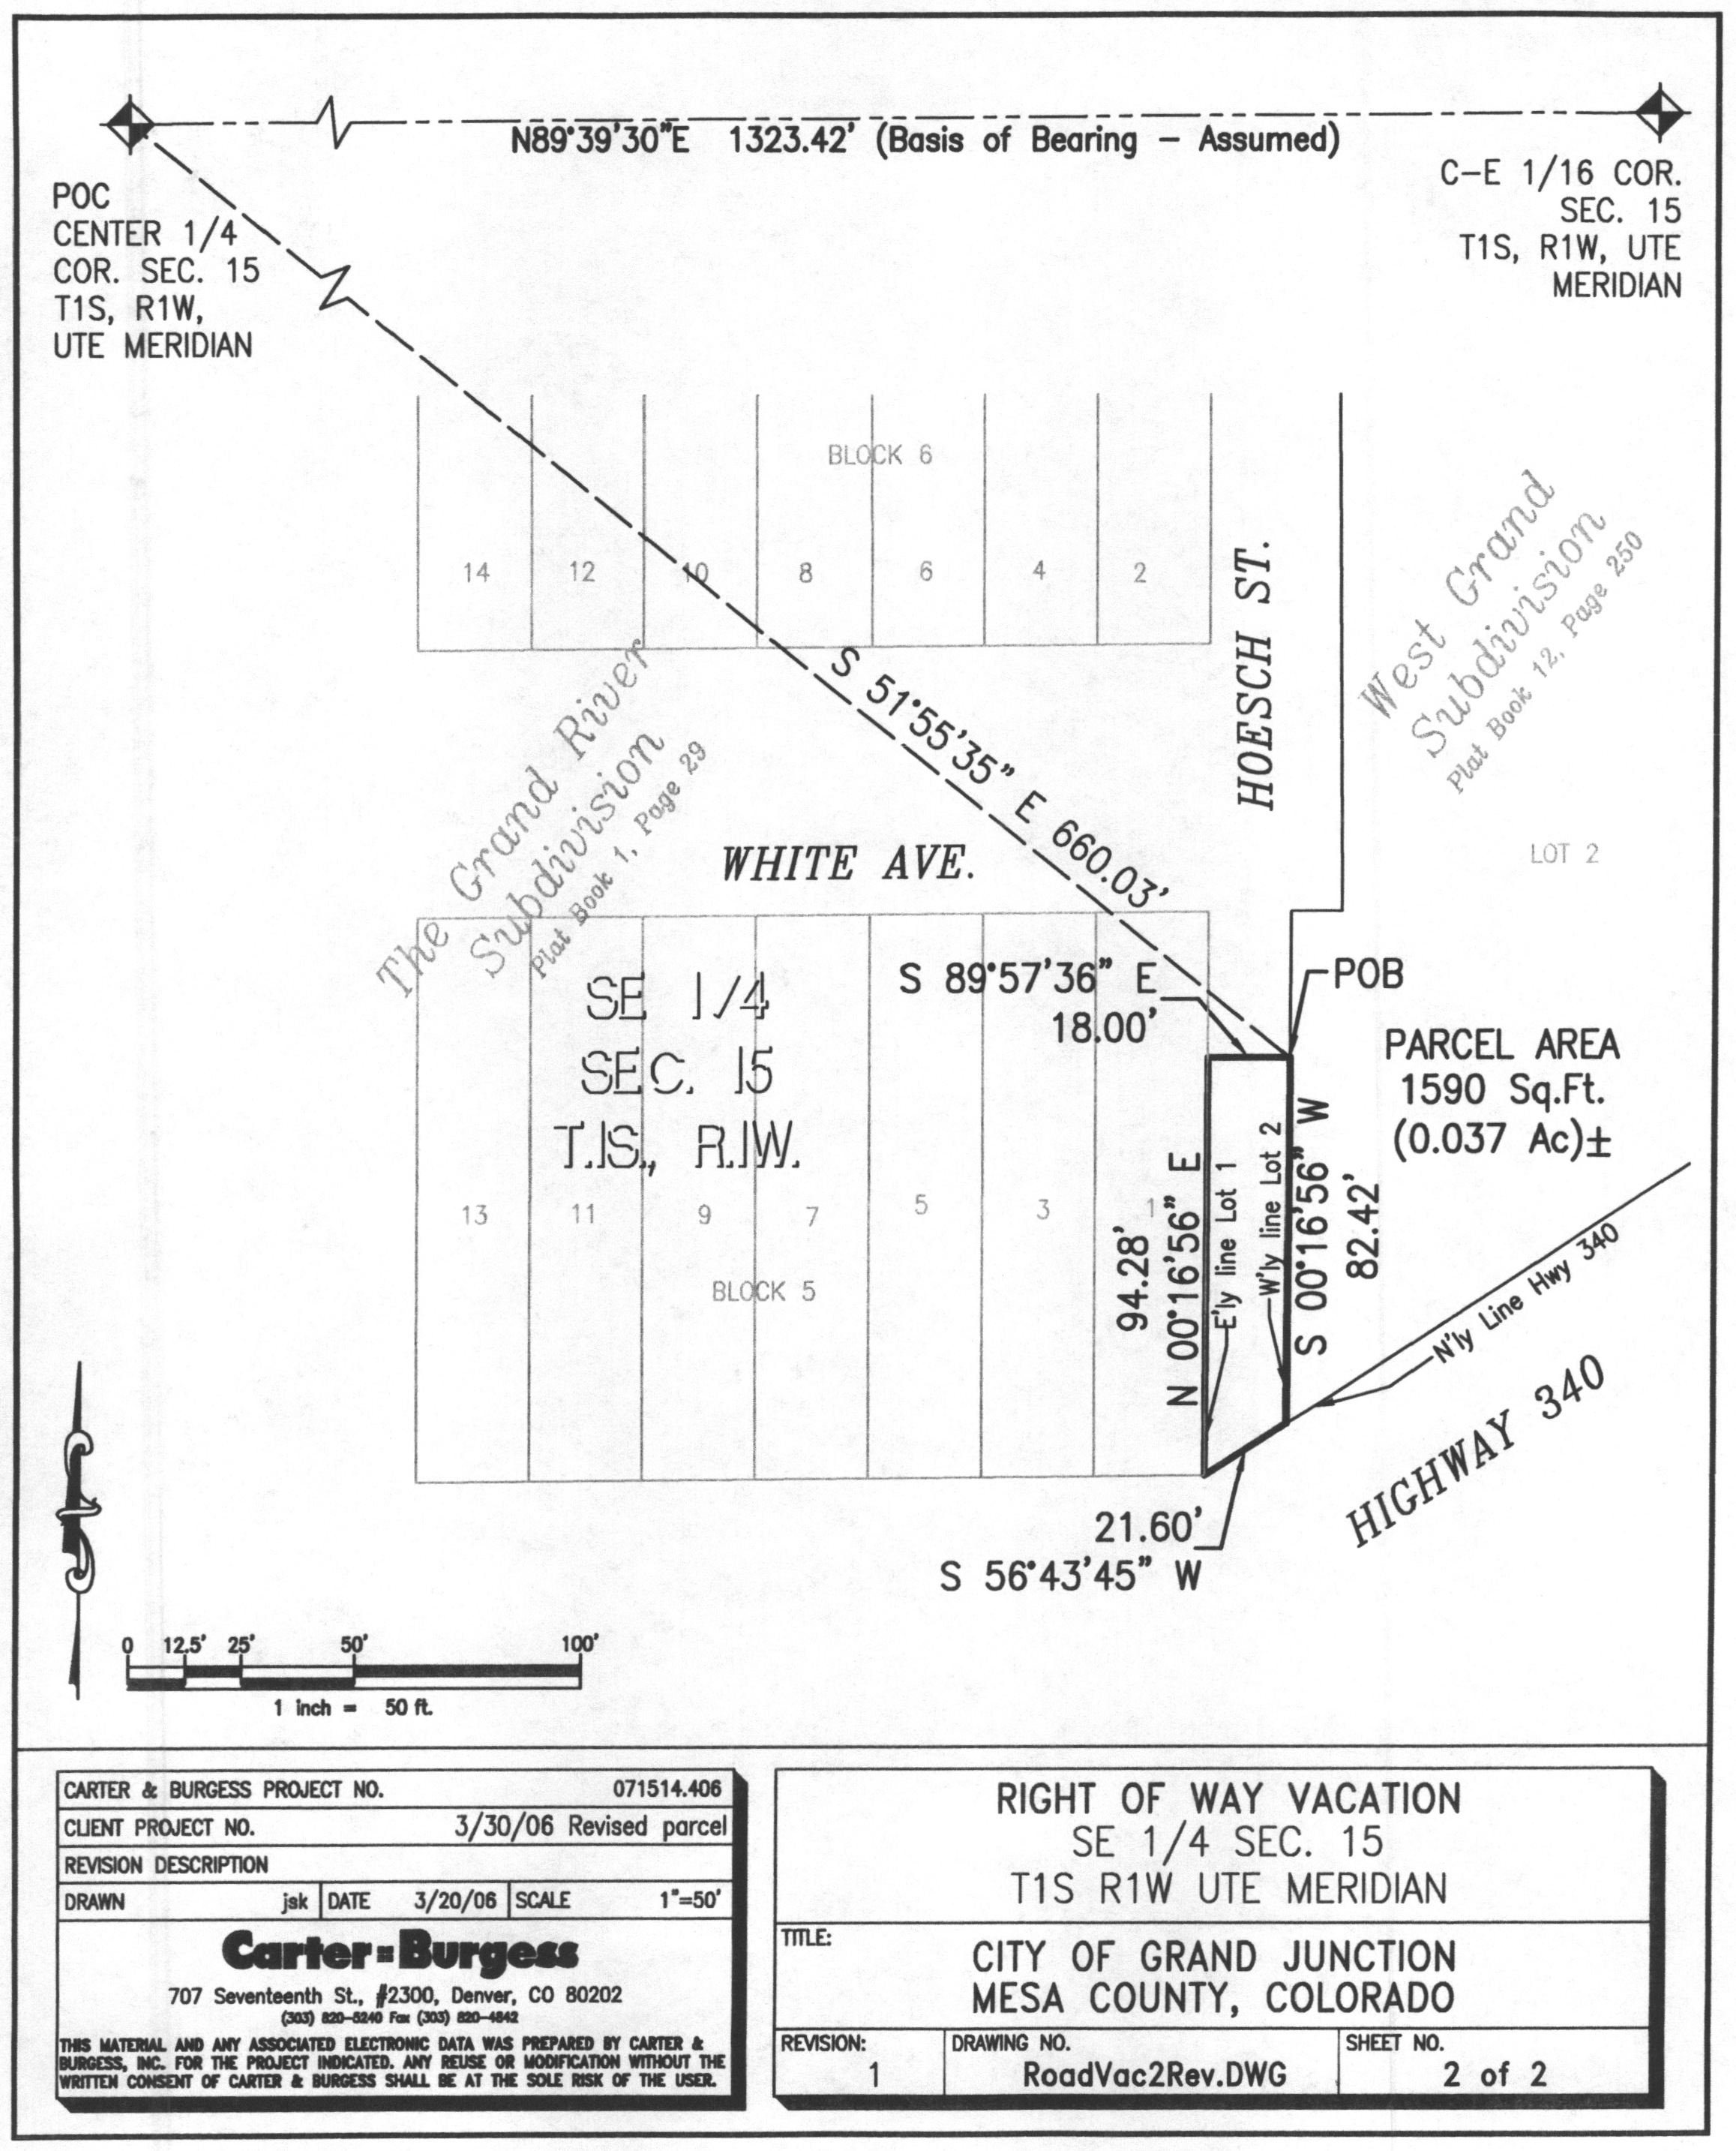
Exhibit “D”

