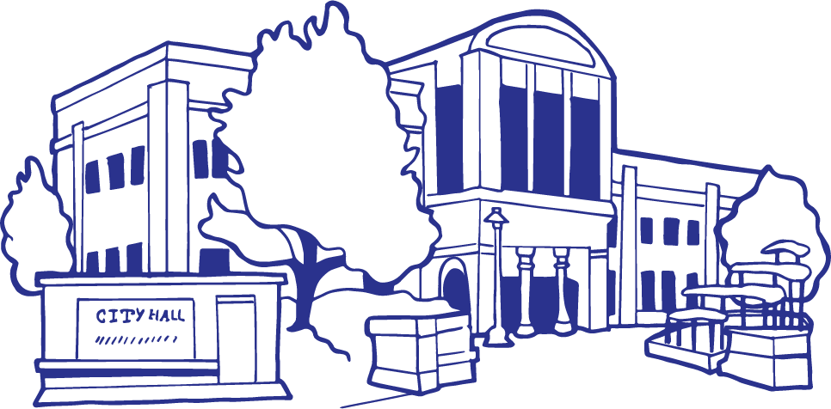
City of Grand Junction, State of Colorado
Proclamation
Whereas, | public works professionals focus on infrastructure, facilities and services that are of vital importance to sustainable and resilient communities and to the public health, high quality of life and well-being of the people of Grand Junction, Colorado; and
Whereas, | these infrastructure, facilities and services could not be provided without the dedicated efforts of public works professionals, who are engineers, managers, and employees at all levels of government and the private sector, who are responsible for rebuilding, improving, and protecting our nation’s transportation, water supply, water treatment and solid waste systems, public buildings, and other structures and facilities essential for our citizens; and
Whereas, | it is in the public interest for the citizens, civic leaders and children in Grand Junction to gain knowledge of and to maintain an ongoing interest and understanding of the importance of public works and public works programs in their respective communities; and
Whereas, | the year 2023 marks the 63rd annual National Public Works Week sponsored by the American Public Works Association/Canadian Public Works Association.
NOW, THEREFORE, I, Anna Stout, by the power vested in me as Mayor of the City of Grand Junction, do hereby proclaim May 21–27, 2023 as
“National Public Works Week”
in the City of Grand Junction and urge all citizens to join with representatives of the American Public Works Association and government agencies in activities, events, and ceremonies designed to pay tribute to our public works professionals, engineers, managers, and employees and to recognize the substantial contributions they make to protecting our national health, safety, and quality of life.
 |  | IN WITNESS WHEREOF, I have hereunto set my hand and caused to be affixed the official Seal of the City of Grand Junction this 17th day of May 2023.
 |  | Mayor

