CITY OF GRAND JUNCTION

ORDINANCE NO. 3960

AN ORDINANCE AMENDING AND CORRECTING ORDINANCE NO. 3898

VACATING RIGHTS-OF-WAY FOR AN ALLEYWAY

LOCATED AT THE EASTERN 250’ OF THE EAST/WEST ALLEY AND THE NORTH/SOUTH ALLEY BETWEEN 6TH AND 7TH STREETS AND PITKIN AND SOUTH AVENUES

MESA COUNTY CORRECTION AND TREATMENT FACILITY – 636 SOUTH AVENUE

RECITALS:

A vacation of the dedicated right-of-way for has been requested by the adjoining property owners.

The Planning Commission, having heard and considered the request, found the criteria of the Code to have been met, and recommends that the vacation be approved.

The City Council finds that the request is consistent with the Growth Plan, the Grand Valley Circulation Plan and Section 2.11 of the Zoning and Development Code. The utilities within the right-of-way to be vacated are to be relocated and new easements dedicated. This ordinance is not effective until the existing utilities are relocated and accepted and the new easement deeds recorded.

NOW, THEREFORE BE IT ORDAINED BY THE CITY COUNCIL OF THE CITY OF GRAND JUNCTION THAT:

Ordinance 3898 is amended and corrected to vacate the following described dedicated right-of-way subject to the listed following conditions:

- Applicants shall pay all recording/documentary fees for the Vacation Ordinance, any easement documents and dedication documents.
- The vacating ordinance is not effective until the utilities are relocated, inspected and accepted; and, required utility easements are dedicated and deeds are recorded.
- The right-of-way shown on “Exhibit B” will be retained as a Utility Easement.

The following right-of-way is shown on “Exhibit A” as part of this vacation of description.

Dedicated right-of-way to be vacated:

A part of the alleys in Block 149 of the Grand Junction Colo. Second Division Survey as Amended, recorded in the Mesa County records, January 22, 1909 at Reception No. 80773; said vacation being described as follows:

Beginning at the southeast corner of Lot 15 of said Block 149;
Thence South 00°04'34" West, a distance of 20.00 feet to the southeast corner of the east-west alley in said Block 149;
Thence along the south line of said alley, North 89°50'18" West, a distance of 205.87 feet;
Thence North 00°02'59" East, a distance of 20.00 feet to the north line of said alley;
Thence South 89°50'18" East, a distance of 55.52 feet to the southeast corner of Lot 10 of said Block 149;
Thence North 00°03'43" East, a distance of 125.89 feet to the northeast corner of said Lot 10;
Thence South 89°49'01" East, a distance of 15.00 feet to the northwest corner of Lot 11 of said Block 149;
Thence South 00°03'43" West, a distance of 125.88 feet to the southwest corner of said Lot 15;
Thence South 89°50'18" East, a distance of 135.36 feet to the Point of Beginning.

Containing 0.138 acres, more or less.

AND all of a ten foot road right-of-way described in a document recorded in Book 361 at Page 211; In the City of Grand Junction, Mesa County, Colorado.

The following as depicted on “Exhibit B” is to be retained as a Utility Easement.

A parcel of land situated in Block 149 of the Grand Junction Colo. Second Division Survey as Amended, recorded in the Mesa County records, January 22, 1909 at Reception No. 80773; being a part of Lots 8, 9, 10 and the vacated alleys of said Block 149 and being described as follows:

Beginning at a point on the east line of said Lot 10, whence the southeast corner of said Lot 10 bears South 00º03'43" West, a distance of 12.56 feet;
Thence North 89°51'31" East, a distance of 7.50 feet to the centerline of the vacated north-south alley through said Block 149 as it adjoins said Lot 10;
Thence along the centerline of said vacated alley, South 00°03'43" West, a distance of 22.60 feet to the centerline of the vacated east-west alley through said Block 149;
Thence along the centerline of said vacated alley, North 89°50'18" West, a distance of 63.01 feet to the west line of said vacated alley;
Thence along said west line and its extension into Lot 8 of said Block 149, North 00°02'59" East, a distance of 10.74 feet to a point which is 0.76 feet north of the south line of said Lot 8;
Thence South 89°47'26" East, a distance of 55.27 feet to a point which is 0.69 feet north and 0.24 feet west of the southeast corner of said Lot 10;
Thence North 00°13'17" East, a distance of 11.86 feet to a point which is 0.21 feet west of the east line of said Lot 10;
Thence North 89°51'31" East, a distance of 0.21 feet to the Point of Beginning.

Containing 767 sq ft (0.018 acres), more or less.

Introduced for first reading on this 2nd day of August, 2006

PASSED and ADOPTED this 16th day of August, 2006.

ATTEST:
/s/: James J. Doody
President of City Council

/s/: Stephanie Tuin
City Clerk
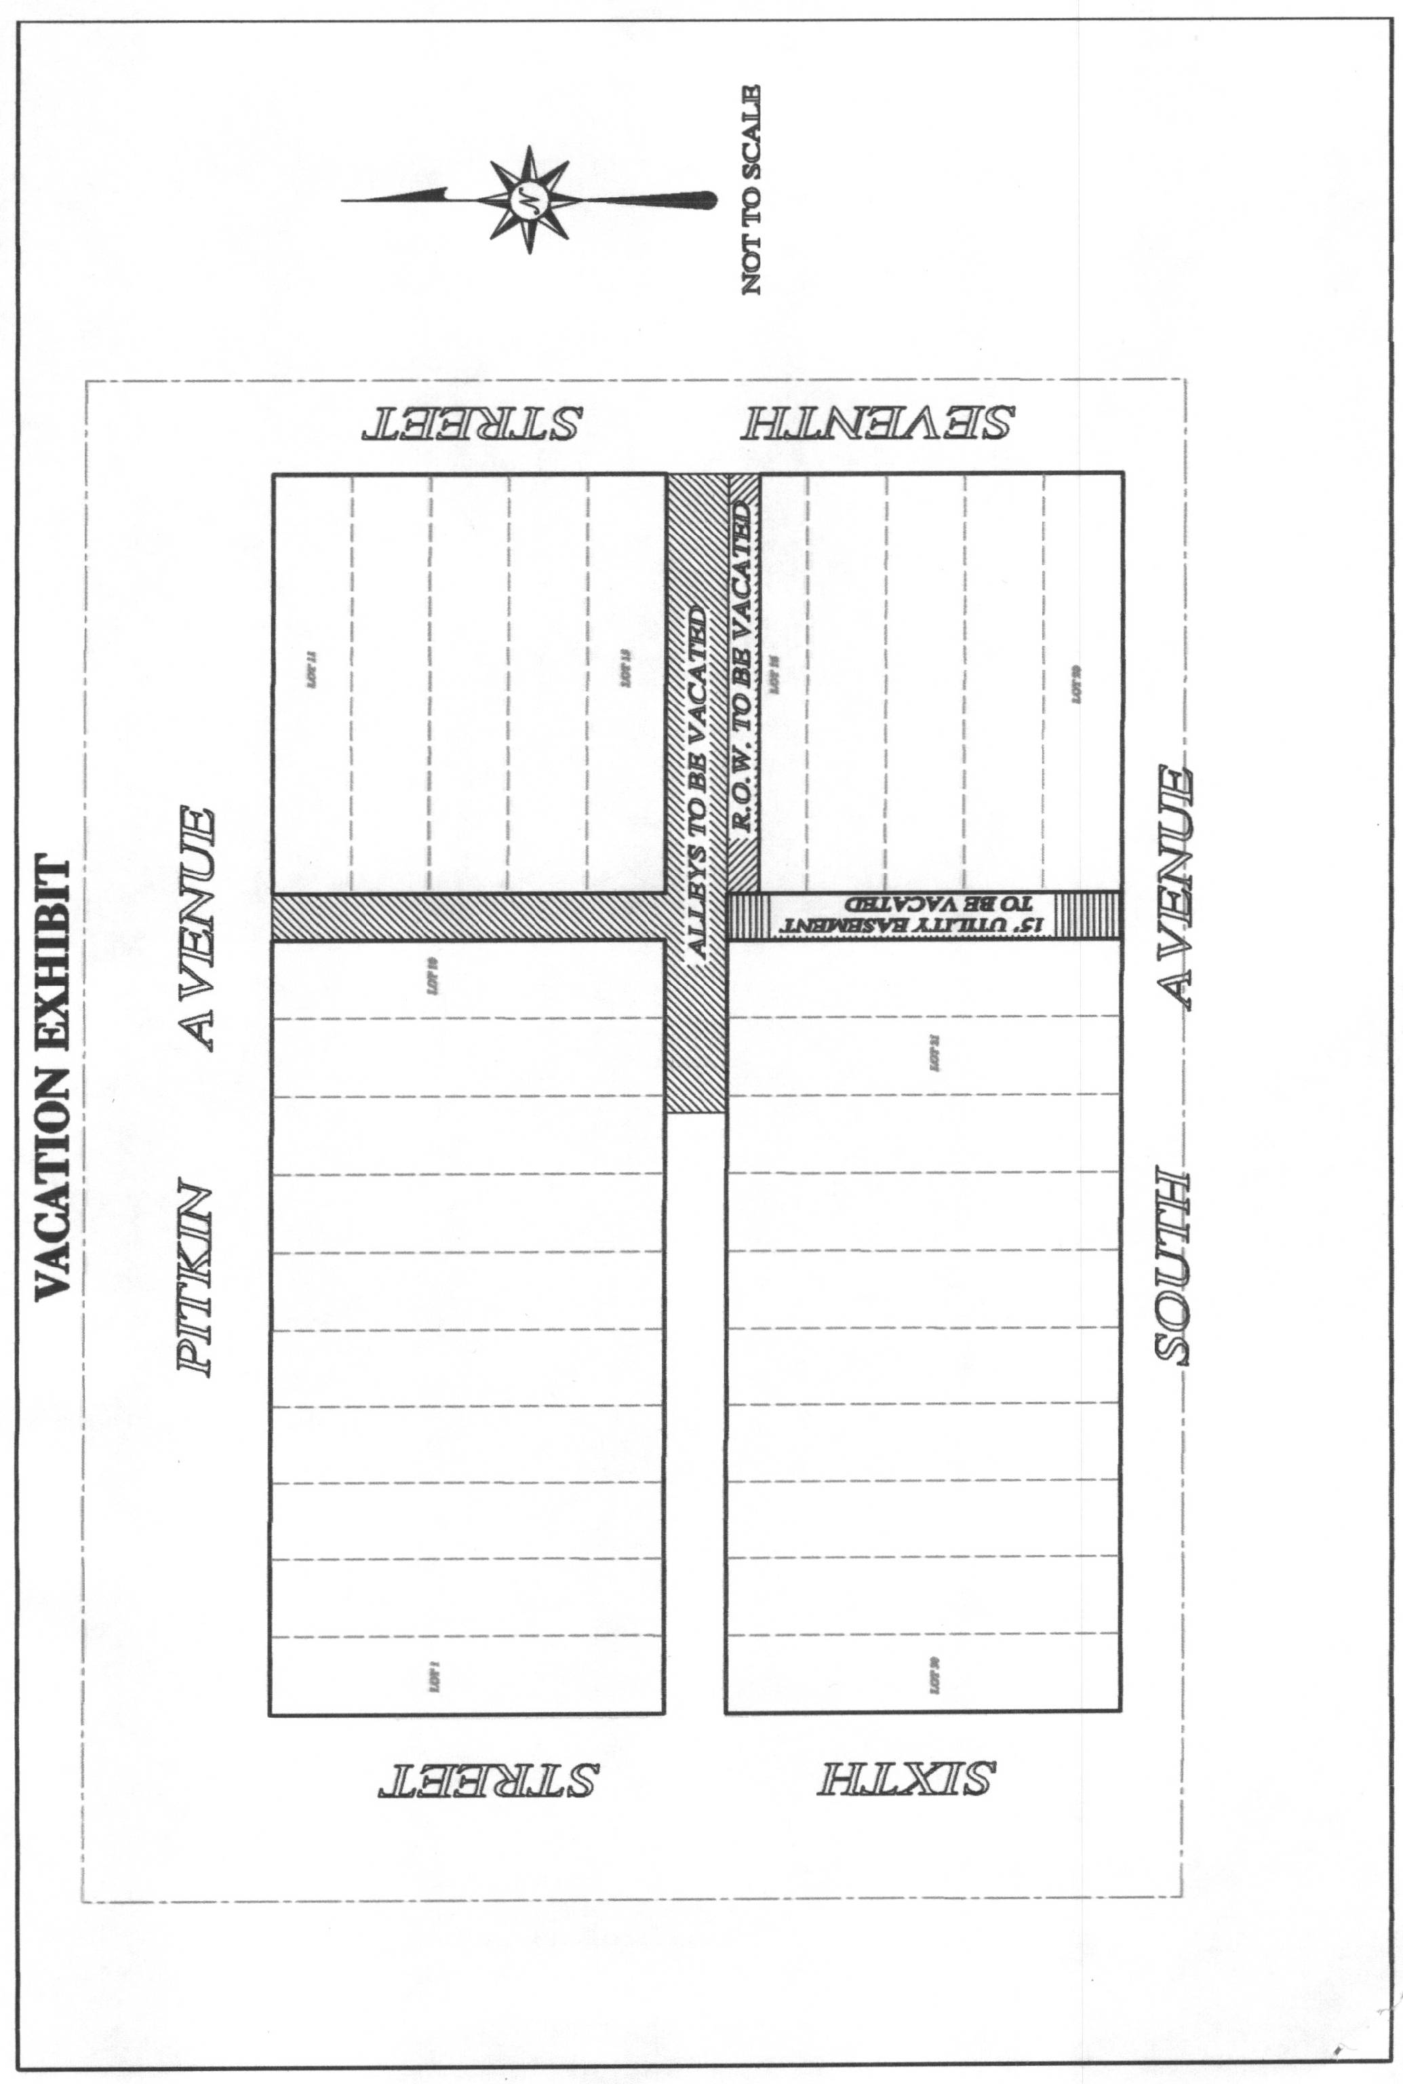
“A”
“B”
