**2025 Online Open Enrollment Instructions**

**For Online Enrollment from a City Worksite Computer**

*These instructions are for employees who are completing Open Enrollment from a City worksite computer (i.e., your work computer in your office, a co-worker’s computer at a City facility, a City kiosk near your worksite or a computer in the HR Training Room).*

1. *Log in* to the **HR Portal** at <https://erp-web.gjcity.org/Websites.HR.Portal/Default.aspx>

Note: This is where you log in to *view* your bi-weekly paychecks. If you cannot recall your Username, please *click* the **Retrieve Username** link. If you have forgotten your password, please *click* the **Reset Password** link and check your work email. You can call HR at 970-244-1512 if you have any questions about resetting your password.

1. Once you have logged in to the City of Grand Junction HR Portal, you will be able to *view* Open Enrollment information at the top of your screen. If you are ready to begin your online Open Enrollment for your 2025 City of Grand Junction benefits, *click* the **BENEFIT ENROLLMENT** tab toward the top of the screen and *select* Open Enrollment.

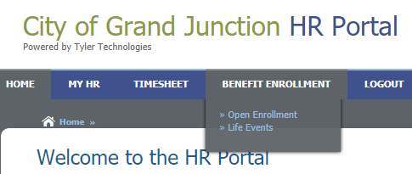

1. You will be able to enroll, disenroll or change your enrollment in the following benefits:

* Medical
* Dental
* Vision
* Medical FSA (Flexible Spending Account)
* Dependent Care FSA (Flexible Spending Account)
* Health Savings Account (HSA) – if enrolled in the Cigna HDHP (High Deductible Health Plan)
* Voluntary Benefits: VOYA Life/AD&D Insurance, Aflac, LifeLock, Trustmark, PetPartners & MissionSquare 457/IRA elections or changes should be done using the links on the Welcome Page or HR Portal. They are not elected using this online platform. If you do not want any changes to your elections, you do not need to do anything.

**Helpful Hints:**

* If you need to go back to a previous screen, simply *select* the desired benefit from the left-hand side of your screen.

**PLEASE CAREFULLY READ THROUGH THE INSTRUCTIONS & INFORMATION ON EACH PAGE!**

1. After you have read through the information on the screen, *click ‘***CONTINUE TO ENROLLMENT**’.

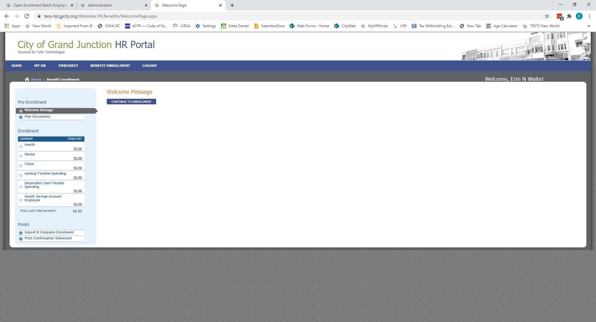

At the top of the screen, you will see your **current** (2024) selection for each benefit. In the screenshot below, the sample employee is currently on the High Deductible Pre-Tax Health Plan with Employee + 2 Dependents coverage.

1. Per the instructions on the screen, please select the radio button next to the desired plan with your desired coverage level (i.e., **Employee Only**, **Employee + 1 Dependent** or **Employee + 2 or More Dependents**.).

Note: Please pay attention to the “Pre-Tax” and “After-Tax” options.

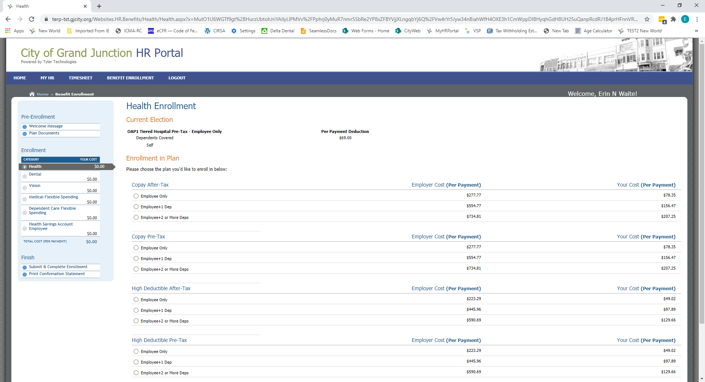

If you wish to decline coverage for the current election, simply select the radio button next to the, “I would like to decline coverage” option toward the bottom of the screen. Note: You must either select coverage or decline coverage – you may not leave the selection blank.

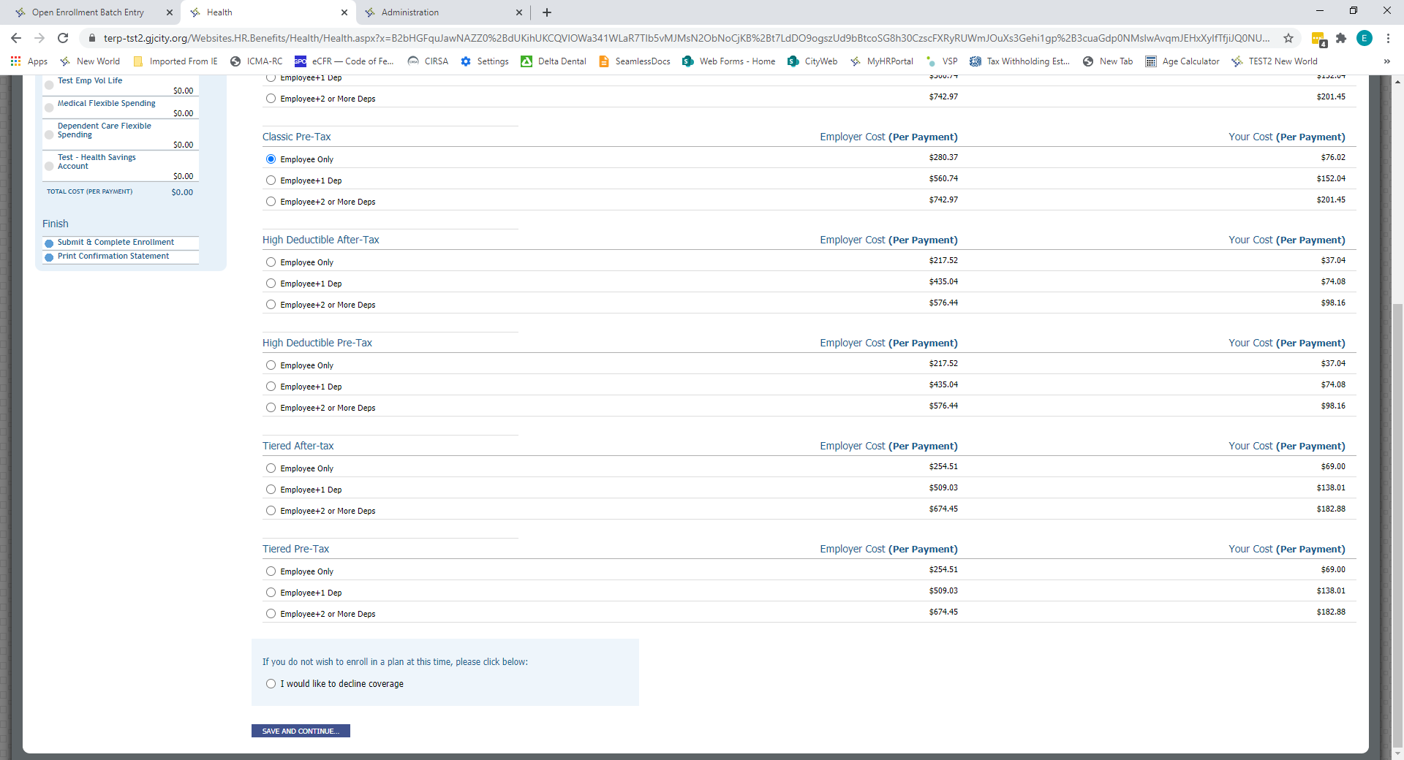

If you selected coverage with at least one Dependent, you will be given the opportunity to *select* the Dependent(s) who should be covered on the next screen. Please Note: If you have a new dependent who is not listed, you will need to stop and contact Human Resources (970-244-1512) to have the Dependent added to your account/record. You will then be able to come back to your online Open Enrollment to continue the process.

*Click* the **SAVE AND CONTINUE** button to move to the next benefit election screen.

**Selecting your Covered Dependent(s)** – Below is a screenshot of what you will see when you *select* a Dependent. The below example is of an employee selecting a Dependent for Dental. Simply *select* the desired Dependent(s) for the plan you just chose and then *click* the **SAVE AND CONTINUE…** button. You will make selections for each type of coverage, then click **save and continue** to move from health to dental to vision.

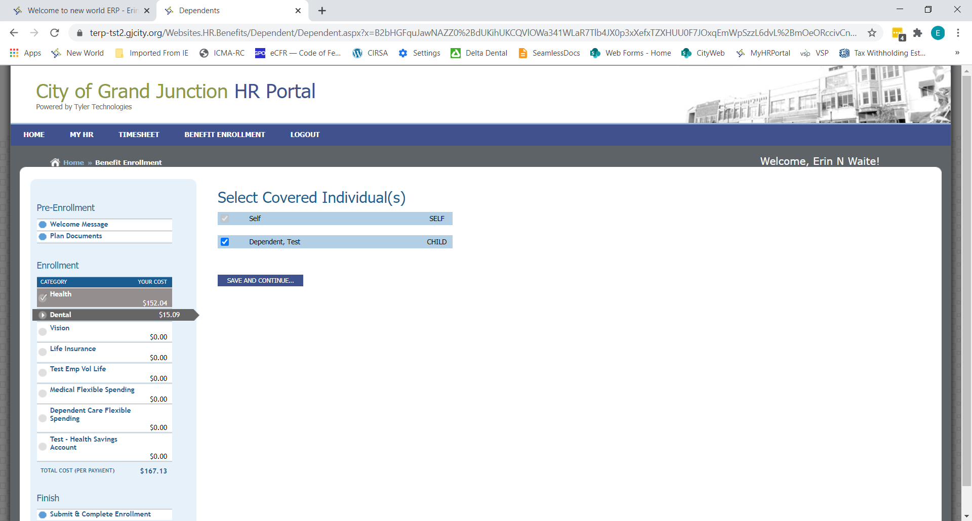

1. You will now see that your 2025 health, dental and vision elections are shaded gray and are saved on the left-hand side of the screen and your Total Cost (per pay period) is shown as well. Please Note: If you have any Voluntary Benefits (Aflac, LifeLock, PetPartners, Trustmark, Voluntary Life for Spouse and/or Child), those amounts will NOT be shown on this screen.
2. **Medical Flexible Spending/Dependent Care Flexible Spending**

A Medical Flexible Spending account is an account where you can contribute **pre-tax** money to pay qualified medical expenses such as copays, prescriptions, glasses & more. **Employees are eligible for a Medical Flexible Spending account if they are NOT on the High Deductible Health Plan (HDHP).** If you are on the High Deductible Health Plan and you wish to put aside additional pre-tax money (in addition to your Health Savings Account funds) for Dental and Vision expenses, you may enroll in a Limited Purpose Medical FSA.

**Reminder! Flexible Spending Accounts are USE IT OR LOSE IT accounts. Make sure you plan accordingly and don’t put away more money than you will use. If you do not use all the money in the account, you will forfeit those funds.**

**You may not make changes to Flexible Spending Account amounts during the year unless you have a qualifying event.**

In the example below, the employee has elected a Medical Flexible Spending Account. To do so, simply *select* the Flexible Spending Account radio button and then enter the desired yearly amount. The system will automatically break the amount down by pay period. For example, if the employee *selected* $400 annually, it would equal $15.39/pay period. If you do not wish to enroll, simply *click* the radio box next ‘**I would like to decline coverage’** option near the bottom of the screen.

A Dependent Care Flexible Spending account allows you to set aside money from your paycheck on a pre-tax basis for qualified day care/childcare expenses. You will sign up for this account the same way you signed up for the Medical Flexible Spending Account.

1. **Health Savings Account (HSA)**

A Health Savings Account (HSA) goes hand-in-hand with the High Deductible Health Plan. **If you enrolled in the High Deductible Health Plan, you must also enroll in the HSA, and you must contribute at least $750 for the year. $750/year is the equivalent of $28.85/pay period.** If you do not enroll in the High Deductible Health Plan, you **may not** enroll in an HSA.

The City also contributes to the HSA on your behalf. If you have Employee-Only coverage, the City will contribute $750 to your account in January of 2025. If you have Employee + 1 (or more) dependent(s), the City will contribute $1500 on your behalf - $750 in January of 2025, and another $750 in July of 2025.

If you are enrolled on the High Deductible Health Plan, you must *select* the **Health Savings Account** radio button and *enter* the amount you wish to contribute for the year. Note: This is the amount that YOU wish to contribute – this does not include any City contributions. You must also enter four zeros, “0000” in the **ACCOUNT NUMBER** box.

If you are a **NEW** enrollee on the High Deductible Health Plan, you must also complete a Home Loan HSA application and provide a copy of your Driver’s License. Please click the link toward the top of the Health Savings Account Enrollment screen to be taken to the Home Loan application.

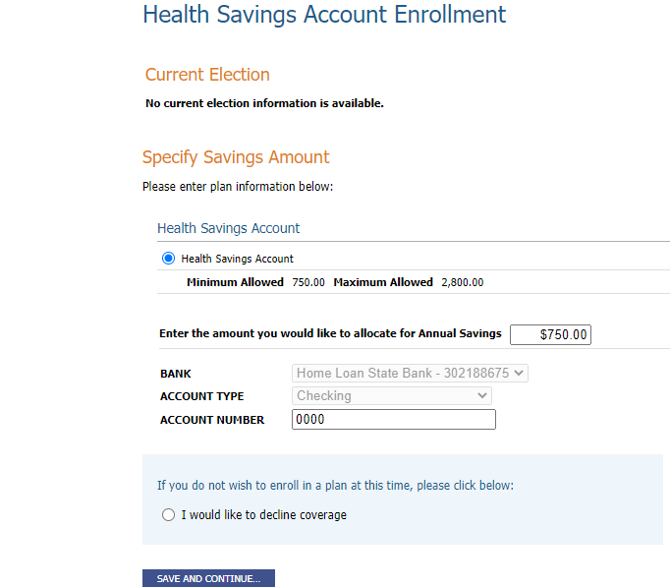

If you are NOT on the High Deductible Health Plan, you must *select* the radio button toward the bottom of the screen – **I would like to decline coverage**.

1. Once you have made all your benefit elections, you will be taken to a **Confirm & Submit** screen. Please *verify* all the elections that you made and make sure all your correct dependents (if any) are listed. You will see a Total Cost for the benefits you just elected. Please Note: This total does not include any Voluntary benefits such as Aflac, Voluntary Life, LifeLock, etc.

Once you have confirmed that your 2024 benefit elections are accurate on this screen, *click* the **SUBMIT** button at the bottom of the screen. A small pop-up screen that reads, “Submit current enrollment options?” will appear toward the top of your screen. *Click* the **OK** button. Your online Open Enrollment is now complete!

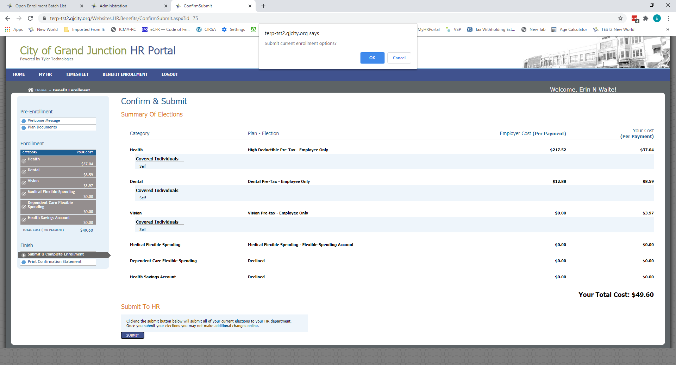

The final screen gives you the option of printing a Confirmation Statement of your benefit elections. Simply *click* the **PRINT CONFIRMATION STATEMENT** button to *print* a copy of your benefit elections. You may keep that statement for your records.

