**RESOLUTION NO. 55-13**

**A RESOLUTION** **AUTHORIZING AN AGREEMENT BETWEEN THE GRAND VALLEY DRAINAGE DISTRICT AND THE CITY OF GRAND JUNCTION CONCERNING THE WILSEA DRAIN**

Recitals.

The Grand Valley Drainage District owns the Wilsea drain in the vicinity of 24 and G Roads in Grand Junction. The Wilsea is just one of many of the District’s drains. For many years, the agricultural uses of the lands originally served by the drains have diminished leaving little if any agricultural return flow water in the drain. The Wilsea drains original purpose was to collect water so that lands could be cultivated; more recently, in large part due to residential and other development, water in the drain originates from streets and developed and developing commercial and residential areas.

The City, as part of the land use and development review processes, requires that developers plan for storm water drainage. Two such developments, the medical office building and Community Hospital, are current relevant examples of the process. Both will discharge to the Wilsea drain. While developers have historically relied on the District’s facilities to convey storm water discharges, and the District has allowed the same to occur in the past, it can no longer do so because the storm water drainage needs will continue to expand, including water quality, not just quantity.

In order to address the growing demand for storm water facilities the City has expressed its willingness to, pursuant to the terms of the attached written agreement, accept future ownership, maintenance and operational control of the Wilsea drain.

NOW, THEREFORE, BE IT RESOLVED BY THE CITY COUNCIL OF THE CITY OF GRAND JUNCTION, COLORADO:

That the City Council finds and determines that the Wilsea Drain transfer agreement is in the best interest of the City and therefore authorizes and directs the City Manager to execute the agreement and act in accordance therewith.

PASSED and ADOPTED the 21st day of August 2013.

/s/ Martin Chazen

President of the City Council Pro Tem

ATTEST:

/s/ Stephanie Tuin

City Clerk

AGREEMENT

FOR TRANSFER OF

A GRAND VALLEY DRAINAGE DISTRICT DRAIN

The Grand Valley Drainage District, hereinafter referred to as “the District,” is a Title 37, C.R.S., Colorado political subdivision.

The City of Grand Junction, hereinafter referred to as the “City,” is a Colorado home rule city, authorized by Article XX of the Colorado constitution and the City’s home rule charter, and acts through its City Manager.

**RECITALS:**

1. The District represents that it owns the Drain described herein and the associated easements, right- of ways and interests in land (collectively the “Drain”). For the past 30 plus years, the agricultural uses of the lands originally served by the Drain have abated, leaving little if any seep or irrigation return flow (IRF) water in the Drain.
2. The District has maintained the Drain to the Colorado River even though very little seep or IRF water typically accumulates in it. The City is an urban service provider with one of the services that it provides for its citizens, in certain areas of the City, being municipal separate storm sewer system (MS4) collection.
3. The City and the District are members of the 5-2-1 Drainage Authority, an entity that is responsible for storm water management in the Grand Valley, including MS4 water.
4. The Drain is one in a series of ditches constructed and/or reconstructed by the District consistent with the District’s statutory mission to address drain, seep and IRF waters and to protect urban and rural properties from episodic torrential storms.
5. The original purpose of the Drain was to collect seep waters so that lands could be cultivated. Over time, as agricultural activities expanded within the District, IRF (“waste water”) from irrigation flowed into the Drain via laterals and lands within the District. More recently, in large part due to residential and other development, water flowing in the Drain consists of surface drainage and used and unused waters from lands within the District and lands to the north of the District boundaries.
6. The City and the District have concluded that the Drain will potentially carry significant volumes of storm water from streets, undeveloped areas and residential, commercial and other developments within the City limits. The remaining, minor (but not precisely measured) volume in the Drain is from seepage and irrigation return flows (“Drainage”).
7. The City, as part of the land use and development review processes, requires that developers plan for storm water drainage. For years, developers have constructed facilities that direct storm water discharges into the Drain, and the District has allowed the same to occur.
8. In order to accommodate the storm water drainage needs of the community and recognizing that residential, commercial and other development will continue to expand into the areas historically served by the District, the City has indicated its willingness to, pursuant to the terms of this written Agreement, accept future ownership, maintenance and operational control of the Drain, as specifically described on the Drain Exhibit Map, attached hereto as **Exhibit A** and incorporated herein by reference.
9. The District has determined that ownership of the Drain by the District is no longer necessary so long as the Drain continues to be owned, operated and maintained by the City and/or the 5-2-1 Drainage Authority to provide for the continuing passage of Drainage from the lands of the District to the Colorado River, and so long as capacity for Drainage will be preserved upon transfer of ownership, maintenance and operational control of the Drain to the City. The District reserves and retains its rights to continue to discharge Drainage into the Drain.

NOW THEREFORE, the parties agree as follows:

1. The District agrees to indemnify and hold the City harmless with regard to existing and future seep water and IRF water, herein defined as “Drainage.” Nothing herein shall be deemed to be a waiver, extension or modification of any statutes of limitations, governmental immunity(ies) or other defenses relating to any alleged act(s) of negligence by the District; further, the parties specifically intend that no person is an intended beneficiary of this Agreement or of the Quit Claim Deed from the District to the City.

2. The City agrees:

* 1. Effective on the date of mutual execution of the Quit Claim Deed to it, the City agrees to accept liability for and relating to any and all loss or damage of every description or kind whatsoever from the City’s operation and maintenance of the Drain, including the receipt and conveyance of Drainage, after the date of mutual execution of the Quit Claim Deed.
  2. On and after the date of mutual execution of the Quit Claim Deed to it, the City agrees to accept existing amounts and patterns of Drainage into the Drain. The City may modify the alignment of the Drain as shown on Exhibit A, provided that the new alignment shall be designed and constructed in a manner that will continue to accept the amount of Drainage discharge into the Drain which exists as of the date of this agreement.
  3. The City agrees that the Drain is quitclaimed by the District to the City on an “AS-IS, WHERE-IS” basis with no representations, warranties or covenants of any kind (other than what is stated in Paragraph 1, above), express or implied, either oral or written, made by the District, or any agent or representative thereof, including without limitation; (i) the physical or structural condition of the Drain; (ii) the compliance of the Drain with any laws, ordinances or regulations of any federal, state, local or other governmental entity; (iii) title to the Drain; and (iv) the suitability or fitness of the Drain for any purpose, including without limitation use as a storm water and/or MS4 facility, all of which representations, warranties and covenants the District hereby expressly disclaims.
  4. The City agrees to assume all costs incident to the ownership, operation and maintenance of the Drain, as of the date of mutual execution of the Quit Claim Deed.

GRAND VALLEY DRAINAGE DISTRICT CITY OF GRAND JUNCTION

BY: _______________________________ BY: _____________________________

Manager City Manager

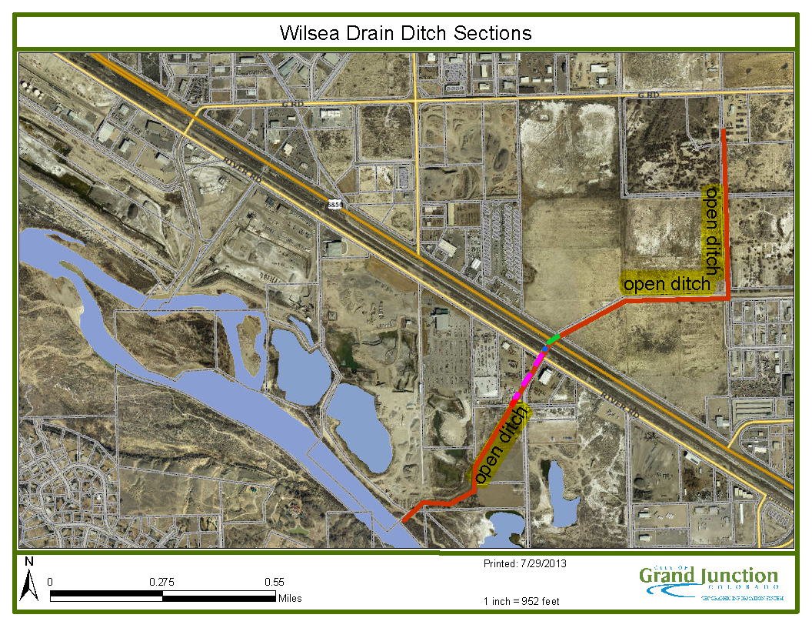

**Exhibit A**