CITY OF GRAND JUNCTION

ORDINANCE NO. 4021

AN ORDINANCE VACATING A PORTION OF THE RIGHT-OF-WAY

FOR SOUTH 6TH STREET

LOCATED ADJACENT TO 420 SOUTH 6TH STREET
MESA COUNTY PARKING LOT

RECITALS:

A vacation of the dedicated right-of-way for South 6th Street has been requested by the adjoining property owner.

The City Council finds that the request is consistent with the Growth Plan, the Grand Valley Circulation Plan and Section 2.11 of the Zoning and Development Code.

The Planning Commission, having heard and considered the request, found the criteria of the Code to have been met, and recommends that the vacation be approved.

NOW, THEREFORE BE IT ORDAINED BY THE CITY COUNCIL OF THE CITY OF GRAND JUNCTION THAT:

The following described dedicated right-of-way for is hereby vacated subject to the listed conditions:

- Applicants shall pay all recording/documentary fees for the Vacation Ordinance, any easement documents and dedication documents.
- The vacation area shall be retained as a multi-purpose easement.

The following right-of-way is shown on “Exhibit A” as part of this vacation of description.

Dedicated right-of-way to be vacated:

A portion of the ROW of South Sixth Street fronting Lot 30 of Block 149 in the City of Grand Junction, County of Mesa, State of Colorado, being more particularly described as follows: BEG at the SW COR of said Lot 30; thence along the extension of South line of said Lot 30, N89°51'34"W, a DIS of 7.48 ft; thence N00°01'24"E a DIS of 125.98 ft to the extension of the north line of said Lot 30; thence N89°50'18"E a DIS of 7.51 ft to the NW COR of said Lot 30; thence S00°02'11"W at DIS of 125.98 ft to the POB.

Containing 944 sq ft, more or less.

Introduced for first reading on this 17th day of January, 2007

PASSED and ADOPTED this 7th day of February, 2007.

ATTEST:

______________________________
President of City Council

______________________________
City Clerk
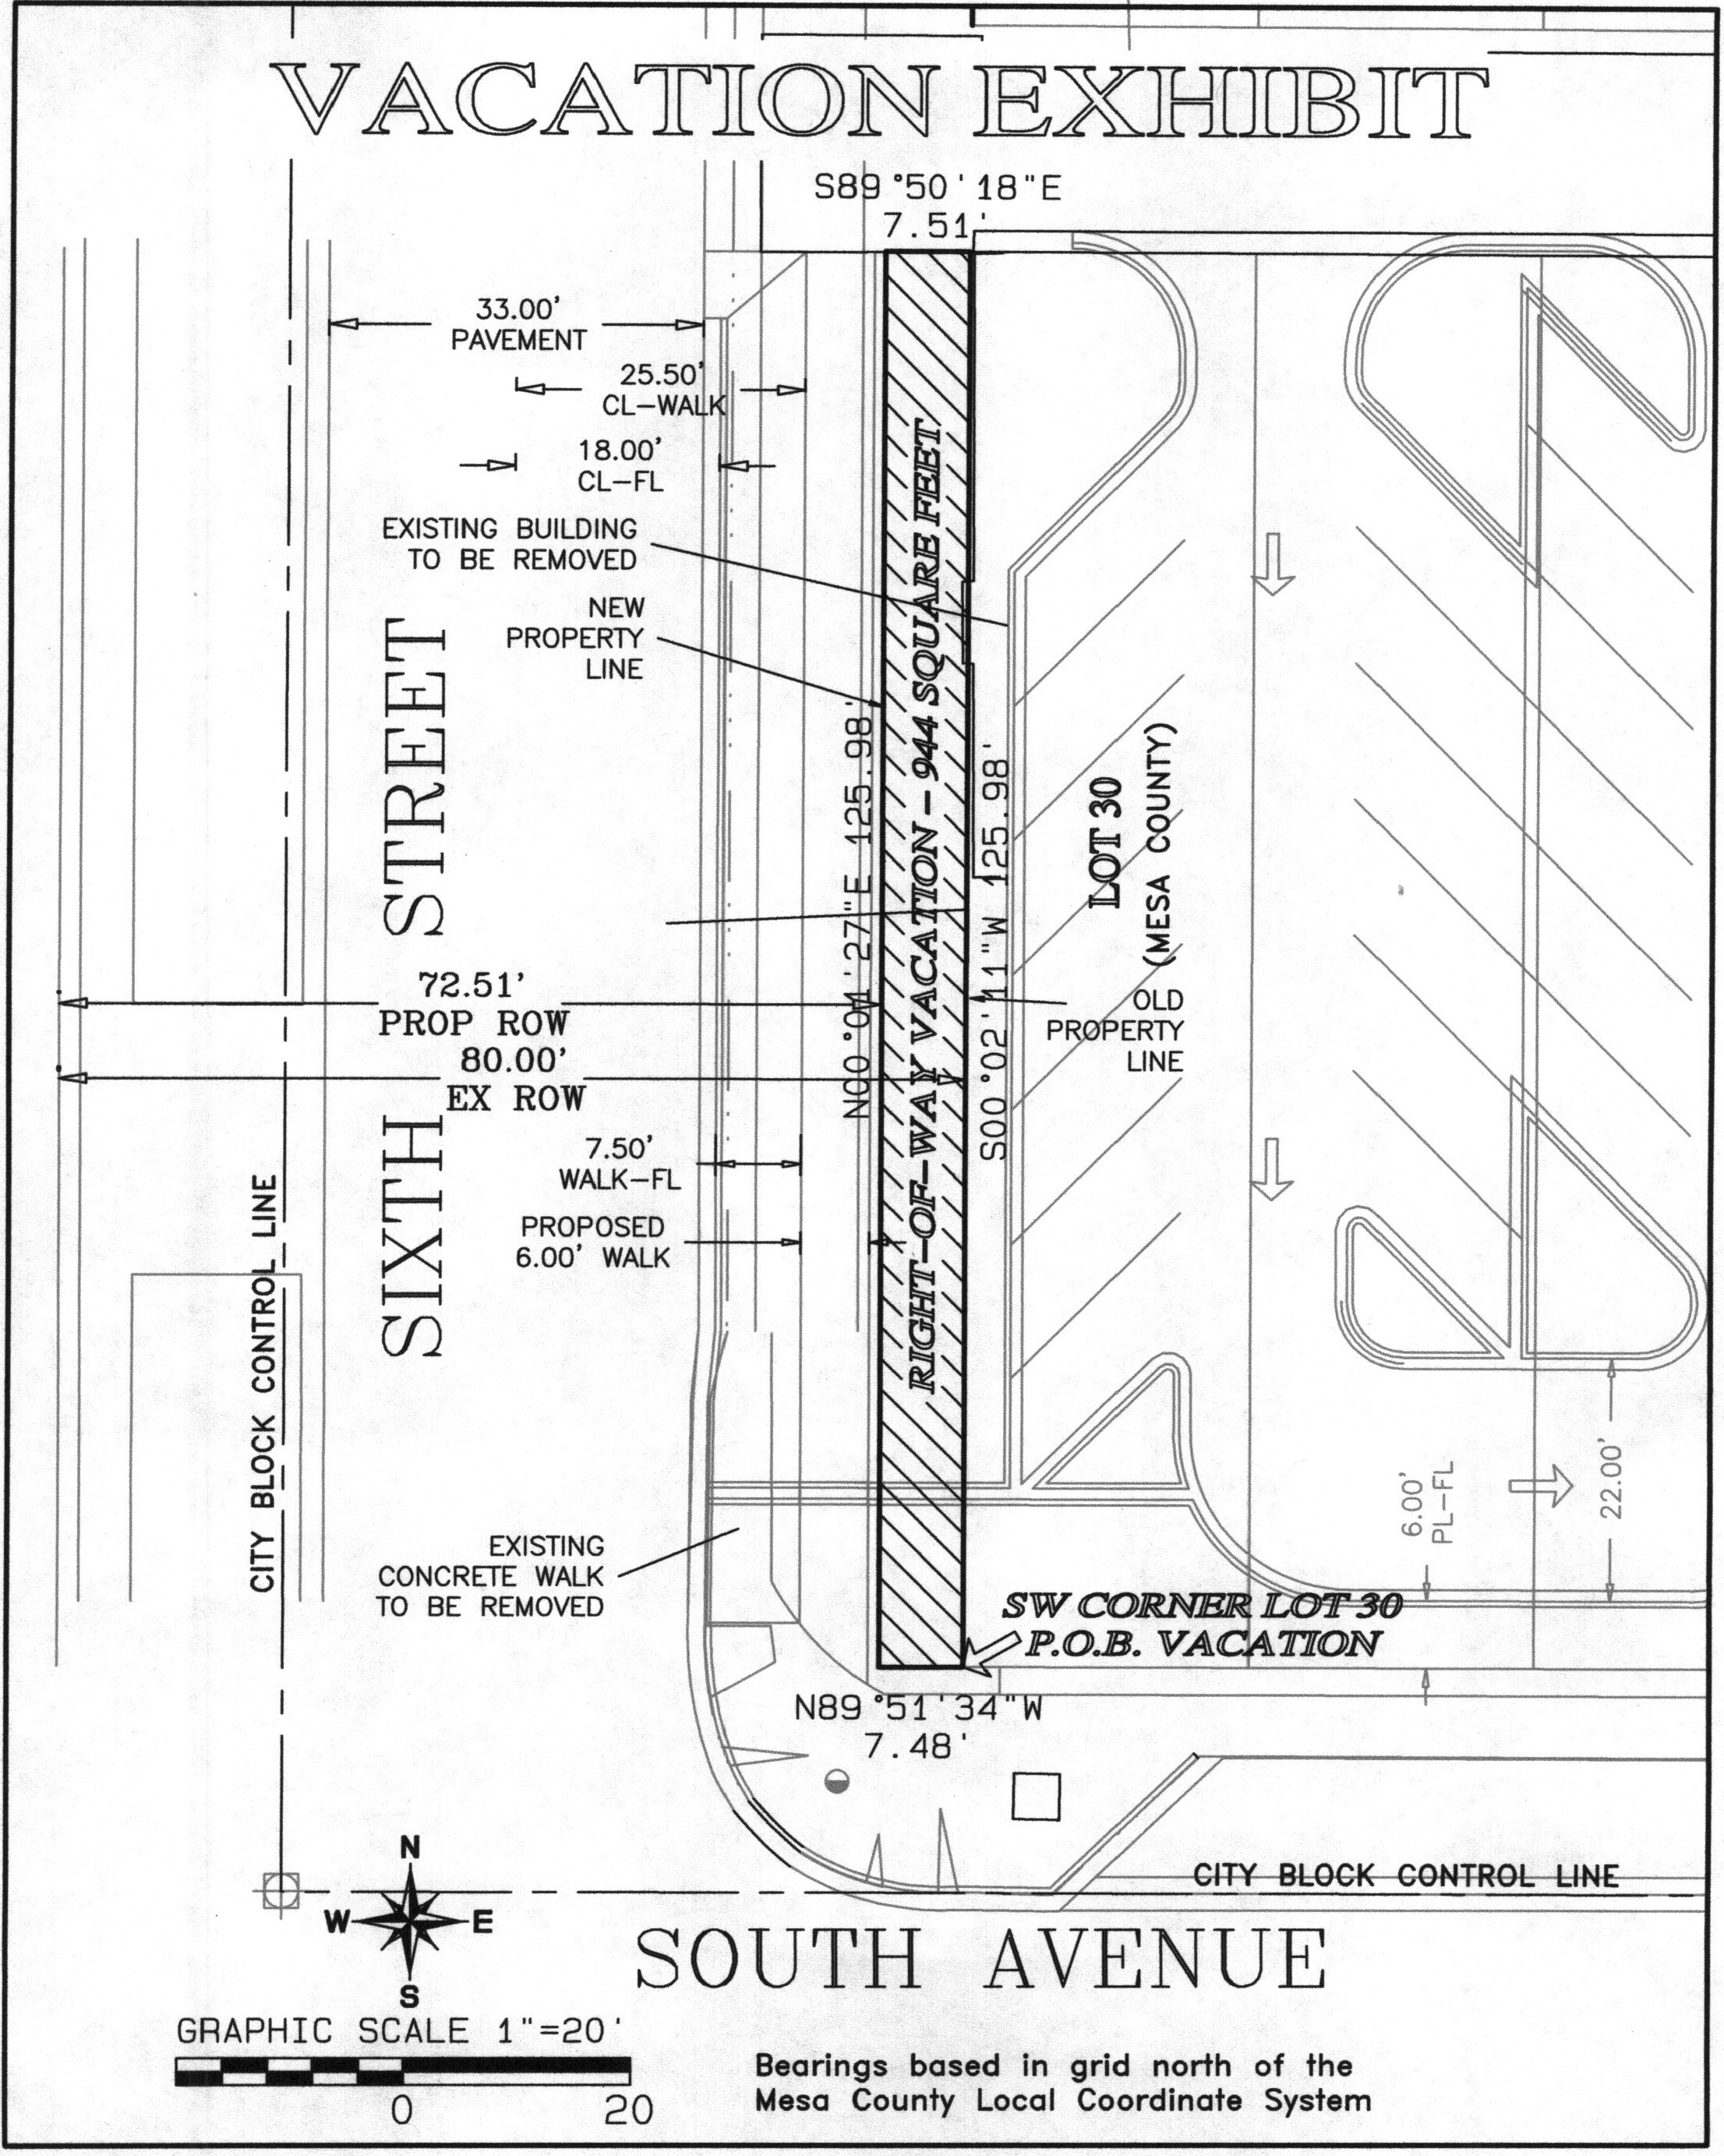
EXHIBIT A

