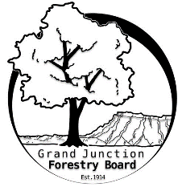

**GRAND JUNCTION FORESTRY BOARD AGENDA**

*Park Operations Office*

*2529 High Country Court, Grand Junction CO 81501*

Friday September 1st, 2023, 8:30 - 10AM

Call to Order

1. Approve Minutes for August Forestry Board Meeting

Public Comments

New Business

Volunteer Appreciation Dinner

12/11/2023 5pm

Update from Education Committee

Farmer’s Market

Realestate / General Homeowner Tri-fold

Review of Forestry Webpage

Zoning Code

Review of Chapter 8

Guidelines for General Contractors and Tree Removal

Forestry Rules and Regulations

Aerial rescue

Other items to discuss

1. Forestry Updates
   1. Private ash trees treated 393 (up from 377)
   2. Christmas lights and fall planting on the horizon

Adjourn

Next Forestry Board Meeting: Thursday October 5th 8:30-10am; Park Operations Office

If you have any questions contact chair, Kamie Long at 970-248-7325 or Robert Davis, City Forester at 970-254-3825