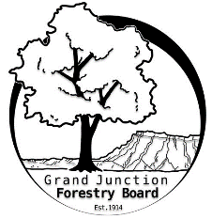

**GRAND JUNCTION FORESTRY BOARD AGENDA**

*Park Operations Office*

*2529 High Country Court, Grand Junction CO 81501*

Thursday October 5th, 2023, 8:30 - 10AM

Call to Order

1. Approve Minutes for September Forestry Board Meeting

Public Comments

1. Forestry Updates
   1. Tree maintenance updated 1/1 through 10/1
      1. 2023 = 355 trees trimmed; 296 trees removed; trees planted 361
      2. 2022 = 306 trees trimmed; 266 trees removed; trees planted 308
      3. 2021 = 399 trees trimmed; 380 trees removed; trees planted 310
   2. Private ash treatment program status - 10/2/23
      1. 437 requests received
      2. 525 ash treated
   3. Christmas lights starting October 16th – All Forestry staff dedicated for 3 weeks to complete

New Business

Volunteer Appreciation Dinner

12/11/2023 5pm

Education

Farmers Market

Aerial Rescue

Western Colorado Community Forestry Conference

Zoning Code Changes (Niki Galehouse – Planning Supervisor)

Review of Chapter 8

Guidelines for General Contractors and Tree Removal

Forestry Rules and Regulations

Other items to discuss

Adjourn

Next Forestry Board Meeting: Thursday November 2nd 8:30-10am; Park Operations Office

If you have any questions contact chair, Kamie Long at 970-248-7325 or Robert Davis, City Forester at 970-254-3825