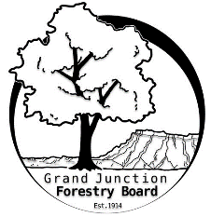

**GRAND JUNCTION FORESTRY BOARD AGENDA**

*Park Operations Office*

*2529 High Country Court, Grand Junction CO 81501*

Thursday November 2nd, 2023, 8:30 - 10AM

Call to Order

1. Approve Minutes for October Forestry Board Meeting

Public Comments

1. Forestry Updates
   1. Holiday Lights completed
   2. Bareroot tree plantings – Bee Hive Park
   3. Fire mitigation on Railroad Island

New Business

Education

Western Colorado Community Forestry Conference

Aerial Rescue

Forestry Website

Review of Chapter 8

Guidelines for General Contractors and Tree Removal

Forestry Rules and Regulations

Other items to discuss

Adjourn

Next Forestry Board Meeting: Thursday December 7th 8:30-10am; Park Operations Office

If you have any questions contact chair, Kamie Long at 970-248-7325 or Robert Davis, City Forester at 970-254-3825