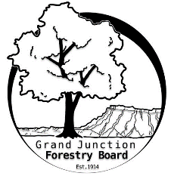

**GRAND JUNCTION FORESTRY BOARD AGENDA**

*Park Operations Office*

*2529 High Country Court, Grand Junction CO 81501*

Thursday December 7th, 2023, 8:30 - 10AM

Call to Order

1. Approve Minutes for November Forestry Board Meeting

Public Comments

The Loss of Vince Urbina

1. Forestry Updates
   1. Main Street Arboretum; marker installation starting this month
   2. Spade moving at Emerson Park
   3. Tree removal season start up - ~250 trees identified
   4. Tree Service License Renewals
   5. Tree City USA Application

New Business

Education Committee Updates

Turf Removal and Tree Roots (from Susan Carter’s program)

Forestry Website

Tree Information Tri-fold

Review templates from Jason Martinez

Updated blurbs / short sections for tri-fold topics

Review of Chapter 8

Guidelines for General Contractors and Tree Removal

Forestry Rules and Regulations

Other items to discuss

Adjourn

Next Forestry Board Meeting: Thursday January 4th 8:30-10am; Park Operations Office

If you have any questions contact chair, Kamie Long at 970-248-7325 or Robert Davis, City Forester at 970-254-3825