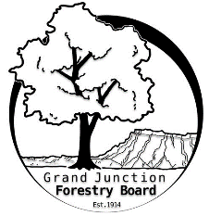

**GRAND JUNCTION FORESTRY BOARD AGENDA**

*Park Operations Office*

*2529 High Country Court, Grand Junction CO 81501*

Thursday January 4th, 2023, 8:30 - 10AM

Call to Order

1. Approve Minutes for December Forestry Board Meeting

Public Comments

New Business

Chair and Vice-chair appointments for 2024

Vince Urbina Memorial

Arbor Day 2024

Commercial Landscapes

Code enforcement compliance

Zoning code landscape regulations – tree maintenance standards

Education Committee Updates

Turf Removal and Tree Roots (from Susan Carter’s program)

Tree Information Tri-fold

Review templates from Jason Martinez

Updated blurbs / short sections for tri-fold topics

Forestry Website

Review of Chapter 8

Forestry Rules and Regulations

Other items to discuss

1. Forestry Updates
   1. Tree removal focus through February
      1. 52 removals completed as of 1/2/24

Adjourn

Next Forestry Board Meeting: Thursday February 1st 8:30-10am; Park Operations Office

If you have any questions contact chair, Kamie Long at 970-248-7325 or Robert Davis, City Forester at 970-254-3825