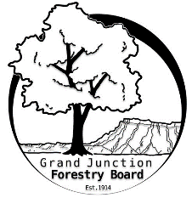

**GRAND JUNCTION FORESTRY BOARD AGENDA**

*Park Operations Office*

*2529 High Country Court, Grand Junction CO 81501*

Thursday March 7th, 2024, 8:30 - 10AM

Call to Order

1. Approve Minutes for February Forestry Board Meeting

Public Comments

New Business

Jamie Beard - Review of Chapter 8

Education Committee Updates

Tree Information Tri-fold

Colroado State Forest Service Grant Funding

Arbor Day and Tree Seedling Distribution

Other items to discuss

1. Forestry Updates
   1. Tree removal focus through February
      1. 228 removals completed through March 1st (3,101 diamteer inches)
      2. Local nursery stock arrival soon

Adjourn

Next Forestry Board Meeting: Thursday April 4th 8:30-10am; Park Operations Office

If you have any questions contact chair, Kamie Long at 970-248-7325 or Robert Davis, City Forester at 970-254-3825