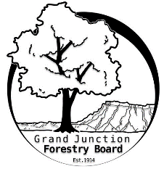

**GRAND JUNCTION FORESTRY BOARD AGENDA**

*Park Operations Office*

*2529 High Country Court, Grand Junction CO 81501*

Thursday April 11th, 2024, 1-2:30 PM

Call to Order

1. Approve Minutes for March Forestry Board Meeting

Public Comments

New Business

Welcome new Forestry Board Member Mollie Freilicher

Jamie Beard - Review of Chapter 8

Tree Seedling Distribution

Arbor Day Planning

Education Committee Updates

Tree Information Tri-fold

Other items to discuss

Need to reschedule May Forestry Board Meeting

1. Forestry Updates
   1. Street tree plantings
   2. Girl scout planting project

Adjourn

Next Forestry Board Meeting: TBD; Park Operations Office

If you have any questions contact chair, Kamie Long at 970-248-7325 or Robert Davis, City Forester at 970-254-3825