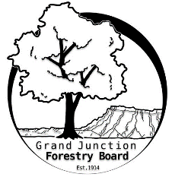

**GRAND JUNCTION FORESTRY BOARD AGENDA**

*Park Operations Office*

*2529 High Country Court, Grand Junction CO 81501*

Thursday May 9th, 2024, 8-9:30 am

Call to Order

1. Approve Minutes for April Forestry Board Meeting

Public Comments

New Business

8:10- 8:40 Jamie Beard - Review of Chapter 8

8:45 – 9:15 Jenny Nitzki – NOAA Urban Heat Island & Sustainability and Adaptation Plan

Arbor Day and Tree Seedling Distribution Review

Education / Code Committee Meeting

Other items to discuss

1. Forestry Updates
   1. Street tree plantings

Adjourn

Next Forestry Board Meeting: June 6th 8:30-10am; Park Operations Office

If you have any questions contact chair, Kamie Long at 970-248-7325 or Robert Davis, City Forester at 970-254-3825