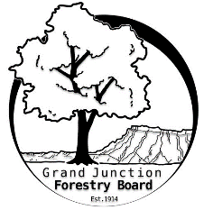

**GRAND JUNCTION FORESTRY BOARD AGENDA**

*Park Operations Office*

*2529 High Country Court, Grand Junction CO 81501*

Thursday August 1st, 2024, 8:30-10:00 am

Call to Order

1. Approve Minutes for July Forestry Board Meeting

Public Comments

New Business

Farmers Market updates

IRA Grant Project

Fire mitigation permitting

Clearing and Grubbing permitting

Rules and Regulations

Scheduling subcommittee meetings

Other items to discuss

1. Forestry Updates
   1. Continuing focus on tree pruning
   2. Mectinite injections on juniper and American elm
   3. Donation from Xcel Energy Foundation for fall tree planting

Adjourn

Next Forestry Board Meeting: September 5th 8:30-10am; Park Operations Office

If you have any questions contact chair, Kamie Long at 970-248-7325 or Robert Davis, City Forester at 970-254-3825