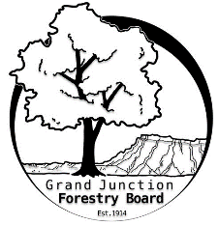

**GRAND JUNCTION FORESTRY BOARD AGENDA**

*Park Operations Office*

*2529 High Country Court, Grand Junction CO 81501*

Thursday October 3rd, 2024, 8:30-10:00 am

Call to Order

1. Approve Minutes for September Forestry Board Meeting

Public Comments

New Business

Chapter 8 update; Jamie Beard CAO

Farmers Market summary

Scheduling subcommittee meetings

Other items to discuss

1. Forestry Updates
   1. N 7th Street
   2. Contracted tree work
   3. Xcel Tree Planting
   4. Holiday lights

Adjourn

Next Forestry Board Meeting: November 7th 8:30-10am; Park Operations Office

If you have any questions contact chair, Kamie Long at 970-248-7325 or Robert Davis, City Forester at 970-254-3825