CITY OF GRAND JUNCTION, COLORADO

ORDINANCE NO. 4091

AN ORDINANCE VACATING RIGHT-OF-WAY

ADJACENT TO NIBLIC DRIVE

LOCATED AT 711 NIBLIC DRIVE AND 718 HORIZON DRIVE

RECITALS:

A vacation of the dedicated right-of-way has been requested by the property owner because it limits the development potential of the two lots. The subject right-of-way is a 50’ unnamed stub street platted with the subdivision and was never built. Due to the physical constraints of the area, the street will never be constructed.

The City Council finds that the request is consistent with the Growth Plan, the Grand Valley Circulation Plan and Section 2.11 of the Zoning and Development Code.
The Planning Commission, having heard and considered the request, found the criteria of the Code to have been met, and recommends that the vacation be approved.

NOW, THEREFORE BE IT ORDAINED BY THE CITY COUNCIL OF THE CITY OF GRAND JUNCTION THAT:

The following described dedicated right-of-way is hereby vacated subject to the listed conditions:

- Applicants shall pay all recording/documentary fees for the Vacation Ordinance, any easement documents and dedication documents.

2. A 14’ multi-purpose easement shall be reserved with this vacation request (See Exhibit B).

“Exhibit A”

Dedicated right-of-way, as described in “Exhibit A”, is the area to be vacated:

A parcel or tract of land situate in the SW1/4 SE1/4 Section 36, Township 1 North, Range 1 West of the Ute Meridian, City of Grand Junction, County of Mesa, State of Colorado, being the same parcel as the un-named 50-foot road right-of-way southwesterly of Lot 1, Block 8 and northeasterly of Lot 6, Block 5 as depicted on the Partee Heights plat, filed in the records of the Mesa County, Colorado, Clerk and Recorder at Plat Book 9, Page 64, being more particular described as follows:

BEGINNING at the NE corner of Lot 6, Block 5 of Partee Heights, in the SW1/4 SE1/4 Section 36, Township 1 North, Range 1 West of the Ute Meridian, as filed in the records of the Mesa County, Colorado Clerk and Recorder at Plat Book 9, Page 64, said point being a 1-inch plastic cap on 5/8-inch rebar, PLS 16413, whence the S 1/4 corner of said Section 36, being a found 3 1/2-inch aluminum cap (unreadable), bears S43°41’47”W, a distance of 862.16 feet, with all other bearings contained herein being relative thereto; thence N50°33’45”W along the northeasterly line of said Lot 6, a distance of 99.13 feet to the NW corner of said Lot 6, monumented by a 1 1/2-inch aluminum cap on 5/8-inch rebar, PLS 16835; thence N50°33’45”W along the southwesterly subdivision line of said Partee Heights, a distance of 171.29 feet to the westerly subdivision line of said Partee Heights, said point not monumented; thence N40°16’23”E along the westerly subdivision line of said Partee Heights, a distance of 50.01 feet to the SW corner of Lot 1, Block 8 of said Partee Heights, said point not monumented; thence along the southerly lot line of said Lot 1 on the following two (2) courses:
(1) S50°33’45”E, a distance of 146.45 feet, said point not monumented;
(2) along the arc of a curve to the left, with an interior angle of 128°39’52”, a radius of 40.00 feet, for an arc distance of 89.82 feet, the chord of which bears N65°06’19”E, a distance of 72.11 feet, said point not monumented; thence S00°46’23”W along the westerly right-of-way line of Niblic Drive as depicted on said Partee Heights plat, a distance of 147.27 feet to the POINT OF BEGINNING; containing 0.32 acres by these measures.

RESERVING therein a 14-foot multipurpose easement to be retained by the City of Grand Junction being a strip of land 14.00 feet in width measured at right angles along the easterly boundary of said vacated right-of-way.

The following right-of-way is shown on “Exhibit B” as part of this vacation description.

INTRODUCED for first reading on this 6th day of June, 2007

ADOPTED this 20th day of June, 2007.

ATTEST:

/s/: James J. Doody
President of City Council

/s/: Stephanie Tuin
City Clerk

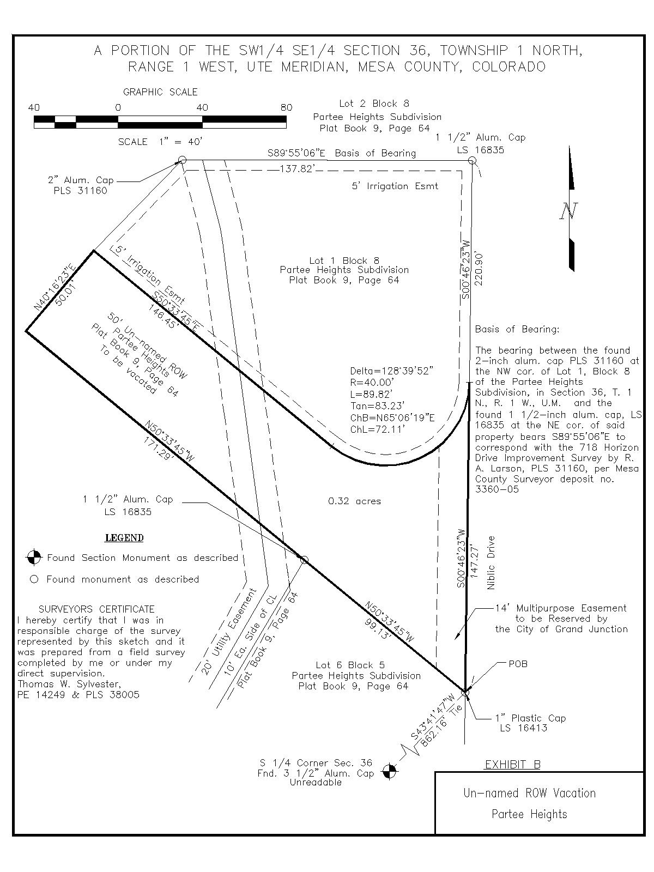
A

