CITY OF GRAND JUNCTION, COLORADO

ORDINANCE NO. 4104

AN ORDINANCE VACATING RIGHT-OF-WAY FOR HILLTOP COURT
LOCATED BETWEEN 2397 AND 2399 MARIPOSA DRIVE

RECITALS:

Two property owners adjacent to Hilltop Court are requesting the vacation of undeveloped Right-of-Way adjacent to their properties. The proposed vacations are being requested to allow the property owners to erect fences, complete driveway and landscaping of yards, etc. for their properties located at 2397 and 2399 Mariposa Drive. The Right-of-Way currently runs between the two residential properties with no existing road improvements.

For that area being vacated, a multi-purpose easement is being retained. This easement is needed for all existing utilities and future utilities that may be located there.

The City Council finds that the property owner’s requests are consistent with the Growth Plan Future Land Use Plan and the Grand Valley Circulation Plan. The application also meets the criteria of section 2.11 of the Zoning and Development Code.

The Planning Commission, having heard and considered the request, found the criteria of the Code to have been met, and recommends that the vacation be approved.

NOW, THEREFORE, BE IT ORDAINED BY THE CITY COUNCIL OF THE CITY OF GRAND JUNCTION THAT:

The following described dedicated right-of-way for Hilltop Court is hereby vacated subject to the listed conditions:

- Applicants shall pay all recording/documentary fees for the Vacation Ordinance, any easement documents and dedication documents; and
- Provided that the Hilltop Court Right-of-Way vacated hereby in said Tracts No.’s 1 and 2 is reserved as a multipurpose easement for the use of City approved public utilities as a perpetual easement for the installation, operation, maintenance and repair of utilities and appurtenances including, but not limited to, electric lines, cable TV lines, natural gas pipelines, sanitary sewer lines, storm sewers, water lines, telephone lines, equivalent other public utility providers and appurtenant facilities.

The following right-of-way is shown on “Exhibit A”, Exhibit B and “Exhibit C” as part of this vacation of description.

Dedicated right-of-way to be vacated:

Tract 1, Right-of-Way Vacation
Exhibit A

The Southern portion of right-of-way for Hilltop Court to be vacated, located in The Ridges Filing No. Three, as shown on plat recorded at Book 12, Pages 5 through 8, Mesa County records, in the Southeast Quarter of the Southeast Quarter (SE¼ SE¼) Section 20, Township 1 South, Range 1 West of the Ute Meridian, City of Grand Junction, Mesa County, Colorado and more particularly described as follows:

The basis of bearings being the East line of SE¼ SE¼ Section 20, Township 1 South, Range 1 West of the Ute Meridian, City of Grand Junction, Mesa County, Colorado, as shown on Exhibit C of this document, which bears South 00 degrees 16 minutes 07 seconds West, a distance of 1317.04 feet, from the Northeast corner to the Southeast corner said SE¼ SE¼ Section 20, as established by observation of Mesa County GPS local coordinate system, with all bearings contained herein relative thereto; thence South 01 degrees 17 minutes 35 seconds West a distance of 130.74 feet; thence North 26 degrees 01 minutes 36 seconds West, a distance of 160.00 feet, along the South right-of-way line of Mariposa Drive, as shown on said plat of The Ridges, Filing No. Three, to the Southeast corner of said Lot 8B, Block Nineteen, The Ridges, Filing No. Three; thence South 63 degrees 58 minutes 24 seconds West, a distance of 110.00 feet to the Southwest corner of said Lot 8B, the POINT OF COMMENCING; thence North 26 degrees 01 minutes 36 seconds West, a distance of 75.00 feet to the existing Northwest corner of said Lot 8B, the POINT OF BEGINNING; thence North 26 degrees 01 minutes 36 seconds West, a distance of 17.10 feet, along the Westerly boundary of said Block 19, The Ridges Filing No. Three; thence North 41 degrees 03 minutes 26 seconds East, a distance of 119.42 feet; thence South 26 degrees 01 minutes 39 seconds East, a distance of 46.56 feet, to a point at the intersection of Hilltop Court right-of-way (a 50 foot wide right-of-way) and Mariposa Drive (a 60 foot wide right-of-way), as shown on said plat of The Ridges, Filing No. Three, to a point at the beginning of a non-tangent curve to the left; thence along said non-tangent curve to the left, having a delta angle of 113 degrees 19 minutes 53 seconds, with a radius of 20.00 feet, an arc length of 39.56 feet, with a chord bearing of North 82 degrees 41 minutes 44 seconds West, with a chord length of 33.42 feet; thence South 40 degrees 38 minutes 24 seconds West, a distance of 89.39 feet, along the Southerly right-of-way of said Hilltop Court to the POINT OF BEGINNING.

Said parcel containing an area of 2041.5 square feet, as described.

Tract 2, Right-of-Way Vacation
Exhibit B

The Northern portion of right-of-way for Hilltop Court to be vacated, located in The Ridges Filing No. Three, as shown on plat recorded at Book 12, Pages 5 through 8, Mesa County records, in the Southeast Quarter of the Southeast Quarter (SE¼ SE¼) Section 20, Township 1 South, Range 1 West of the Ute Meridian, City of Grand Junction, Mesa County, Colorado and more particularly described as follows:

The basis of bearings being the East line of SE¼ SE¼ Section 20, Township 1 South, Range 1 West of the Ute Meridian, City of Grand Junction, Mesa County, Colorado, as shown on Exhibit C of this document, which bears South 00 degrees 16 minutes 07 seconds West, a distance of 1317.04 feet, from the Northeast corner to the Southeast corner said SE¼ SE¼ Section 20, as established by observation of Mesa County GPS local coordinate system, with all bearings contained herein relative thereto; thence South 01 degrees 17 minutes 35 seconds West a distance of 130.74 feet; thence North 26 degrees 01 minutes 36 seconds West, a distance of 160.00 feet, along the South right-of-way line of Mariposa Drive, as shown on said plat of The Ridges, Filing No. Three, to the Southeast corner of Lot 8B, Block Nineteen, The Ridges, Filing No. Three; thence South 63 degrees 58 minutes 24 seconds West, a distance of 110.00 feet to the Southwest corner of said Lot 8B, the POINT OF COMMENCING; thence North 26 degrees 01 minutes 36 seconds West, a distance of 113.81 feet, along the Westerly boundary of said Block 19, The Ridges Filing No. Three to the POINT OF BEGINNING; thence North 26 degrees 01 minutes 36 seconds West, a distance of 15.65 feet, continuing along the Westerly boundary of said Block 19, to the Southwest corner of Lot 7C, said Block Nineteen, to a point on the Northerly right-of-way line of Hilltop Court right-of-way (a 50 foot wide right-of-way), as shown on said plat of The Ridges, Filing No. Three; thence along said Northerly right-of-way of said Hilltop Court the following three (3) courses: (1) North 40 degrees 38 minutes 24 seconds East, a distance of 67.82 feet, to the beginning of a non-tangent curve to the right; (2) along said non-tangent curve to the right, having a delta angle of 15 degrees 09 minutes 01 seconds, with a radius of 120.50 feet, an arc length of 31.86 feet, with a chord bearing of North 48 degrees 12 minutes 53 seconds East, with a chord length of 31.77 feet, to a point at the beginning of a reverse curve to the left; (3) along said curve to the left, having a delta angle of 81 degrees 48 minutes 05 seconds, with a radius of 20.00 feet, an arc length of 28.55 feet, with a chord bearing of North 14 degrees 52 minutes 53 seconds East, with a chord length of 26.19 feet, to a point on the Westerly right-of-way line of Mariposa Drive (a 60 foot wide right-of-way), as shown on said plat of The Ridges, Filing No. Three; thence South 26 degrees 01 minutes 39 seconds East, a distance of 24.43 feet; thence South 41 degrees 03 minutes 26 seconds West, a distance of 119.42 feet to the POINT OF BEGINNING.

Said parcel containing an area of 1666.1 square feet, as described.

See Street Vacation Exhibits A, B and C attached hereto and incorporated by this reference as if fully set forth.

Provided, however, that the Hilltop Court Right-of-Way vacated hereby in said Tracts No.’s 1 and 2 is reserved as a multipurpose easement for the use of City approved public utilities as a perpetual easement for the installation, operation, maintenance and repair of utilities and appurtenances including, but not limited to, electric lines, cable TV lines, natural gas pipelines, sanitary sewer lines, storm sewers, water lines, telephone lines, equivalent other public utility providers and appurtenant facilities.

INTRODUCED for first reading on this 6th day of June, 2007.

ADOPTED this 20th day of June, 2007.

ATTEST:
/s/: James J. Doody
President of City Council

/s/: Stephanie Tuin
City Clerk
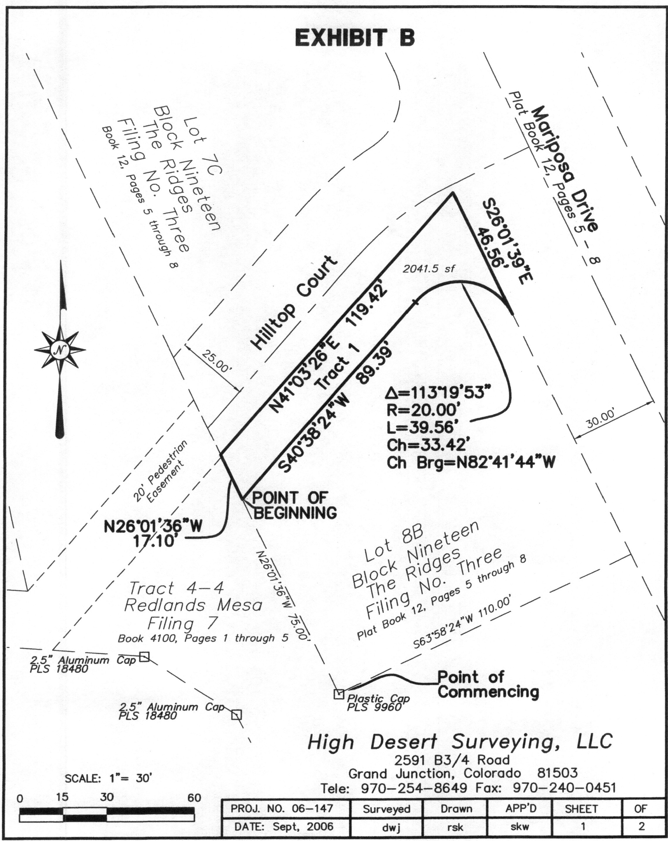
EXHIBIT A
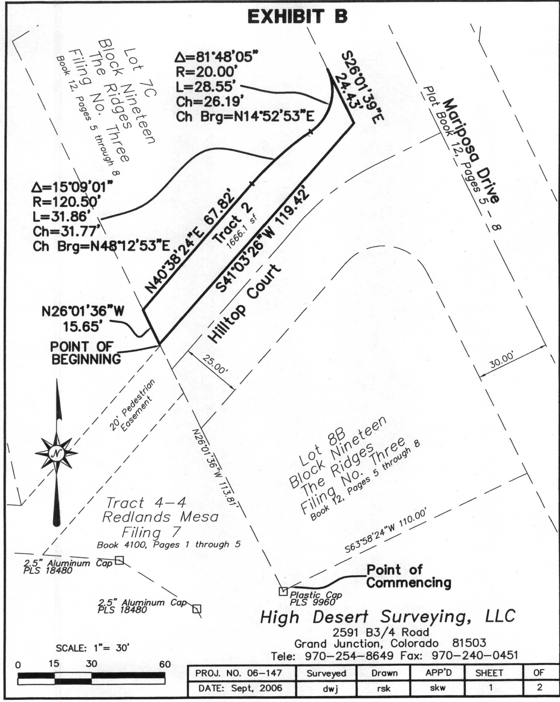
EXHIBIT B
