CITY OF GRAND JUNCTION, COLORADO

ORDINANCE NO. 4163

AN ORDINANCE REZONING APPROXIMATELY 51.04 ACRES FROM R-2 TO PD (PLANNED DEVELOPMENT)

THE RIDGES MESA PLANNED DEVELOPMENT
LOCATED EAST OF HIDDEN VALLEY DRIVE AND HIGH RIDGE DRIVE

Recitals:

A request for a Rezone and Outline Development Plan approval has been submitted in accordance with the Zoning and Development Code. The applicant has requested that approximately 51.04 acres located east of Hidden Valley Drive, High Ridge Drive and north of Bella Pago, be rezoned from R-2 (Residential, 2 units per acre) to PD (Planned Development) retaining R-2 as the default zoning designation.

The PD zoning ordinance will establish the default zoning and maximum and minimum number of dwelling units. It also shows approximate areas of proposed open space and areas of slopes greater than 30%. Possible roadway connections and trails are also shown. Deviations from the R-2 bulk standards, specific design standards and entrance signage details shall be established with the preliminary plan for each phase, if required.

In public hearings, the Planning Commission and City Council reviewed the request for the proposed Rezone and Outline Development Plan approval and determined that it satisfied the criteria as set forth and established in Section 2.12.B.2 of the Zoning and Development Code and the proposed Rezone and Outline Development Plan is consistent with the purpose and intent of the Growth Plan.

NOW, THEREFORE, BE IT ORDAINED BY THE CITY COUNCIL OF THE CITY OF GRAND JUNCTION THAT THE AREA DESCRIBED BELOW IS REZONED FROM R-2 TO PD with AN R-2 default zone:

Property to be Rezoned:

Tax Parcel Number 2945-212-17-007; Lot 7, Ridge Point Filing 1, recorded at Plat Book 14, Pages 348-350 of the Mesa County Clerk and Recorders Office.

PD Phases:

See Attached Exhibit A, Outline Development Plan

Phase 1 – Maximum number of residential units – 28 / totaling 14.16 acres
Phase 2 – Maximum number of residential units – 45 / totaling 22.58 acres
Phase 3 – Maximum number of residential units – 28 / totaling 14.30 acres

The minimum number of dwelling units will be at a density of 0.5 dwelling units per acre.

The public benefit to be obtained by the Planned Development will be
that the applicants have committed to a trail system within the open space areas that will be available for public use. This trail system is not shown on the Urban Trails Master Plan, and therefore is above and beyond the Code requirements. The Open Space provided will exceed that required by the Code in single-family residential developments.

INTRODUCED on first reading on the 17th day of December, 2007 and ordered published.

ADOPTED on second reading this 14th day of January, 2008.

ATTEST:

/s/: James J. Doody
President of Council

/s/: Stephanie Tuin
City Clerk

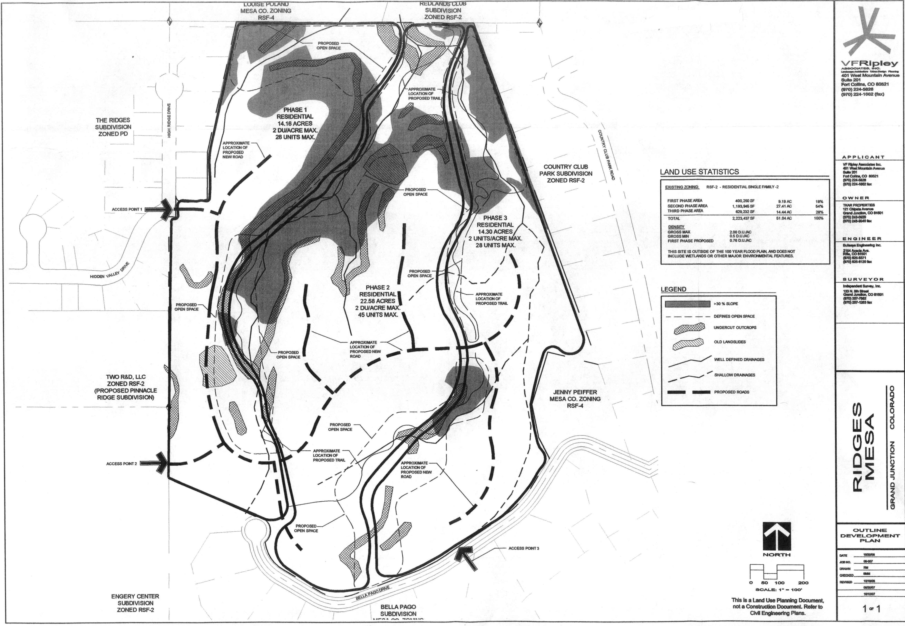

Exhibit A

