CITY OF GRAND JUNCTION

Ordinance No. 4340

AN ORDINANCE VACATING RIGHT-OF-WAY FOR RIMROCK BUSINESS PARK;

A PORTION OF THE WEST SIDE OF 25 1/2 ROAD

RECITALS:

A vacation of the dedicated right-of-way for Rimrock Business Park has been requested by the adjoining property owners.

The City Council finds that the request is consistent with the Growth Plan, the Grand Valley Circulation Plan and Section 2.11 of the Zoning and Development Code.
The Planning Commission, having heard and considered the request, found the criteria of the Code to have been met, and recommends that the vacation be approved.

NOW, THEREFORE BE IT ORDAINED BY THE CITY COUNCIL OF THE CITY OF GRAND JUNCTION THAT:

The following described dedicated right-of-way for Rimrock Business Park is hereby vacated subject to the listed conditions:

- Applicants shall pay all recording/documentary fees for the Vacation Ordinance, any easement documents and dedication documents.

The following right-of-way is shown on “Exhibit A” as part of this vacation of description.

Dedicated right-of-way to be vacated:

Commencing at a BLM marker for the C-N 1/16 corner of Section 15, Township One South, Range One West of the Ute Meridian, whence the N ¼ corner of said Section 15 bears N 00°06’33” W 1325.13 feet;
Thence N 89°56’24” W 30.00 feet along the South line of the S ½, NE ¼, NW ¼ of said Section 15 to the true Point of Beginning;
Thence continuing along said South line N 89° 56’24” W 3.00 feet to the S.W. corner of a right-of-way deed recorded in Book 1405 at Page 975;
Thence N 00°06’33” W 633.90 feet along the West line of said right-of-way deed to a 5/8 “ rebar and cap marked LS-17485;
Thence N 89°53’27” E 3.00 feet along the North line of said right-of-way deed;
Thence S 00°06’33” E 633.91 feet to the true point of beginning, containing 1901.72 square feet more or less.

Introduced for first reading on this 18th day of February, 2009

PASSED and ADOPTED this 4th day of March, 2009.

ATTEST:
/s/: Gregg Palmer
President of City Council

/s/: Stephanie Tuin
City Clerk

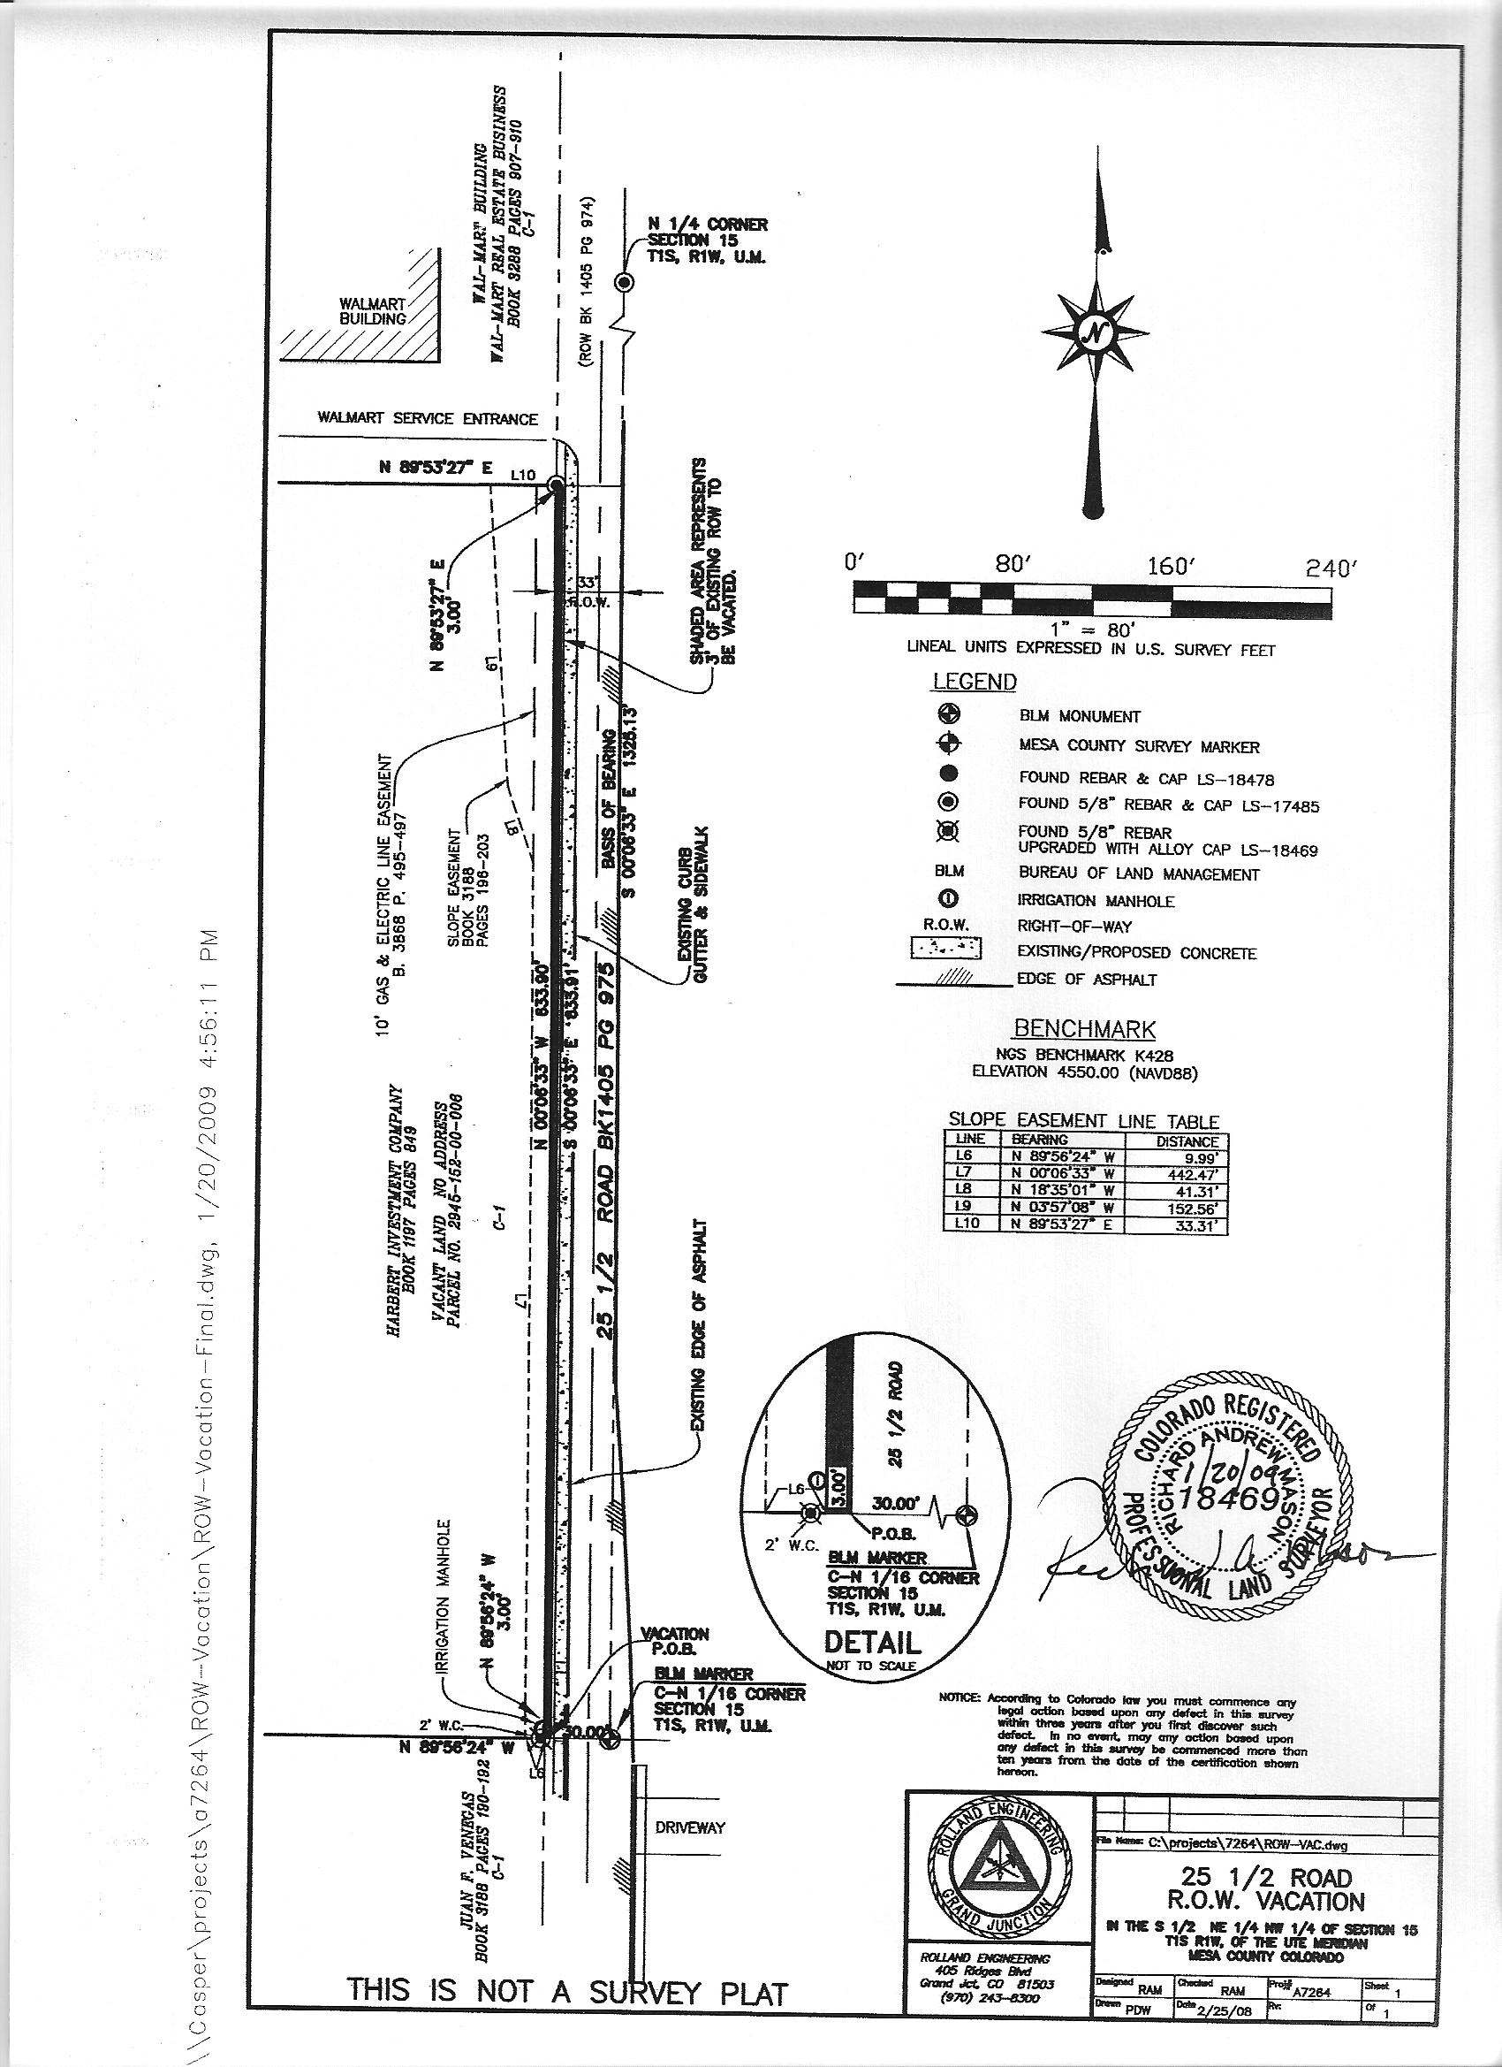
Exhibit A

