CITY OF GRAND JUNCTION

ORDINANCE NO. 4353

AN ORDINANCE VACATING A PORTION OF THE 27 ROAD RIGHT-OF-WAY LOCATED SOUTH OF CARIBBEAN DRIVE AND NORTH OF H ROAD

RECITALS:

A vacation of the dedicated right of way has been requested by the City of Grand Junction on behalf of an adjoining property owner. The City shall reserve and retain all existing utility easements on, along, over, under, through and across the entire area of the right-of-way to be vacated.

The City Council finds that the request is consistent with the Growth Plan, Grand Valley Circulation Plan and Section 2.11 of the Zoning and Development Code.

The Planning Commission, having heard and considered the request found the criteria of the Code to have been met, and recommends that the vacation be approved with the reservation of the utility easement.

NOW, THEREFORE, BE IT ORDAINED BY THE CITY COUNCIL OF THE CITY OF GRAND JUNCTION THAT:

The following described right-of-way is hereby vacated:

The following 27 Road right-of-way is shown on Exhibit A as part of this Vacation description:

A certain parcel of land lying in the Southwest Quarter of the Southwest Quarter (SW 1/4 SW 1/4) of Section 25, Township 1 North, Range 1 West of the Ute Principal Meridian, City of Grand Junction, County of Mesa, State of Colorado, being a portion of that certain 30.00 foot right of way for 27 Road, as described in Book 714, Page 534, Public Records of Mesa County, Colorado and being more particularly described as follows:

BEGINNING at the Northwest corner of Lot 2 of Paradise Hills Park, as same is recorded in Book 4634, Pages 413 and 414, Public Records of Mesa County, Colorado and assuming the West line of said Paradise Hills Park bears S 00°04’07” E with all other bearings mentioned herein in reference thereto; thence from said POINT OF BEGINNING, S 00°04’07” E along the West line of said Paradise Hills Park, a distance of 906.22 feet to a point being the Southwest corner of Lot 1, Paradise Hills Park; thence S 89°55’53” W, along a line perpendicular to the West line of the SW 1/4 SW 1/4 of said Section 25, a distance of 30.00 feet to a point on the West line of the SW 1/4 SW 1/4 of said Section 25; thence N 00°04’07” W along the West line of the SW 1/4 SW 1/4 of said Section 25, a distance of 905.18 feet, more or less, to a point on the South line of Paradise Hills Filing No. Four, as same is recorded in Plat Book 11, Page 164, Public Records of Mesa County, Colorado; thence N 87°56’37” E along said South line, a distance of 30.02 feet, more or less, to the Point of Beginning.

CONTAINING 27,173 Square Feet or 0.62 Acres, more or less, as described.

Introduced for first reading on this 1st day of April, 2009

PASSED and ADOPTED this 15th day of April, 2009.

ATTEST:

/s/ Gregg Palmer
President of City Council

/s/ Stephanie Tuin
City Clerk

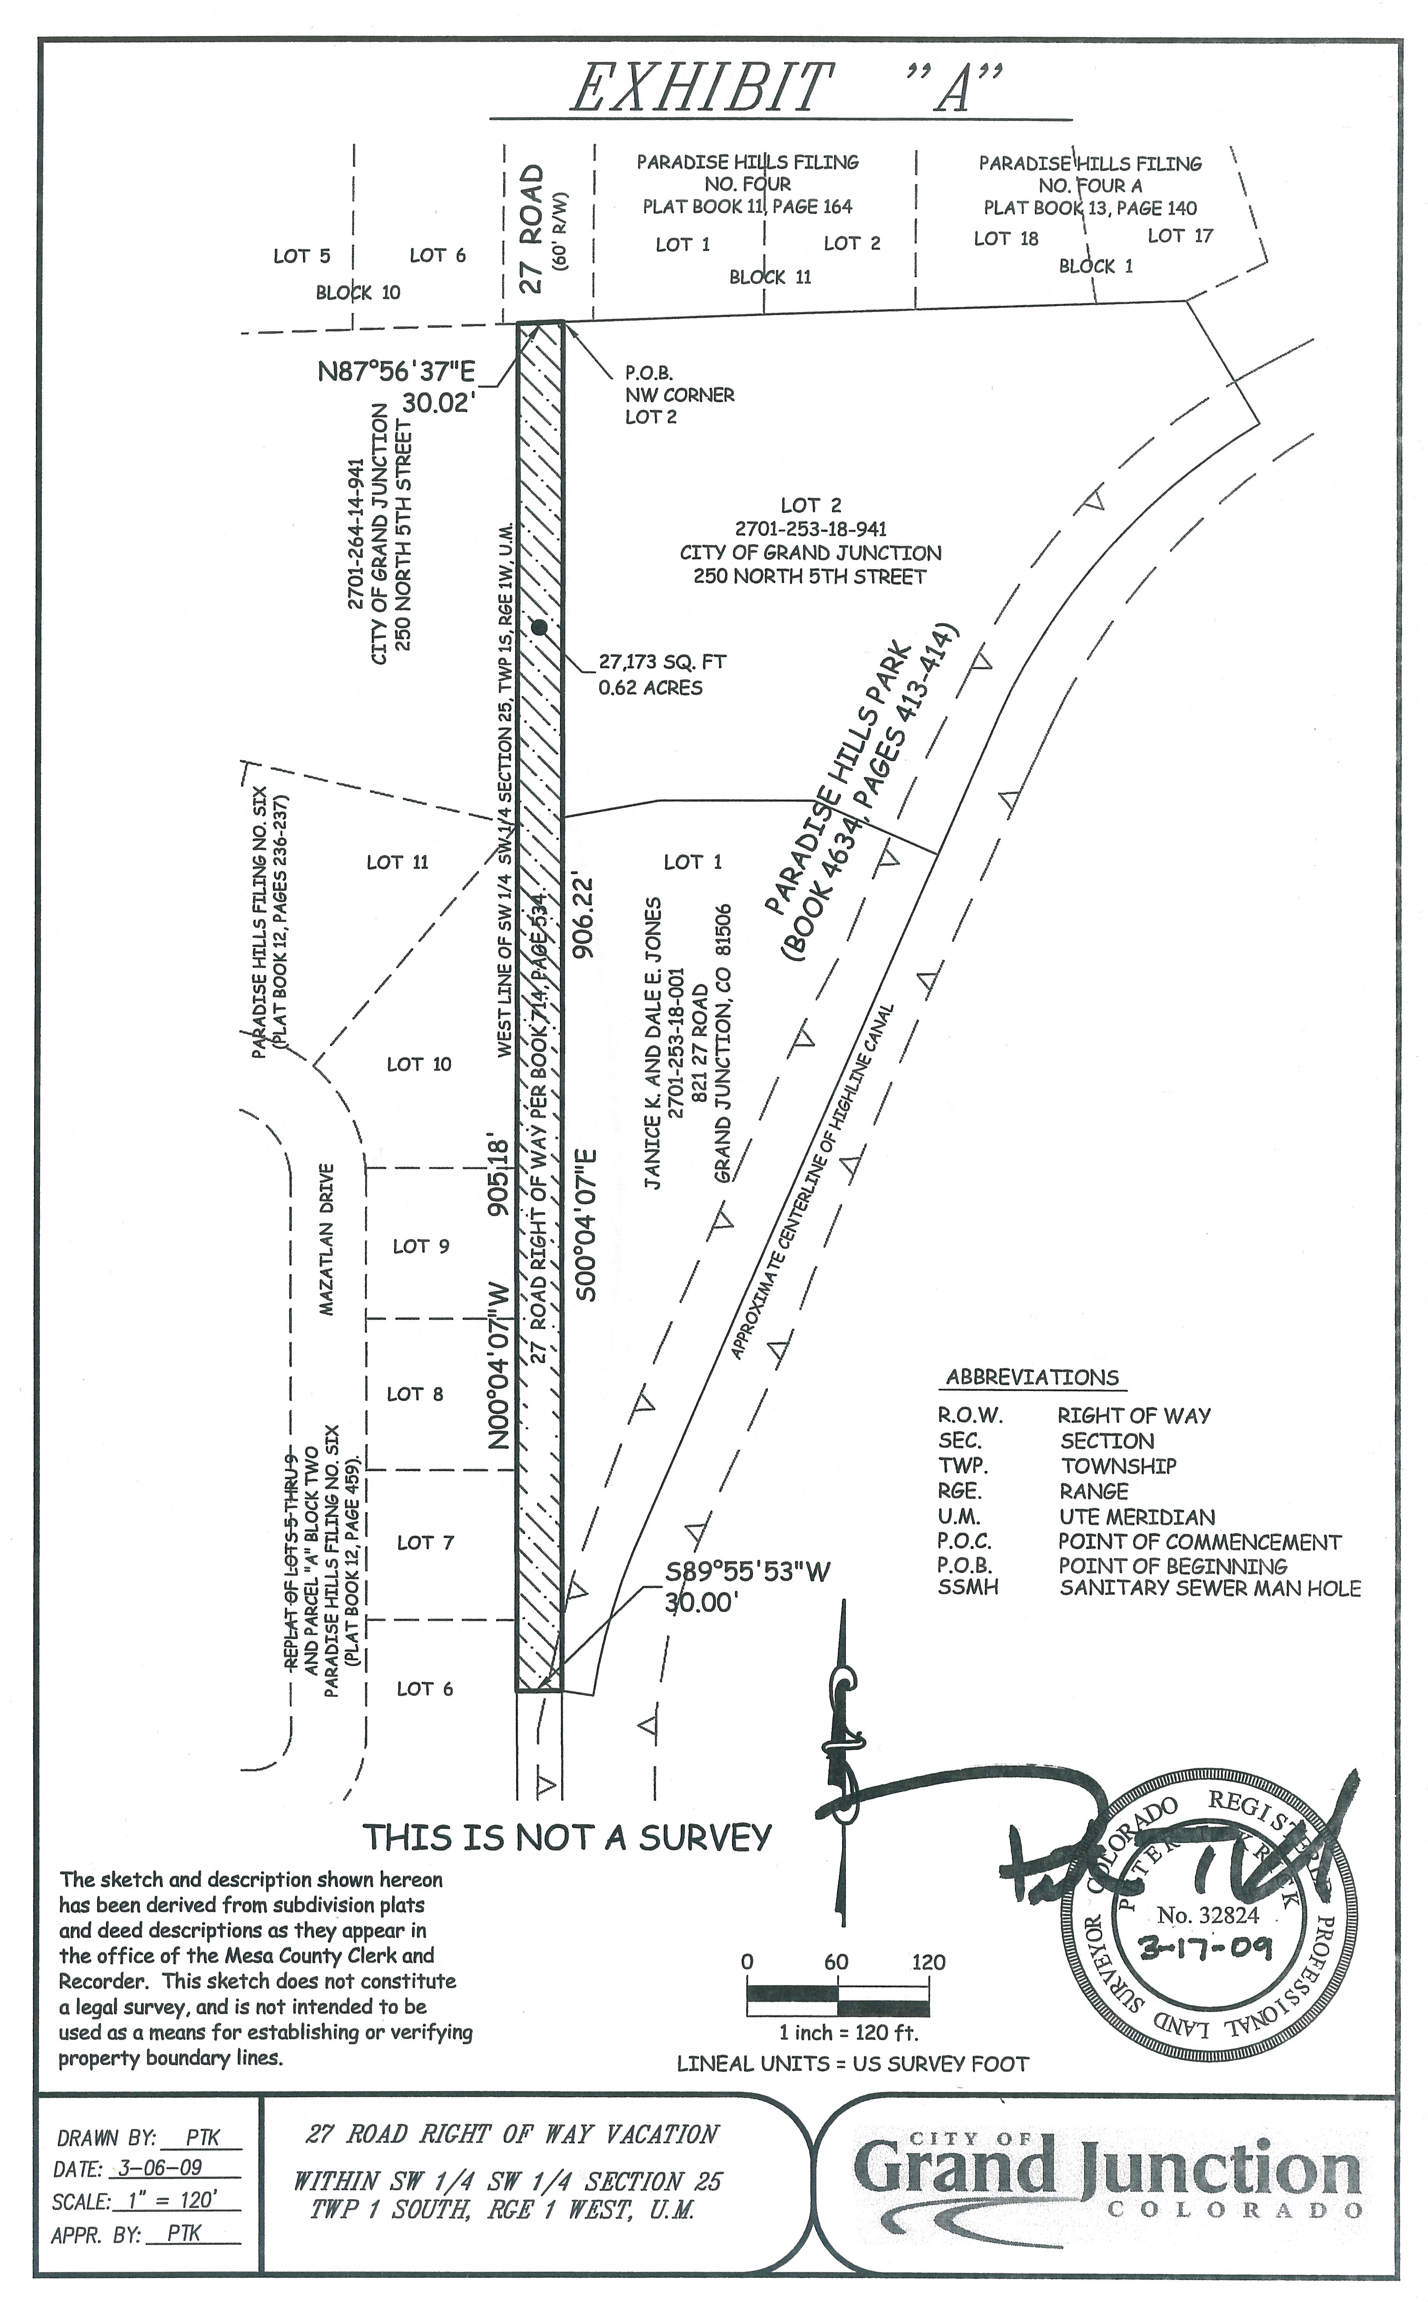
Exhibit “A”

