CITY OF GRAND JUNCTION

ORDINANCE NO. 4356

AN ORDINANCE VACATING A PORTION OF THE SOUTH 7TH STREET RIGHT-OF-WAY LOCATED SOUTH OF THE RIVERSIDE PARKWAY AND NORTH OF STRUTHERS AVENUE AND A PORTION OF THE KIMBALL AVENUE RIGHT-OF-WAY LOCATED WEST OF THE RIVERSIDE PARKWAY

RECITALS:

A request to vacate a portion of the South 7th Street right-of-way located south of the Riverside Parkway and north of Struthers Avenue and a portion of the Kimball Avenue right-of-way located west of the Riverside Parkway, has been made by the City. The City shall reserve and retain a perpetual Multipurpose Easement on, along, over, under, through and across the entire area of the right-of-ways to be vacated.

The City Council finds that the request to vacate the herein described right-of-way portions with the reservation to reserve and retain the easement is consistent with the Growth Plan and Section 2.11 of the Zoning and Development Code.

The Planning Commission, having heard and considered the request on April 28, 2009, found the criteria of the Zoning and Development Code to have been met, and recommends that the vacation be approved as requested subject to the condition that the City shall reserve and retain a perpetual Multipurpose Easement on, along, over, under, through and across the entire area of the hereinafter described right-of-ways.

NOW, THEREFORE, BE IT ORDAINED BY THE CITY COUNCIL OF THE CITY OF GRAND JUNCTION THAT:

The described right-of-way portions in the attached Exhibit A which are incorporated herein as if fully rewritten are hereby vacated and perpetual Multipurpose Easements are hereby reserved and retained on, along, over, under, through and across the entire area of the described portions of right-of-way for City-approved utilities including the installation, operation, maintenance and repair of said utilities and appurtenances which may include but are not limited to electric lines, cable TV lines, natural gas pipelines, sanitary sewer lines, storm sewers, waterlines, telephone lines, traffic control facilities, street lighting, landscaping, trees and grade structures.

Introduced for first reading on this 4th day of May, 2009

PASSED and ADOPTED this 18th day of May, 2009.

ATTEST:
/s/: Bruce Hill
President of City Council

/s/: Stephanie Tuin
City Clerk
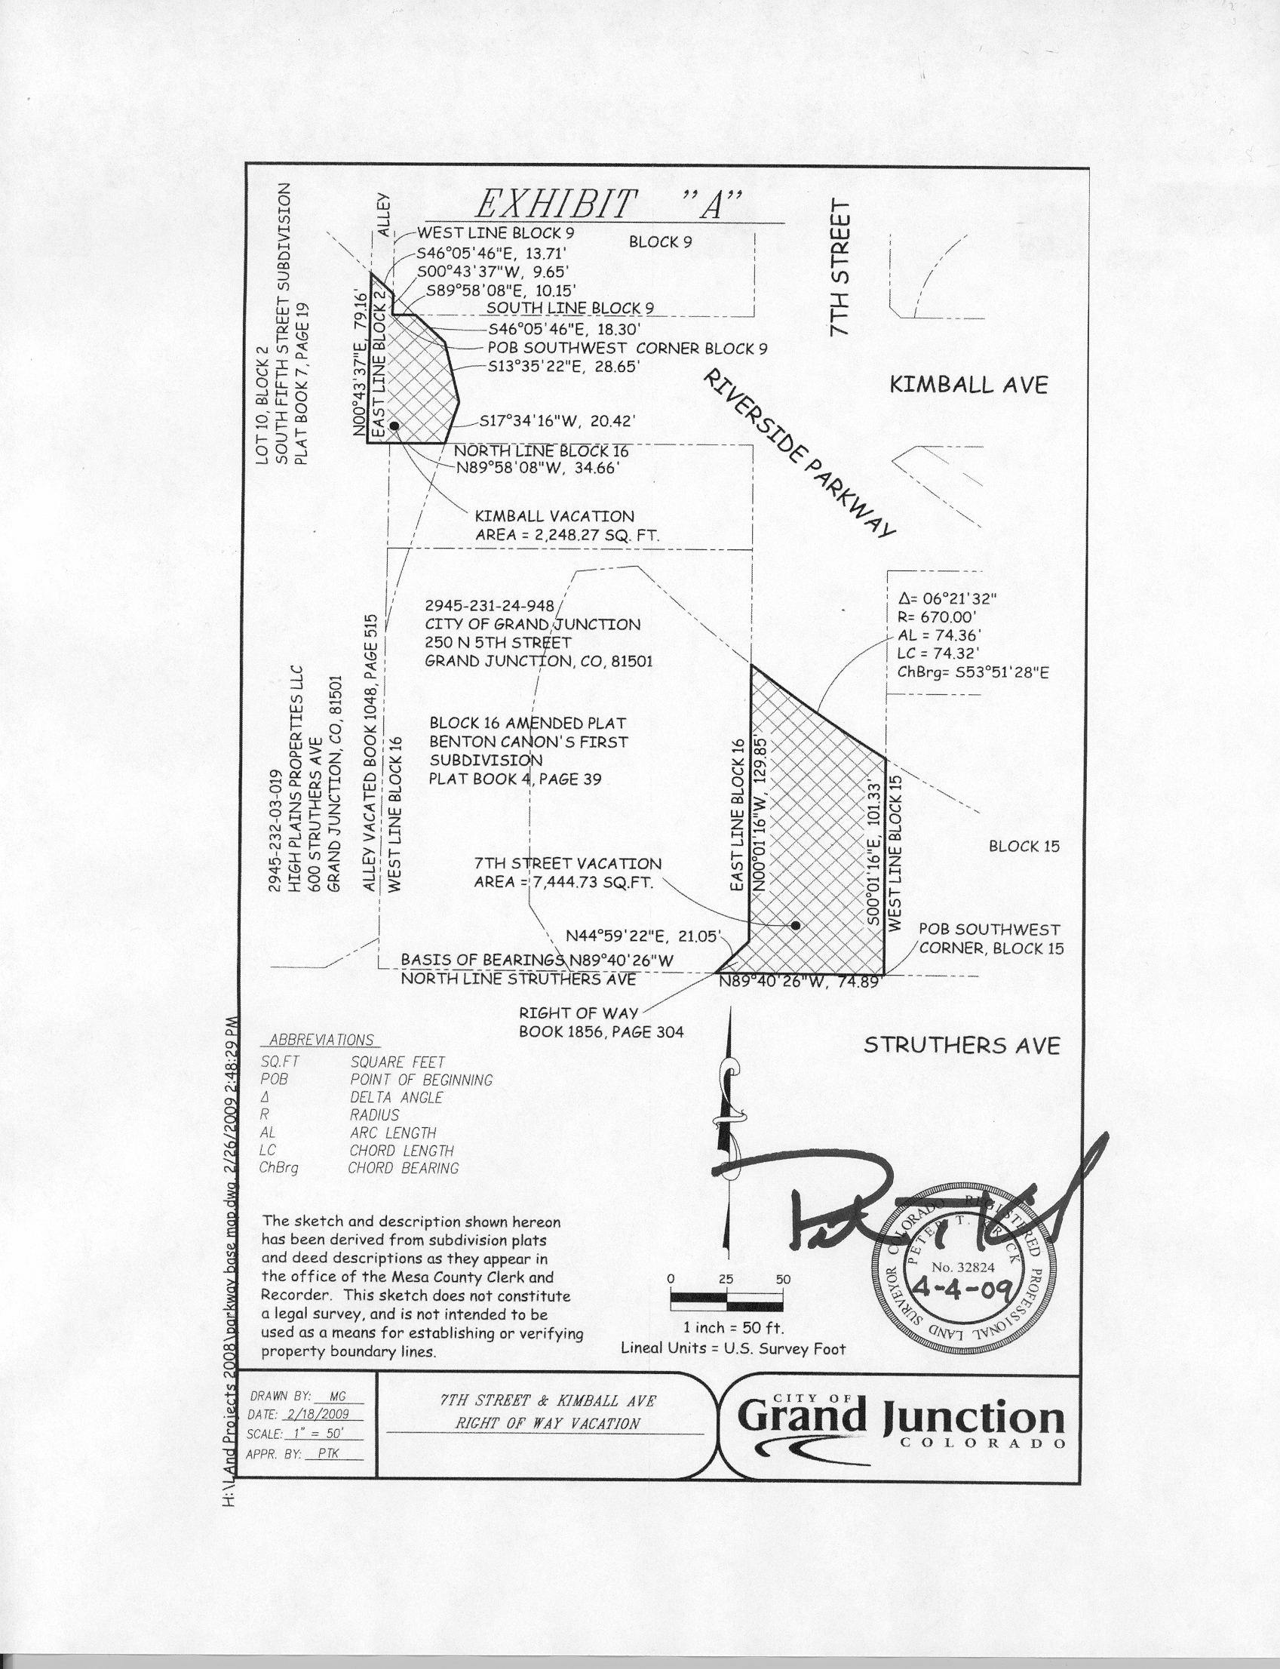
Exhibit “A”

