CITY OF GRAND JUNCTION

ORDINANCE NO. 4431

AN ORDINANCE VACATING PORTIONS OF TEXAS, ELM, HOUSTON AND BUNTING AVENUES AND ASSOCIATED ALLEY RIGHTS-OF-WAY

IN THE MESA STATE COLLEGE AREA

RECITALS:

Mesa State College has requested the vacation of street and alley rights-of-way in the Mesa State College area to allow for expansion of the campus, in accordance with the 1999 Facilities Master Plan. The vacated rights-of-way shall be reserved as Utility and Access Easements to allow for the adequate circulation of through traffic and accessibility to non-Mesa State College owned property and also utilities. Only asphalt or other surface treatment will be allowed within said Utility and Access Easements. Other surface treatment shall be subject to review and approval by the City of Grand Junction.

The City Council finds that the request is consistent with the Comprehensive Plan, the Grand Valley Circulation Plan and Chapter 21.02.100 of the Zoning and Development Code with the conditions of approval including the reservation and granting of the Utility and Access Easements as described with this ordinance.

The Planning Commission, having heard and considered the request, found the criteria of the Code to have been met with the conditions of approval, and recommends that the vacation be conditionally approved.

NOW, THEREFORE BE IT ORDAINED BY THE CITY COUNCIL OF THE CITY OF GRAND JUNCTION THAT:

The following described dedicated rights-of-way are hereby vacated subject to the listed conditions:

The public Streets and Alleys situate within the SE 1/4 of Section 11, Township One South, Range One West of the Ute Meridian, City of Grand Junction, Mesa County, Colorado, described as follows:

1. All of the east-west alley in Block 6, Garfield Park Subdivision, Reception No. 444756.

2. All of Texas Avenue lying west of Elam II Subdivision, as recorded in the records of the Mesa County Clerk & Recorder at Reception No. 2455622, to the east of the most easterly right-of-way line of Cannell Avenue as it abuts Texas Avenue.

3. All of the east-west alley in South Garfield Park Subdivision, as recorded in the records of the Mesa County Clerk & Recorder at Reception No. 539508.

4. All of Elm Avenue lying east of the most easterly right-of-way line of Cannell Avenue as it abuts Elm Avenue and west of Elam II Subdivision, as recorded in the records of the Mesa County Clerk & Recorder at Reception No. 2455622.

5. All of Houston Avenue that remains from the dedication of Houston Avenue on the McMullin & Gormley Sub-division plat, as recorded in the records of the Mesa County Clerk & Recorder at Reception No. 349926 after the right-of-way vacation of Houston Avenue in Ordinance No. 4252.

6. All of the north-south alley in Block 2, McMullin & Gormley Sub-division, as recorded in the records of the Mesa County Clerk & Recorder at Reception No. 349926.

7. All of the north-south alley in Block 3, McMullin & Gormley Sub-division, as recorded in the records of the Mesa County Clerk & Recorder at Reception No. 349926, remaining after the right-of-way vacation of a portion of the same alley in Ordinance No. 4252.

8. All of Bunting Avenue lying east of the east right-of-way line of Cannell Avenue and west of the east right-of-way line of Houston Avenue.

The identified rights-of-way as shown on “Exhibit A” as part of this vacation description.

Temporary utility easements are hereby reserved by the City of Grand Junction on, along, over, under, through and across the areas of the right-of-ways to be vacated for the benefit of the public for the use of City-approved public utilities as perpetual easements for the operation, maintenance and repair of utilities and appurtenances including, but not limited to, electric lines, cable TV lines, natural gas pipelines, sanitary sewer lines, storm sewers, water lines, telephone lines, equivalent other public utility providers and appurtenant facilities. The easement area shall not be burdened or overburdened by the installation, construction or placement of any structures or any other item or fixture which might be detrimental to the facilities of the City-approved public utilities or which might act to prevent or impede reasonable ingress and egress for workers and equipment on, along, over, under, through and across the easement area. Only sod or gravel shall be placed on the surface in the easement area unless written consent has been given by the City Manager’s designee.

Temporary access easements are hereby reserved by the City of Grand Junction on, along, over, under though and across the areas of the right-of-ways to be vacated for maintaining and repairing an access way for vehicular and pedestrian ingress and egress, except as follows:

1. No temporary access shall be reserved on any or all of the east-west alley in Block 6, Garfield Park Subdivision, Reception No. 444756.

2. No temporary access shall be reserved on that portion of Texas Avenue abutting the 30 most easterly feet of Lot 5 and all of Lot 6 and Lot 7 of the South Garfield Park Subdivision, as recorded in the records of the Mesa County Clerk & Recorder at Reception No. 539508.

3. No temporary access shall be reserved on that portion of the east-west alley in South Garfield Park Subdivision abutting the 30 most easterly feet of Lot 36 and all of Lots 35, 34, and 33 as recorded in the records of the Mesa County Clerk & Recorder at Reception No. 539508.

4. No temporary access shall be reserved on that portion of Elm Avenue vacated herein that lies east of the most easterly right-of-way line of Houston Avenue as vacated herein.

5. No temporary access shall be reserved on the portion of Houston Avenue lying south of the northerly right-of-way line of Bunting Avenue.

The easements are reserved and or separately granted as temporary easements as it is understood that the easements are needed for the utilities presently in the right-of-way and for access. It is expected that some utilities will be relocated or removed with the changes and improvements being made to the Mesa State College campus. Mesa State College will work with the City and the appropriate public utility agencies to determine the final location of the utilities and the relocation of the utilities. Once the utilities have been relocated or it is determined that the utility infrastructure need not be moved to the satisfaction of the City Manager or the City Manager’s designee, Mesa State College shall grant new permanent utility easements for the new locations as required by the City Manager. Upon the City’s acceptance of a utility easement, the City Manager shall release all interests in the Temporary Utility Easements pursuant to Section 21.02.100 of the Grand Junction Municipal Code that is no longer needed due to the grant of the new permanent utility easement.

In accordance with the same section, the City Manager may likewise release any and/or all interest in a temporary access easement included herein if it is determined that the access is no longer needed. All temporary access easements installed by Mesa State College shall be maintained and repaired by Mesa State College.

Applicants shall pay all recording/documentary fees for the Vacation Ordinance, any easement documents and dedication documents.

Introduced for first reading on this 19th day of July, 2010.

PASSED and ADOPTED this 2nd day of August, 2010.

ATTEST:

/s/: Teresa A. Coons
President of City Council

/s/: Stephanie Tuin
City Clerk

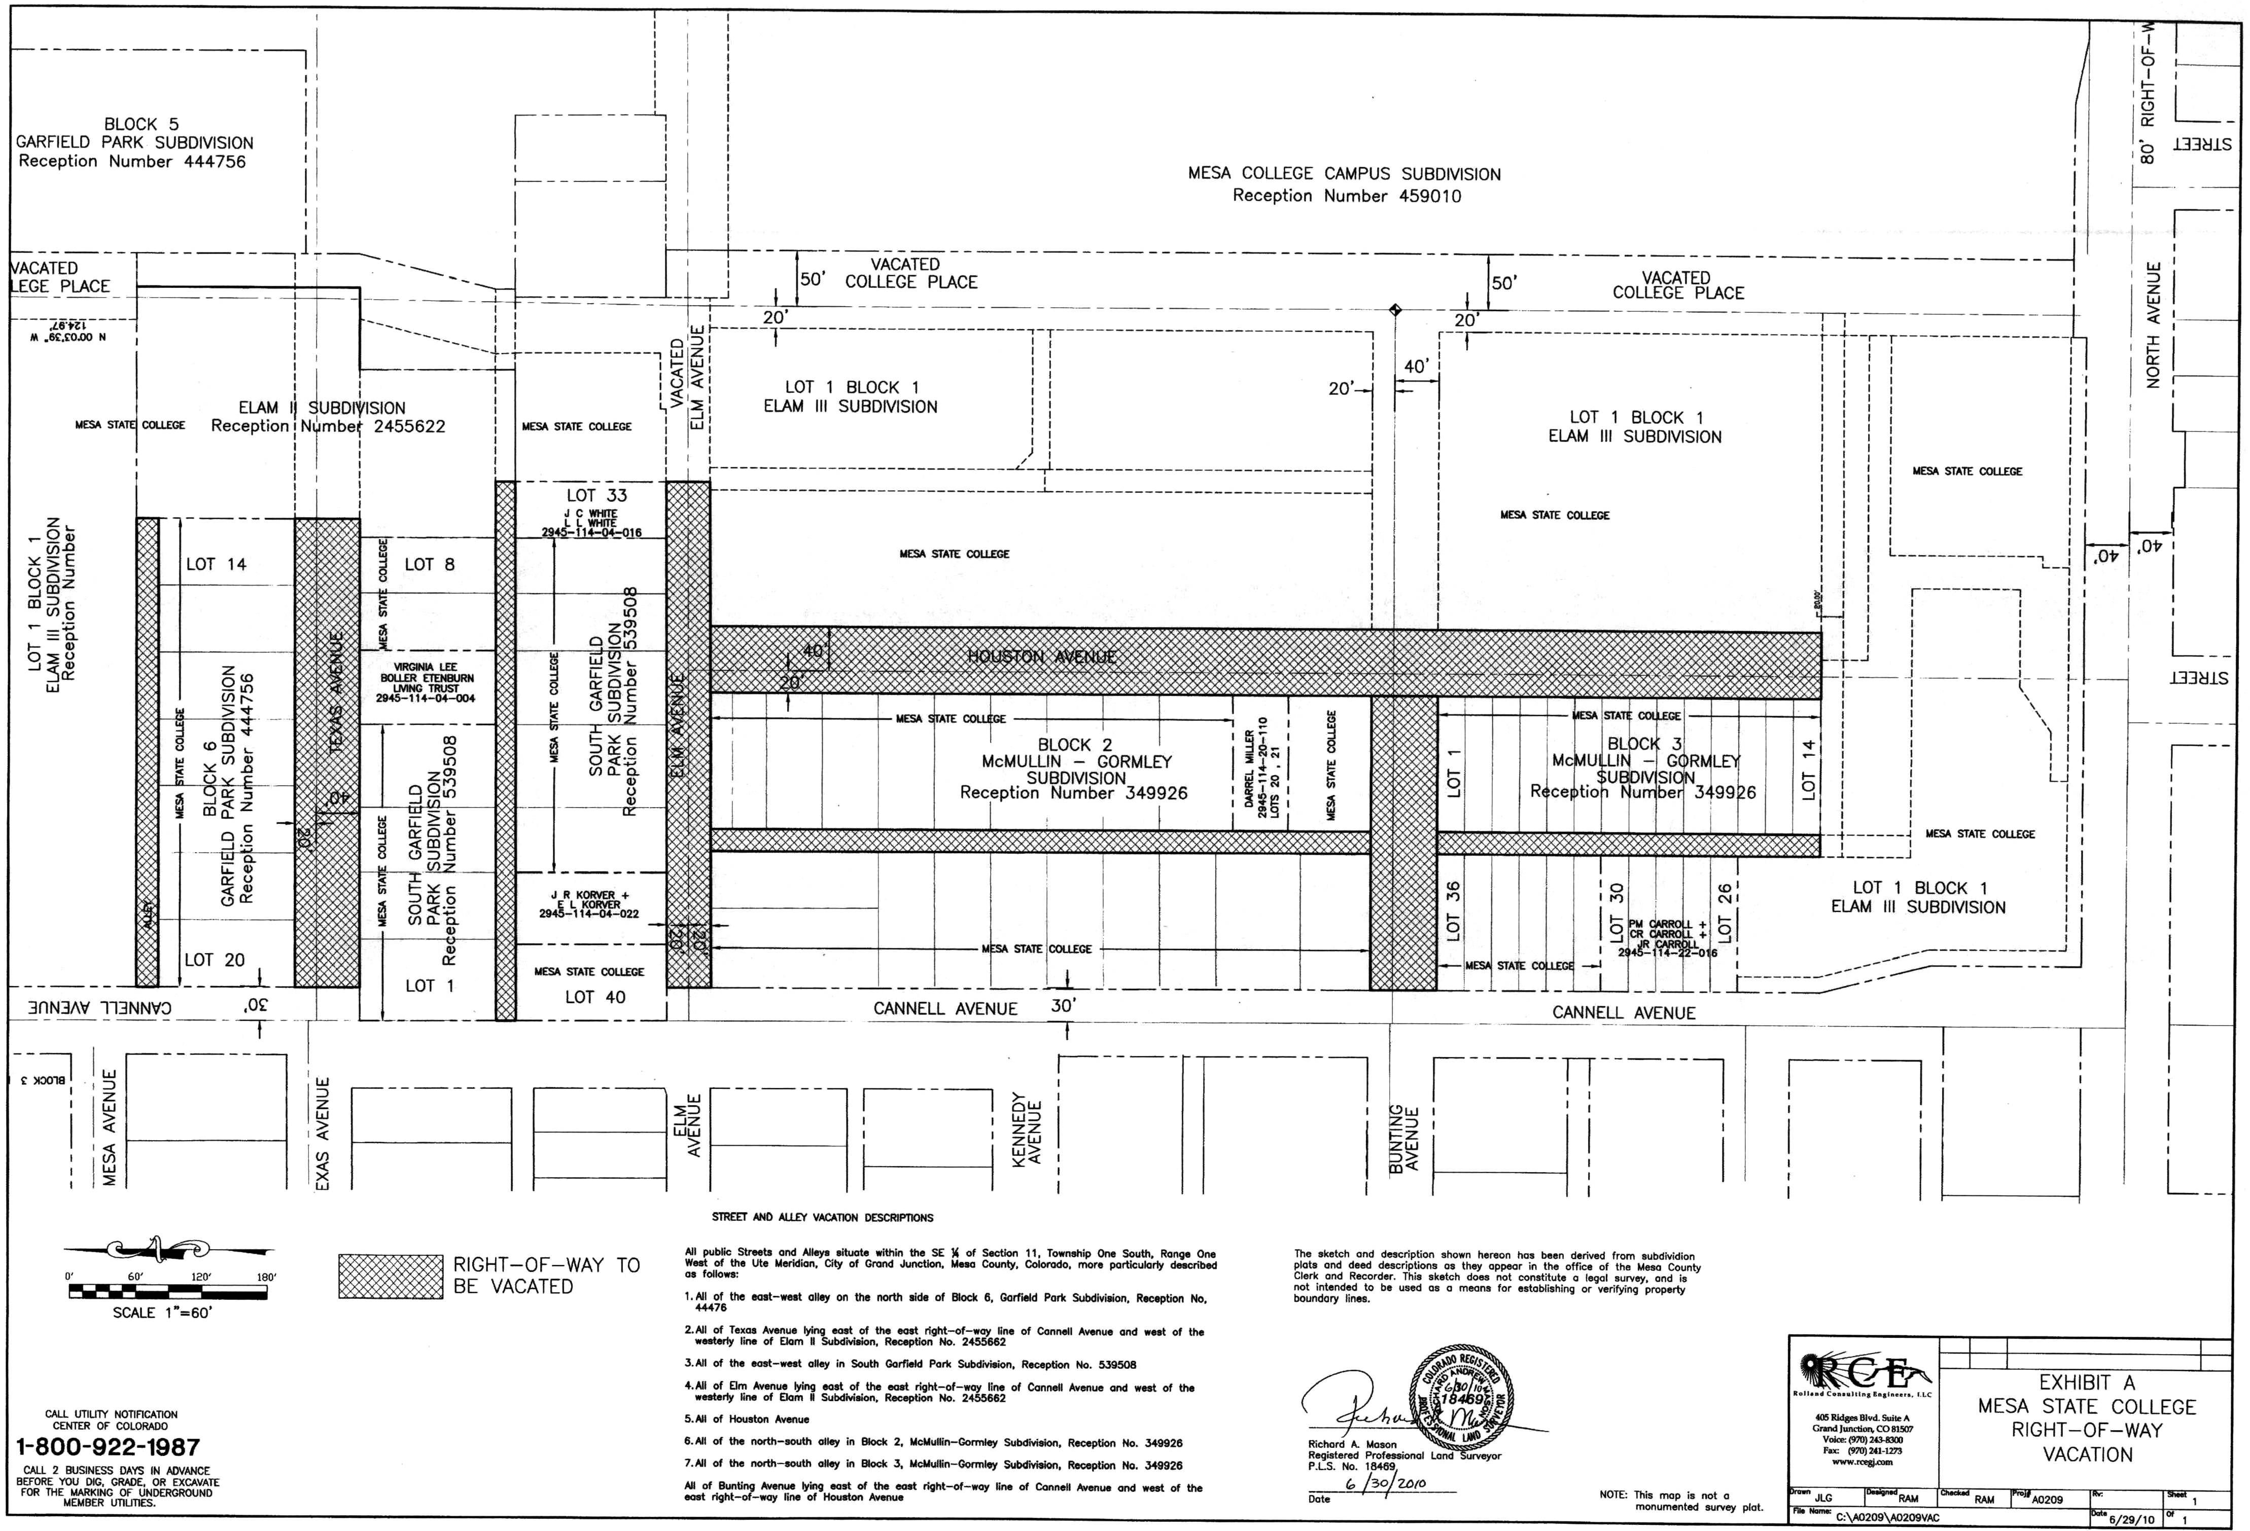
“Exhibit A”

