CITY OF GRAND JUNCTION, COLORADO

ORDINANCE NO. 4484

AN ORDINANCE AMENDING THE GRAND JUNCTION COMPREHENSIVE PLAN, TITLE 31, OF THE GRAND JUNCTION MUNICIPAL CODE, TO CLARIFY WHICH ZONE DISTRICTS IMPLEMENT EACH LAND USE DESIGNATION OF THE COMPREHENSIVE PLAN

Recitals:

On February 17, 2010 the Grand Junction City Council and Mesa County adopted the Grand Junction Comprehensive Plan, also known as Title 31 of the Grand Junction Municipal Code of Ordinances.

Chapter One of the Comprehensive Plan entitled “Land Use Designations” identifies the City and County zone districts that serve to implement each of the land use designations of the Comprehensive Plan.

The City Zoning and Development Code also identify the zone districts that serve to implement the Comprehensive Plan. In Mesa County this information is found in Chapter Four of the Mesa County Land Development Code.

Working with the Comprehensive Plan and the City Zoning Code, City Staff identified inconsistencies between the two regarding which City zone districts implement each land use category of the Comprehensive Plan.

These inconsistencies arose primarily due to changes made late in the City’s legislative process with respect to adoption of the Form Based Districts and the Blended Residential Land Use Categories Map.

The proposed changes to the Comprehensive Plan clarify which zone districts implement each of the land use designations of the Comprehensive Plan and rename the “Agriculture” land use designation “Large Lot 35+”.

The proposed text amendments were distributed to the Mesa County Planning Division and various external review agencies for their review and comment. The City did not receive any comments for or against the proposed text amendments during the review period from external review agencies.

An Open House was held on August 31, 2011 to allow property owners and interested citizens an opportunity to review the proposed amendments, to make comments and to meet with staff to discuss any concerns that they might have. A display ad noticing the Open House was run in the Daily Sentinel newspaper to encourage public review and comment. The proposed amendments were also posted on the City and Mesa County websites with information about how to submit comments or concerns.
A joint meeting between the City Planning Commission and the Mesa County Planning Commission was held on September 27, 2011 to consider the proposed text amendments. The City Planning Commission voted to recommend approval of the proposed amendments to the Grand Junction City Council. The Mesa County Planning Commission is responsible for adopting a resolution to adopt the proposed amendments.

After public notice and a public hearing as required by the Charter and Ordinances of the City, the Grand Junction Planning Commission recommended approval of the proposed amendments for the following reasons:

1. The proposed amendments are consistent with the goals and policies of the Comprehensive Plan.
2. The proposed amendments will help implement the vision, goals and policies of the Comprehensive Plan.

After public notice and a public hearing before the Grand Junction City Council, the City Council hereby finds and determines that the proposed amendments will implement the vision, goals and policies of the Comprehensive Plan and should be adopted.

NOW THEREFORE BE IT ORDAINED BY THE CITY COUNCIL OF THE CITY OF GRAND JUNCTION THAT:

Chapter One of the Comprehensive Plan entitled “Land Use Designations” is hereby amended with the following text amendments as shown on the attached descriptions of land use designations.

INTRODUCED on first reading the 5th day of October, 2011 and ordered published in pamphlet form.

PASSED and ADOPTED on second reading the 17th day of October, 2011 and ordered published in pamphlet form.

ATTEST:

/s/: Tom Kenyon
President of the Council

/s/: Stephanie Tuin
City Clerk
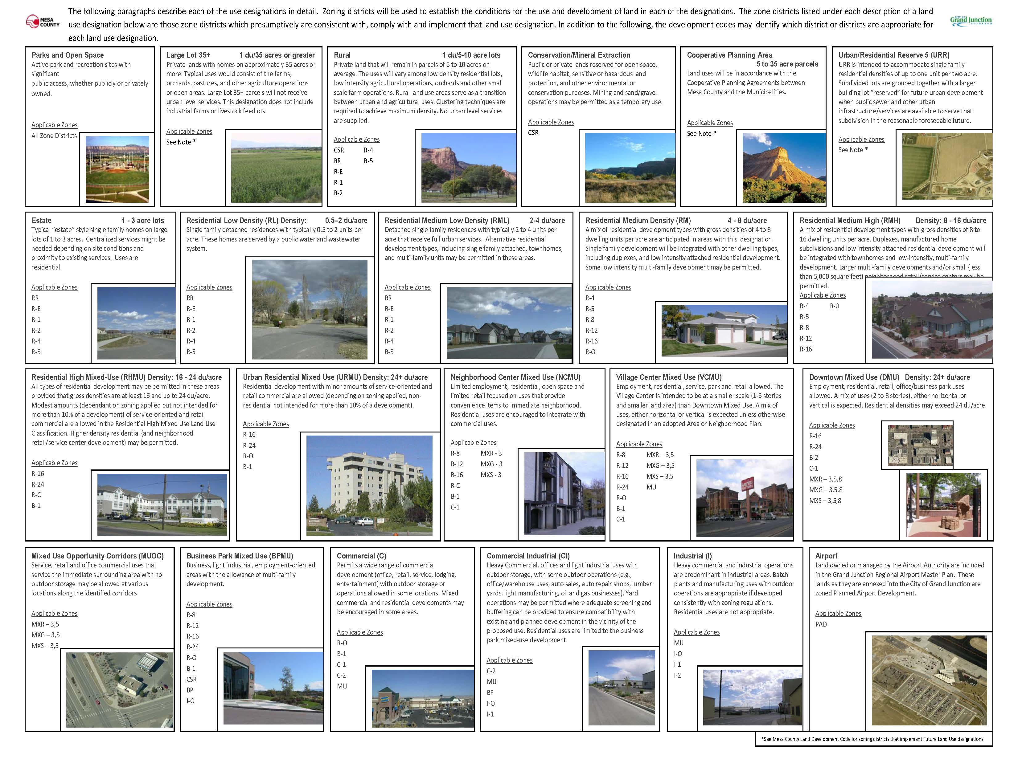
See Note*

